**Splunk Search - Demo**

1. **Create a free account in** [**https://www.splunk.com/en_us/download.html**](https://www.splunk.com/en_us/download.html)
2. **After creating an account , login to the account using the url** [**http://localhost:8000/en-US/app/launcher/home#en-US/app/launcher/home**](http://localhost:8000/en-US/app/launcher/home#en-US/app/launcher/home)
3. **View the page**

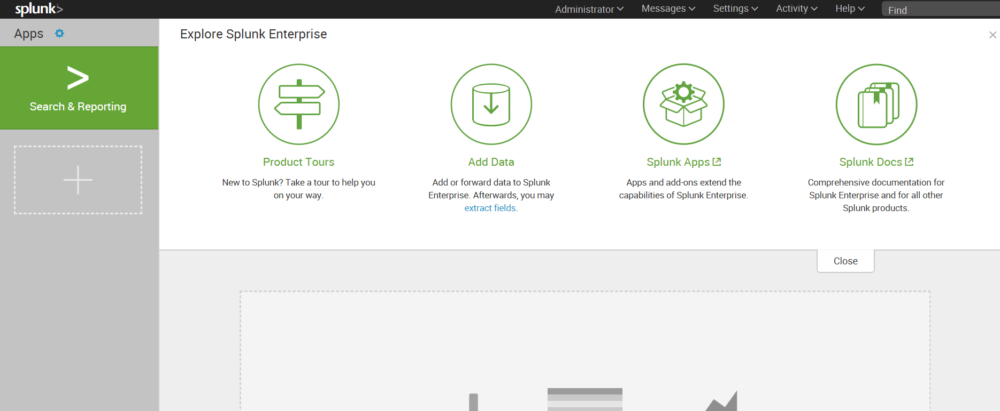

1. **Click on Add data**
2. **Click on monitor data to monitor real time data**

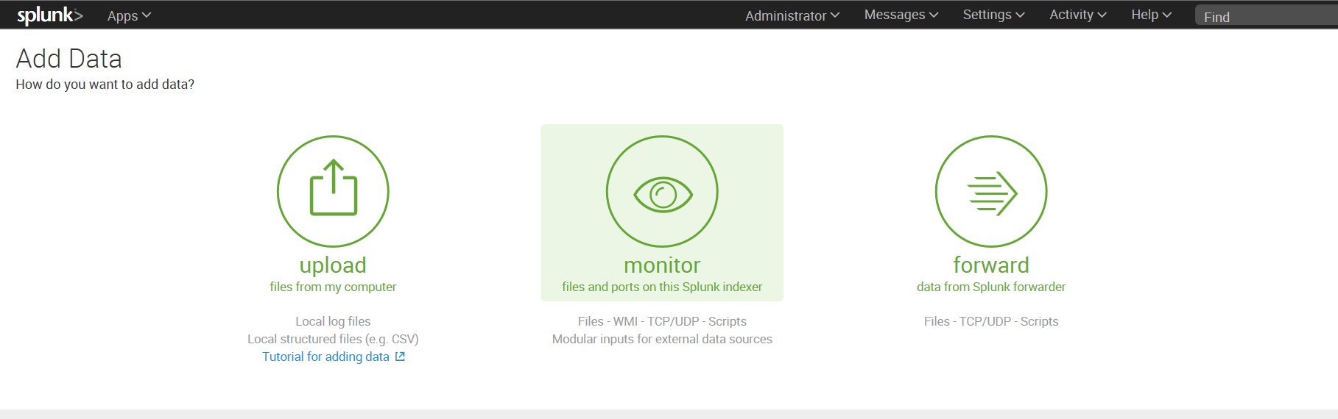

1. **Select the different types of logs**

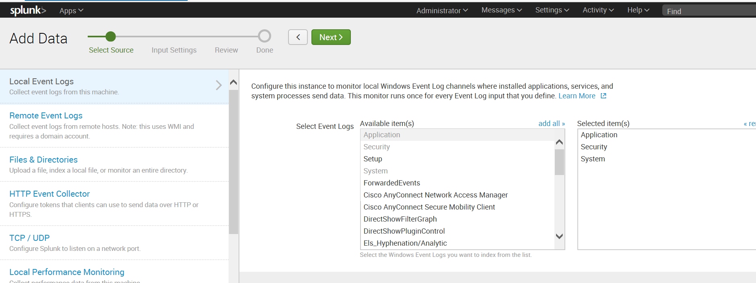

**Click on Next**

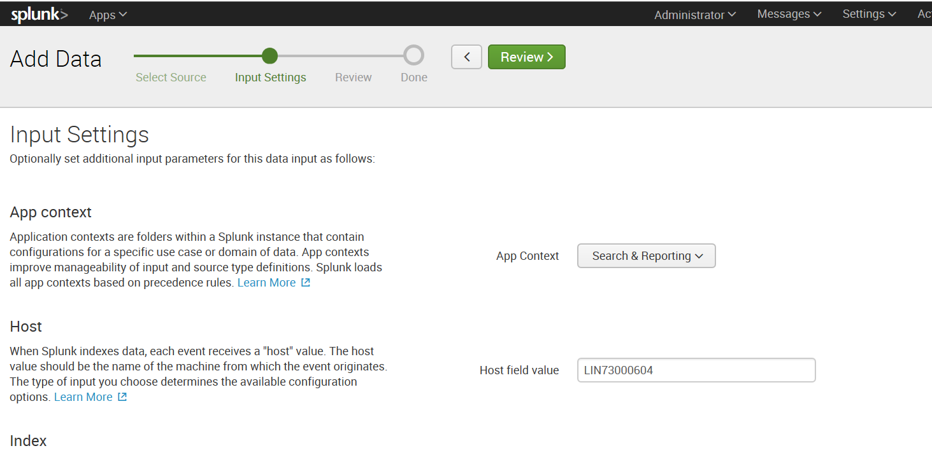

**Click on Review**

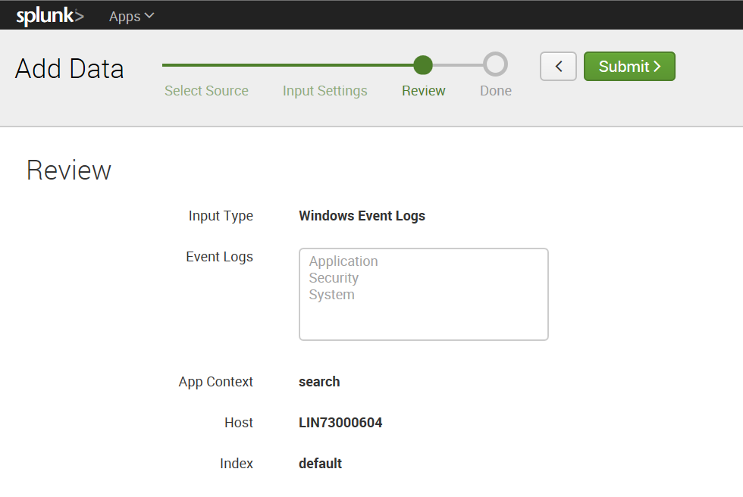

**Click on submit**

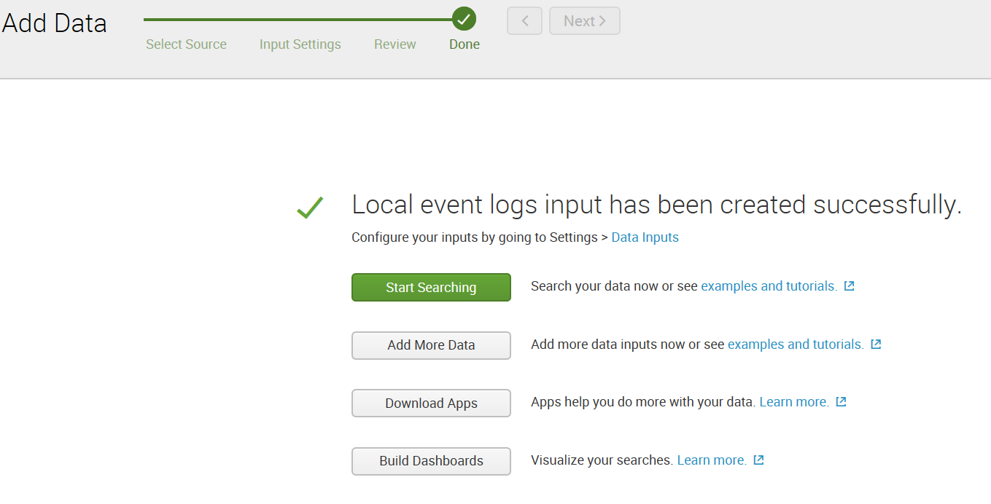

**Click on Searching**

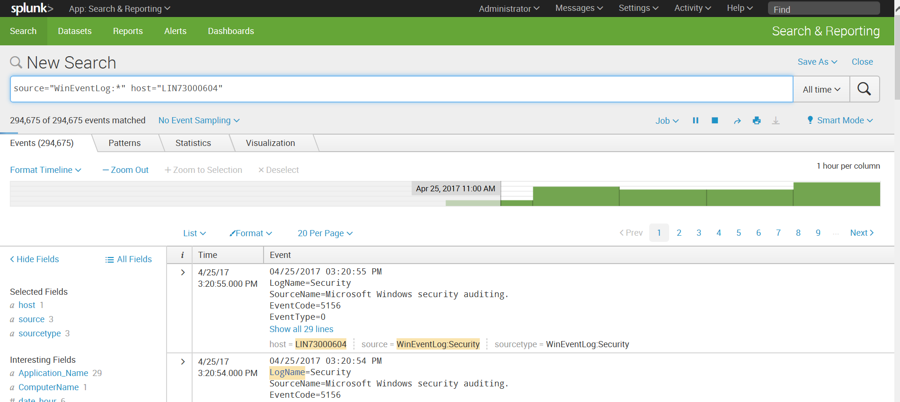

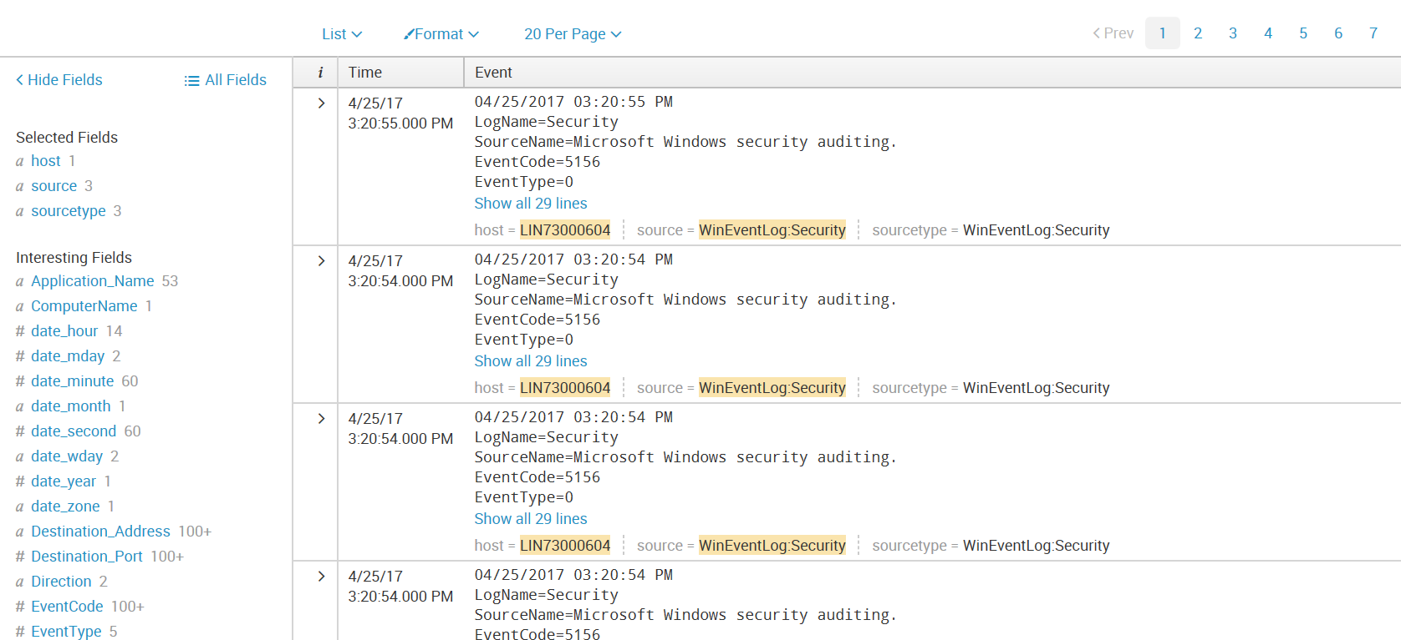

**Search by host, source, and sourcetype**

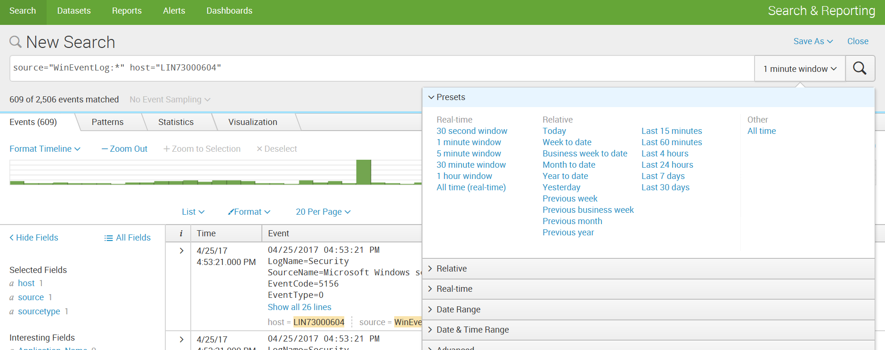

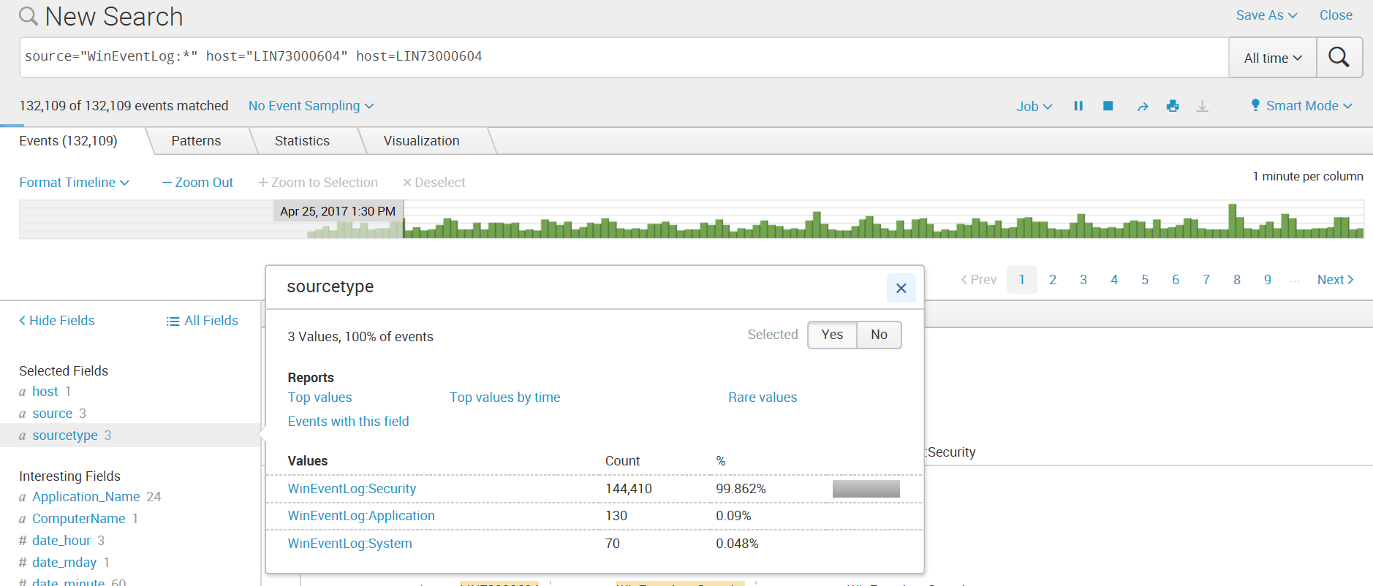

**Add to search**

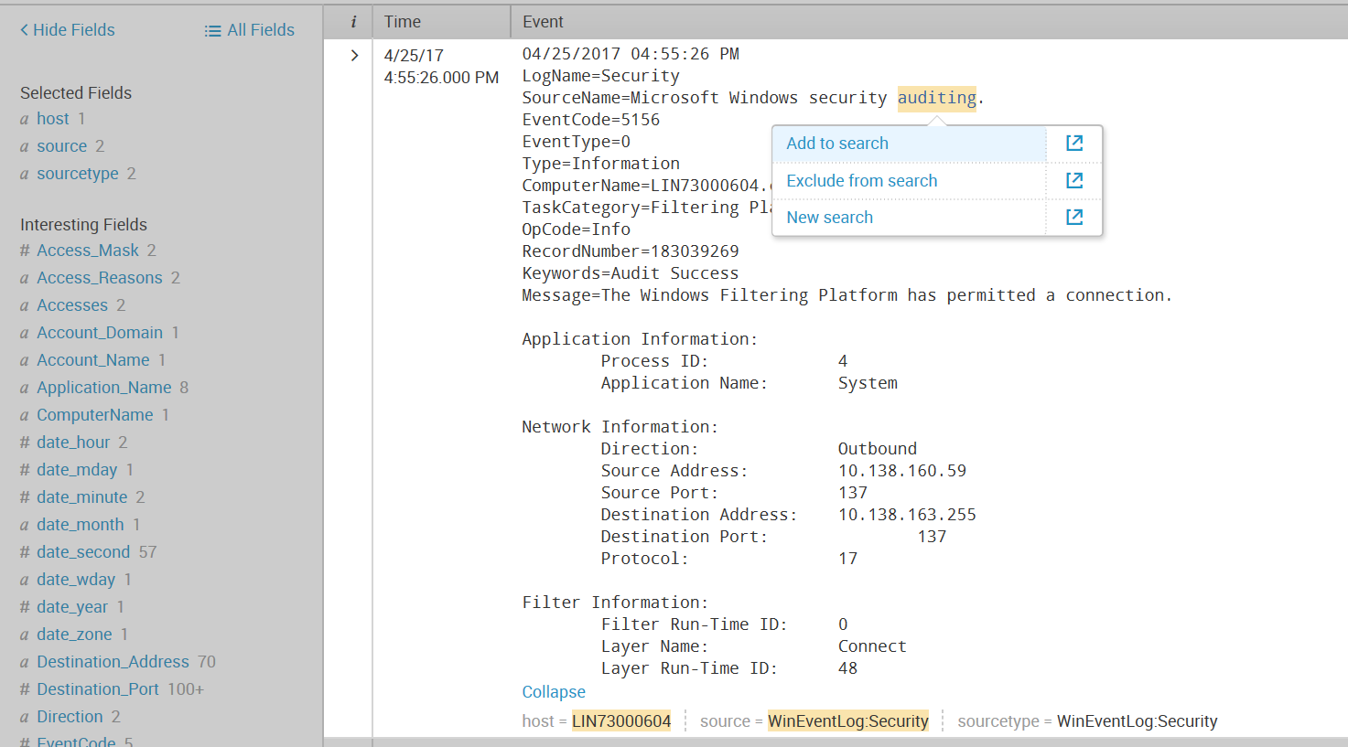

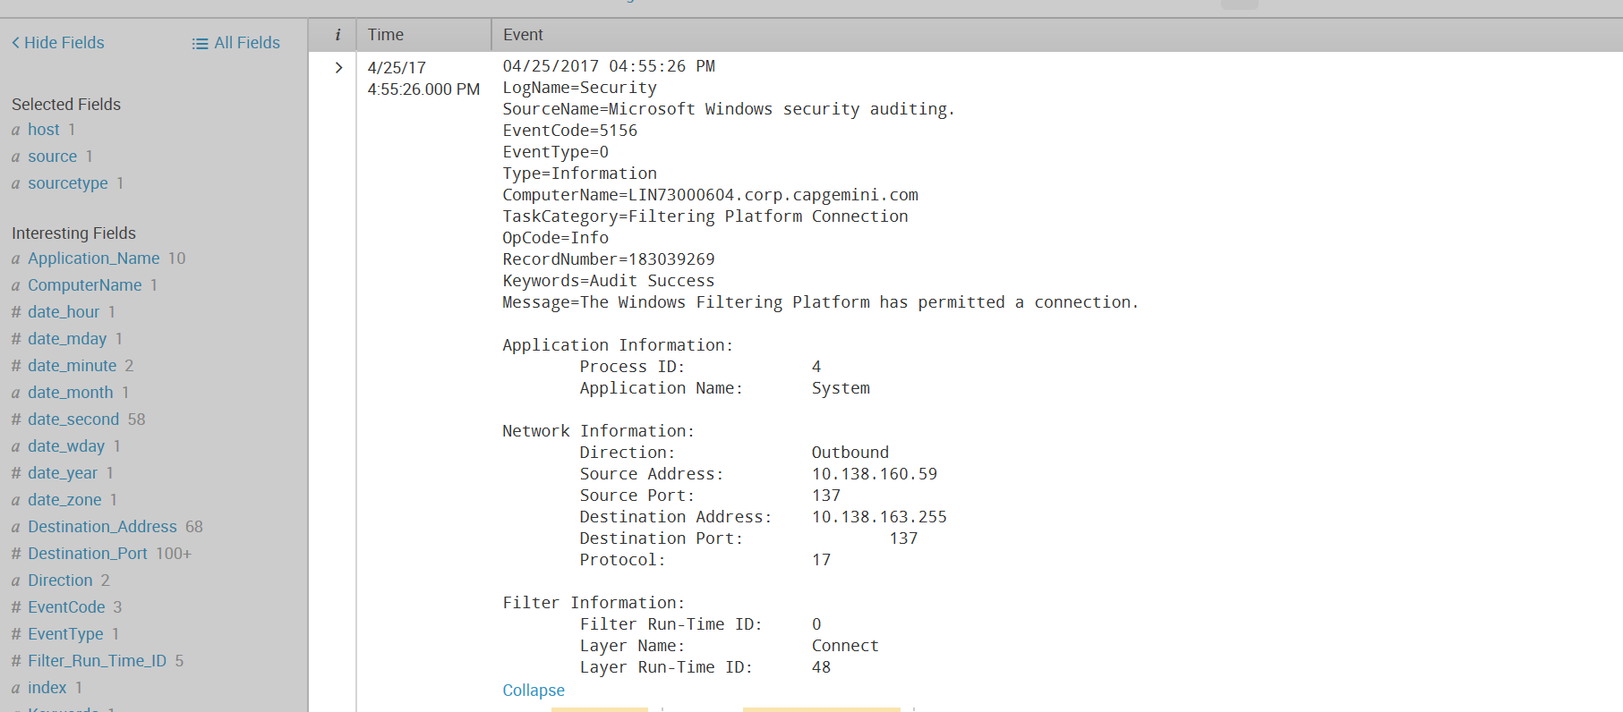

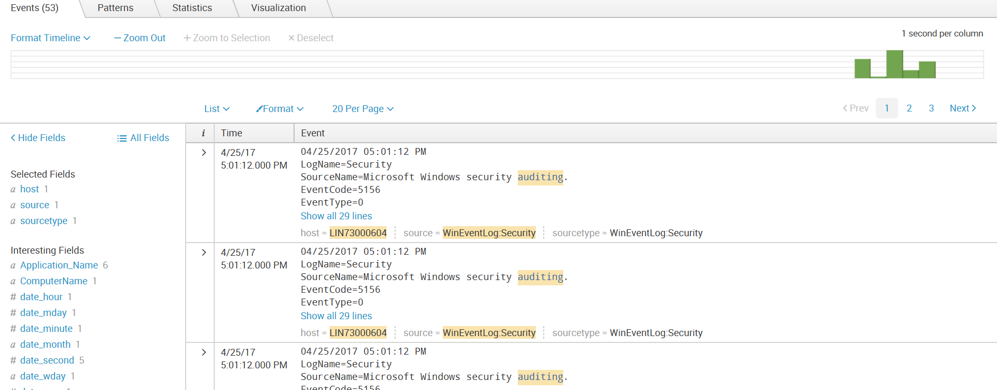

Upload sample data

1. Click on Splunk 🡪 Add Data

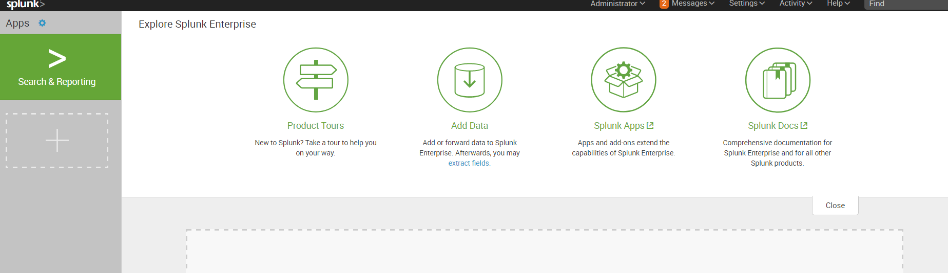

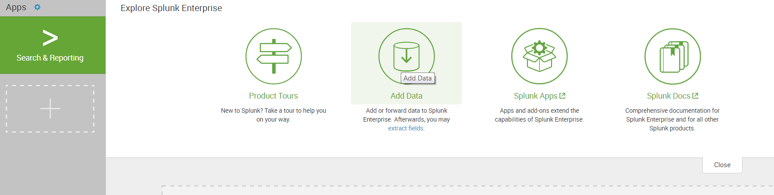

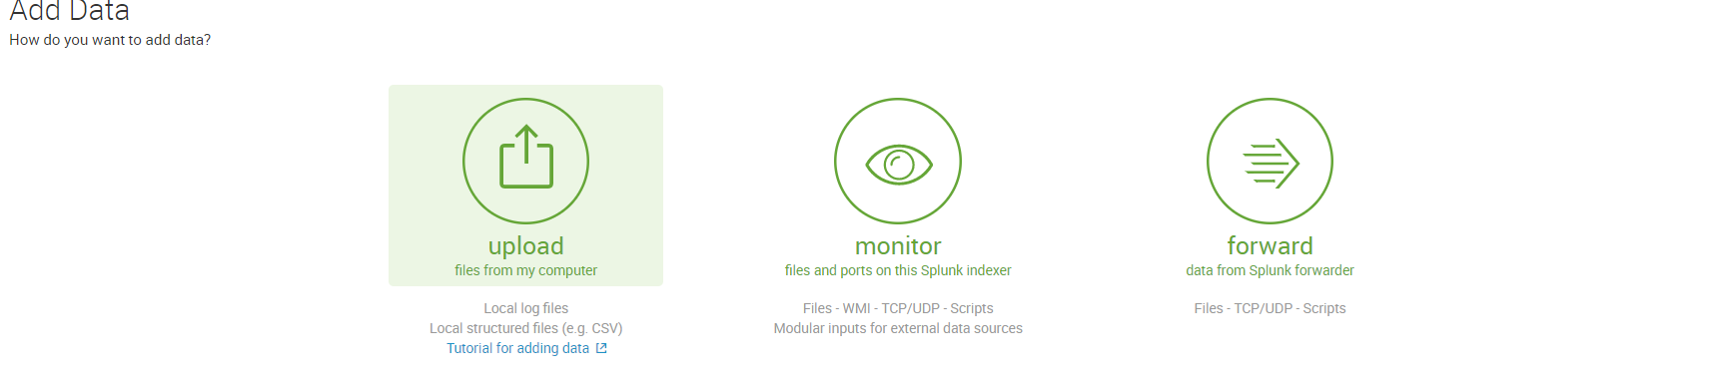

1. Under Select Source, click Select File to browse for the tutorialdata.zip file

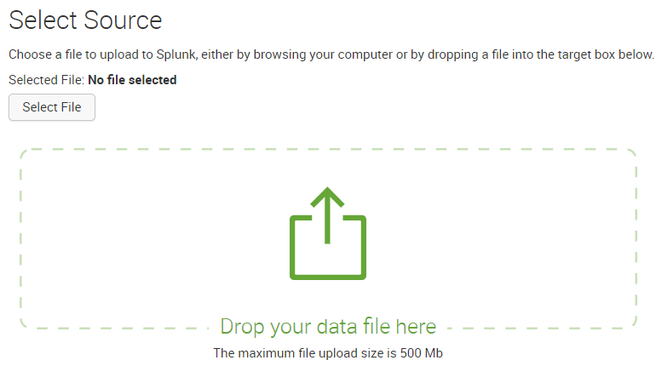

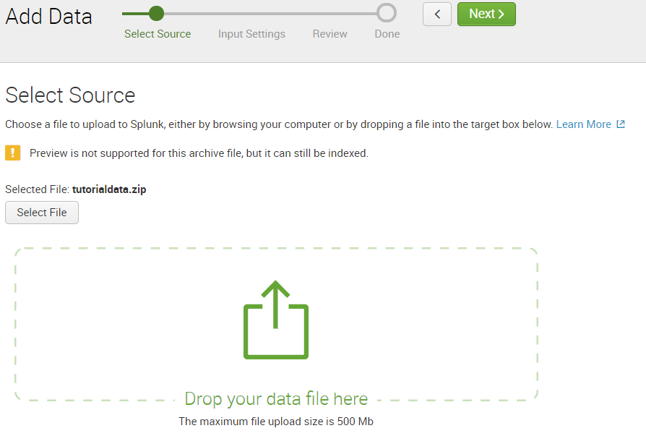

1. Select 🡪source type -> automatic, set the regular expression as given below , index -> default

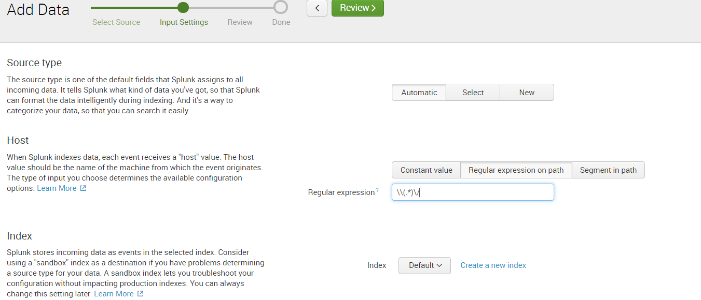

1. Click on Review 🡪 Next

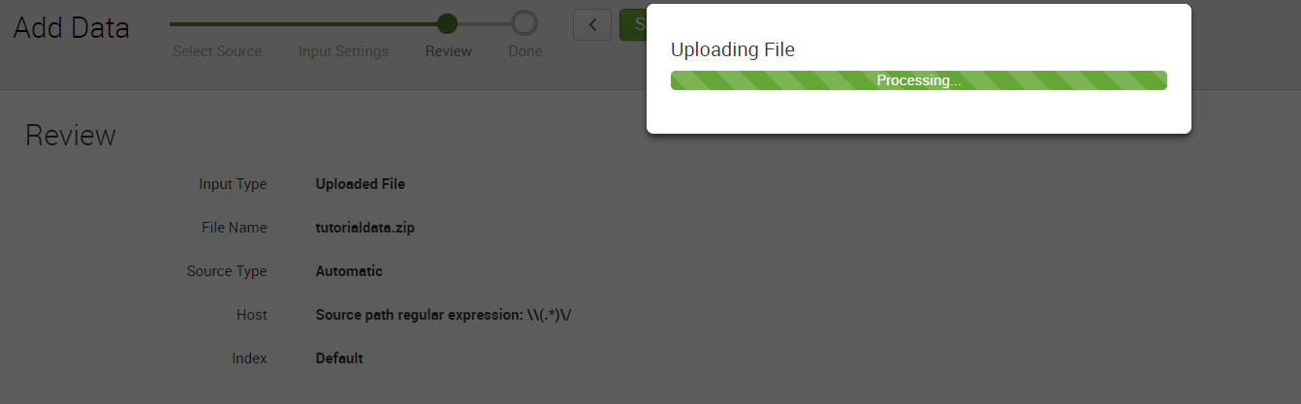

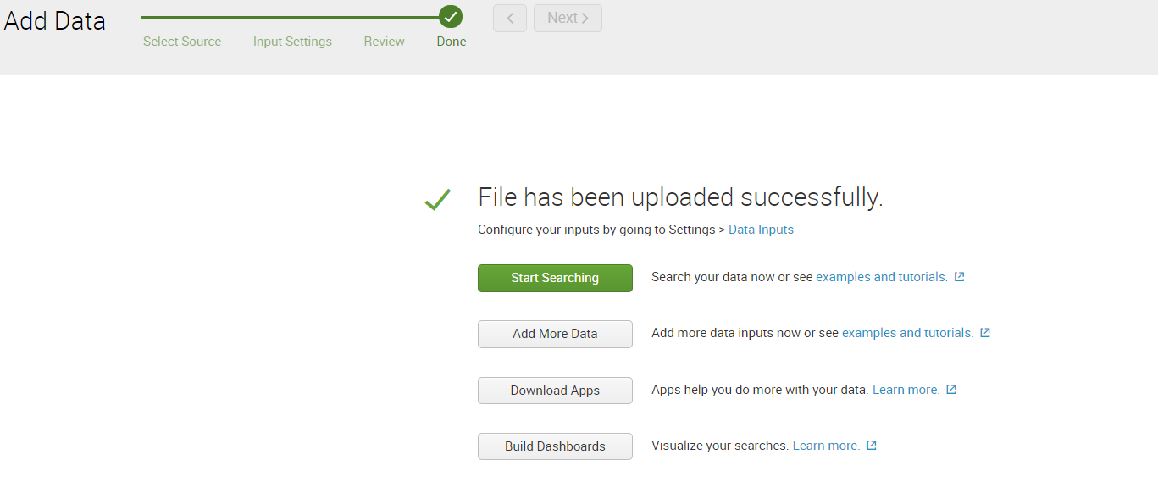 Click on start searching

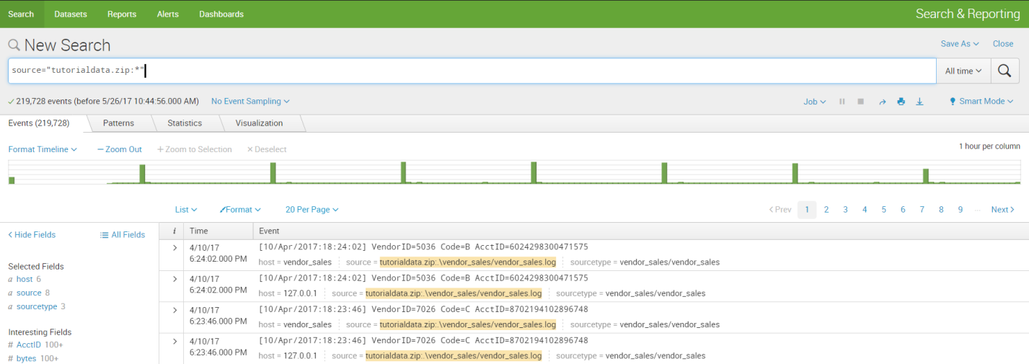

Click Splunk Home to return



Click on Source tab to see the list of sources

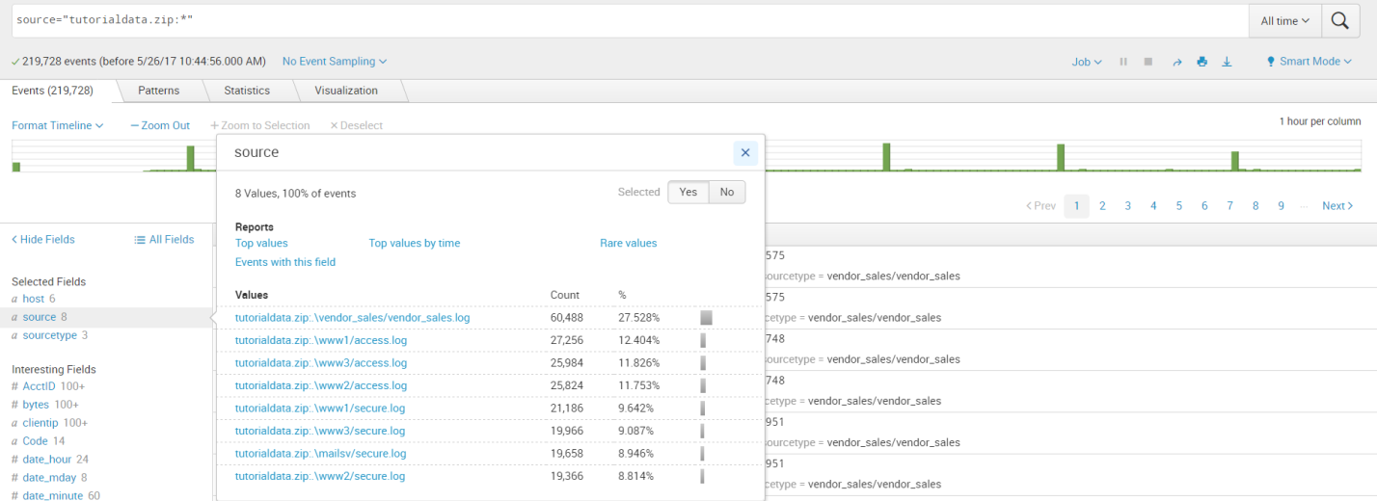

Click on Source type

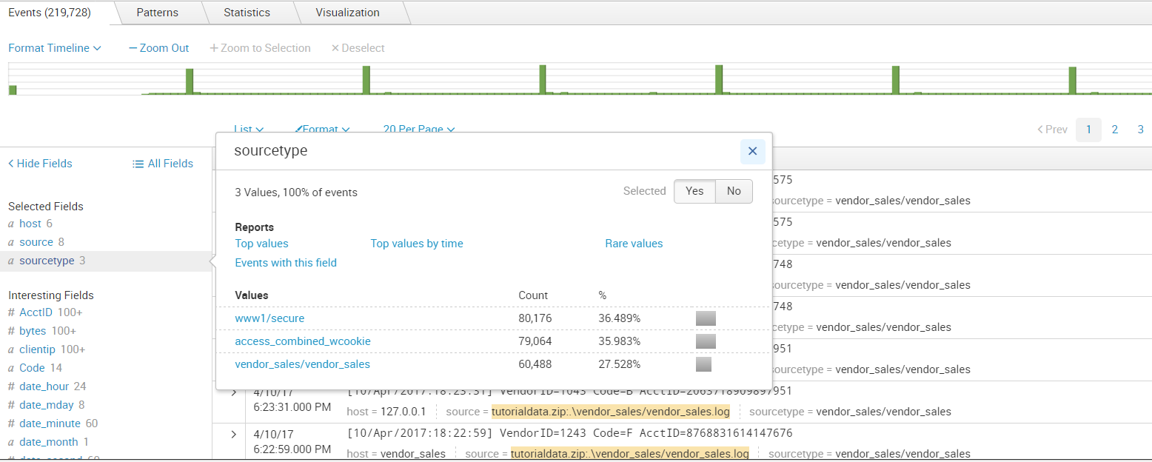

Click on host

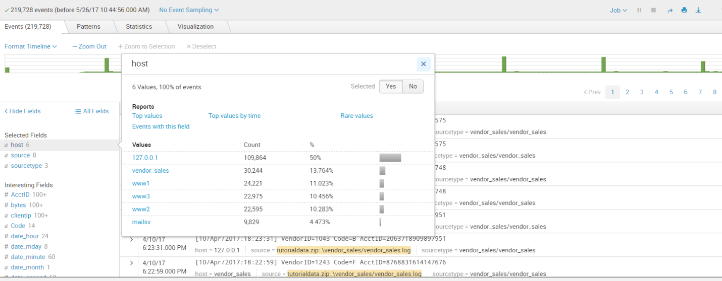

Search for the sources

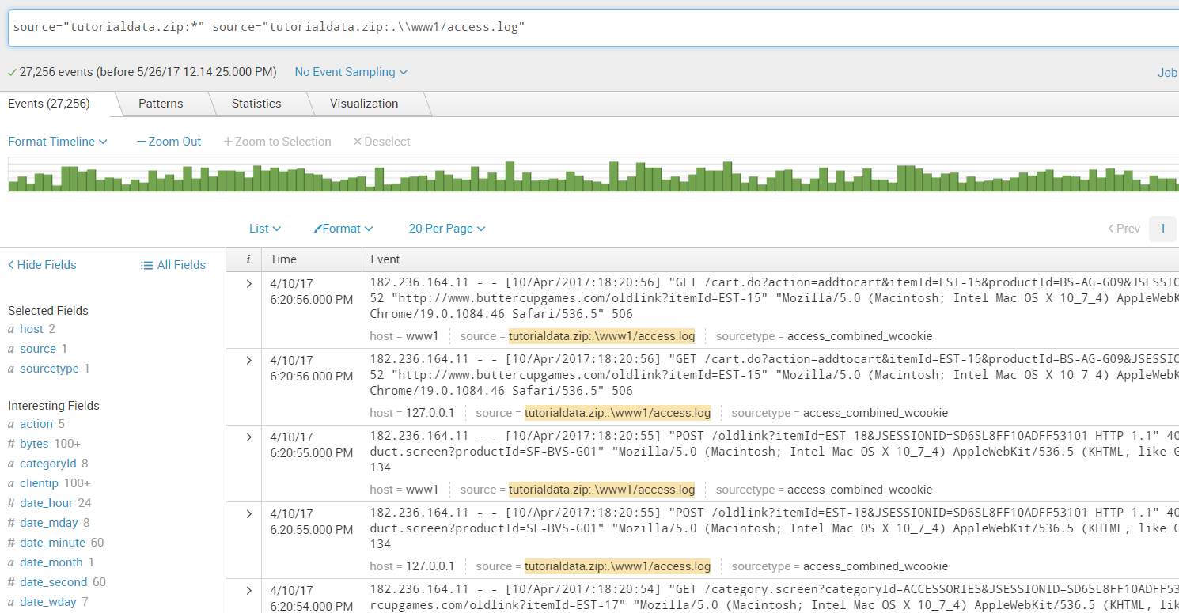

Click on sourcetype 🡪vendorsales

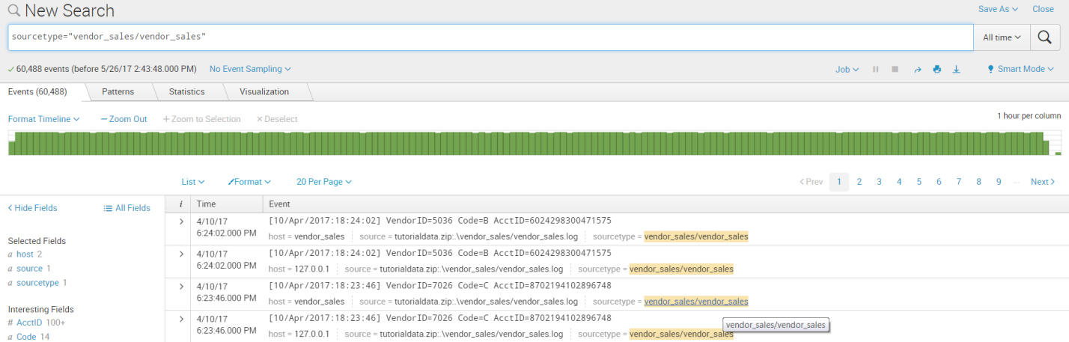

Searches based on time ranges

Exploring data from Buttercup games online store using different time ranges.

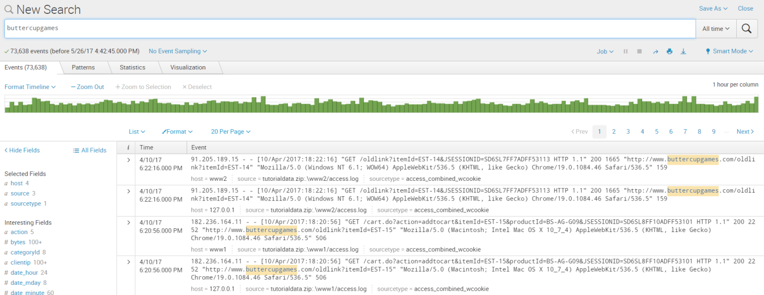

Click on Presets 🡪Relative 🡪yesterday

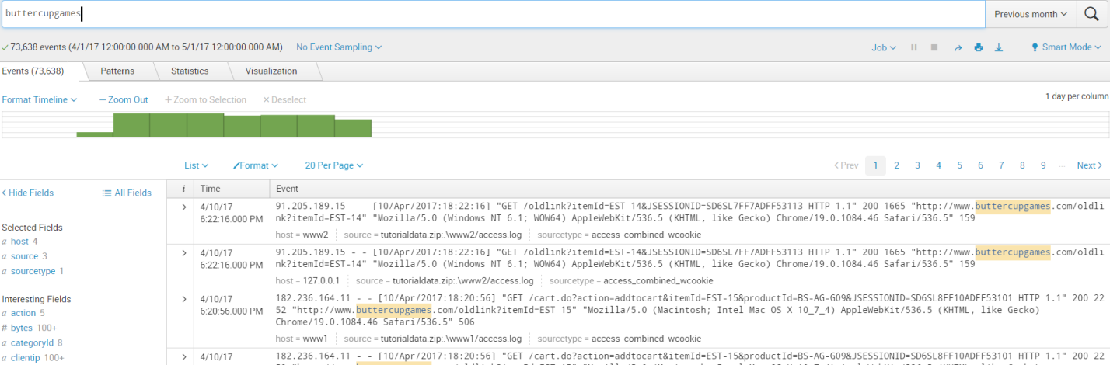

Specify relative time ranges

You can use the Relative option to specify a custom time range.

1. Open the time range picker.

2. To run a search over the last two hours, select the Relative time range option

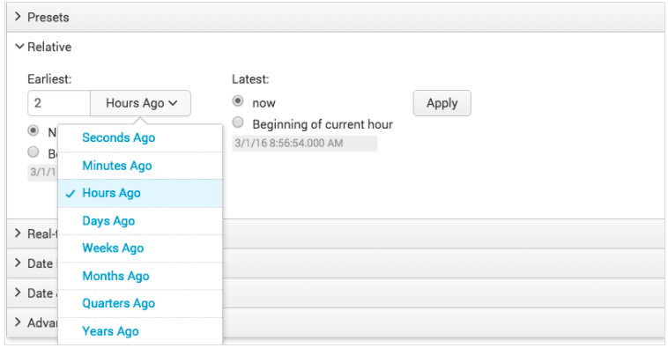

**Specify date and time ranges**

You can also use the **Date Range** and **Date & Time Range** options to specify a custom time range.

* Use **Between** to specify that events must occur between an earliest and latest date.
* Use **Before** to specify that events must occur before a date.
* Use **Since** to specify that events must occur after a date.

You use the **Date Range** option to specify dates. The following screen image shows the calendar that you can use to select a date.

To search for the terms error, fail, failure, failed, or severe, in the events that also mention buttercupgames, run the following search.

buttercupgames (error OR fail* OR severe)

Tip: Instead of typing the search string, you can copy and paste the search Click the spyglass icon to the right of the time range picker to run the search.

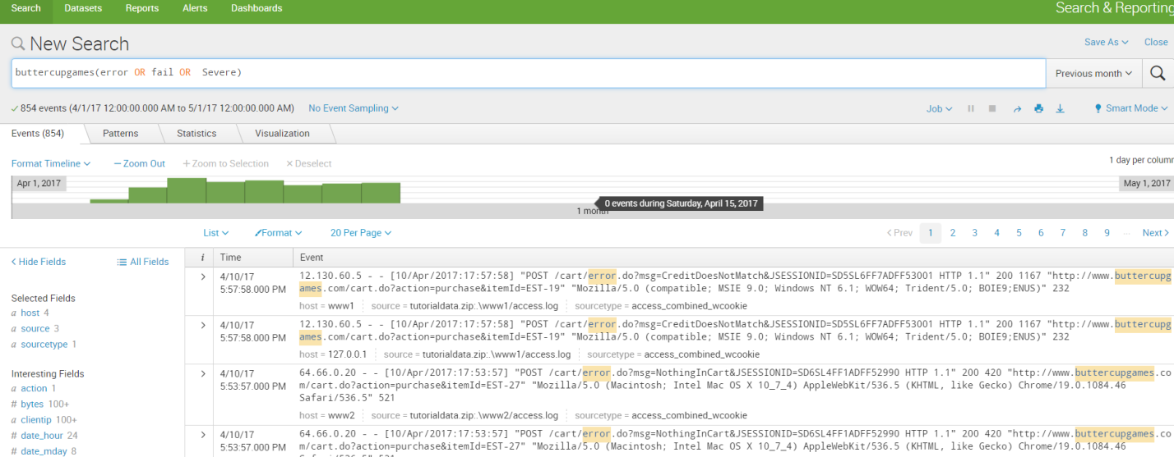

[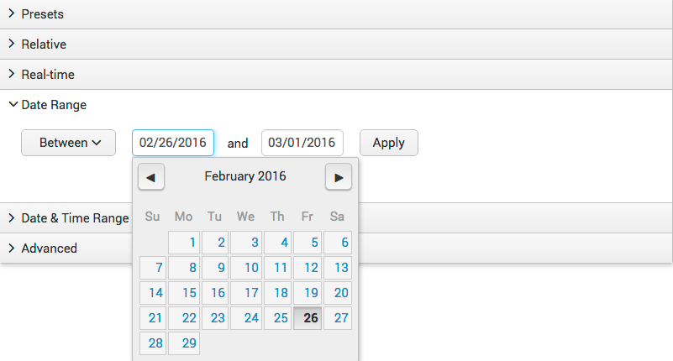](http://docs.splunk.com/File:6.4_timerange_daterange.png)

Search with filed name

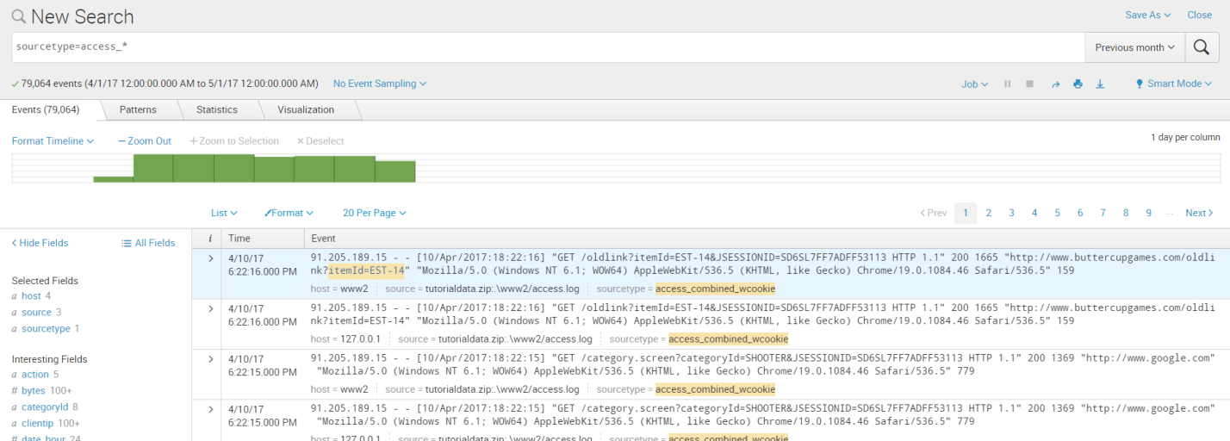

Access combined format of Apache logs,

* IP addresses for the users accessing the website.
* URIs and URLs for the pages requested and referring pages.
* HTTP status codes for each page request.
* GET or POST page request methods.

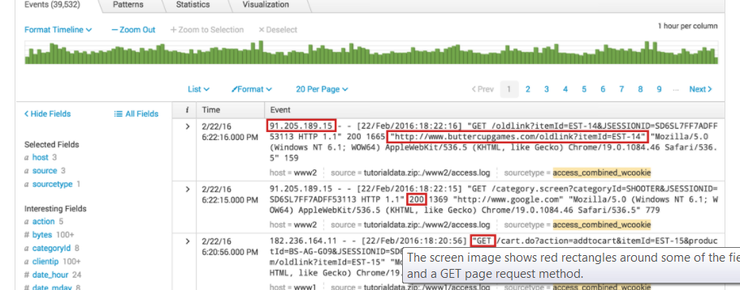

Specify Selected Fields

To add fields to the Selected Fields list, click All Fields.

The Select Fields dialog box shows a list of fields in your events. The # of Values column shows the number of unique values for each field in the events. Because your search criteria specifies the source type, the sourcetype field has just 1 value.

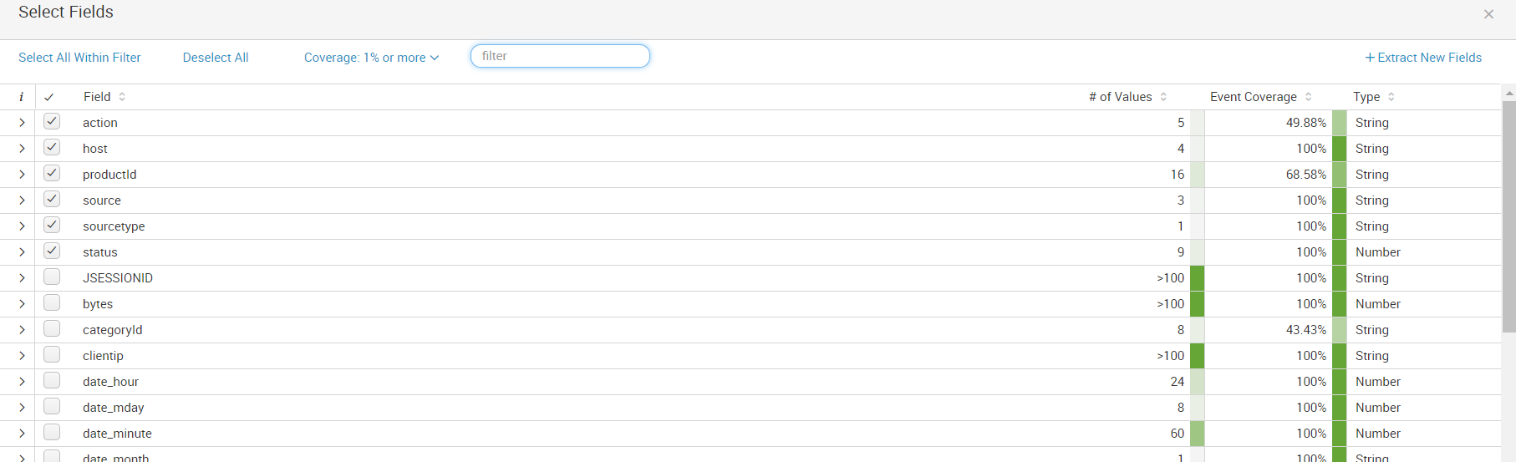

Identifying field values

The Fields sidebar displays the number of unique values for each field in the events. These are the same numbers that appear in the Select Fields dialog box.

1. Under Selected Fields, notice the number 5 next to the action field.

2. Click the action field.

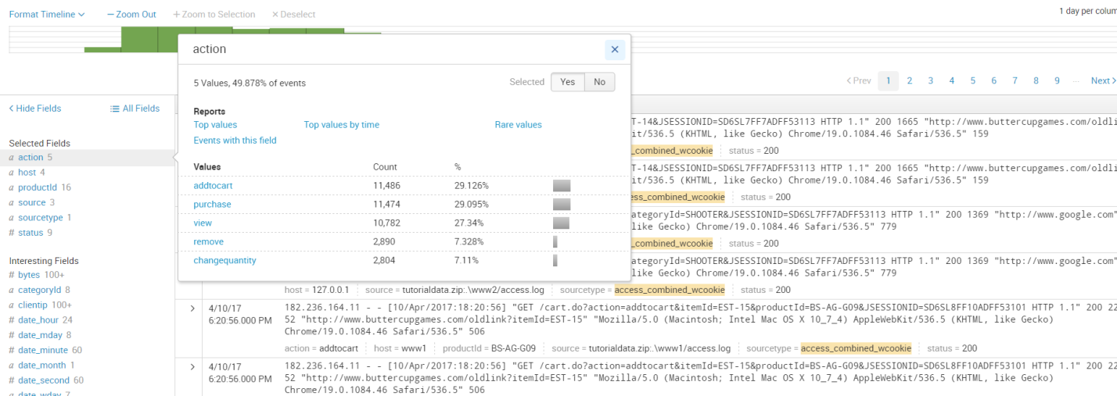

Run targeted Searches

### Search for successful purchases

Search for successful purchases from the Buttercup Games store.

1. Start a new search.

2. Run the following search.

sourcetype=access_* status=200 action=purchase

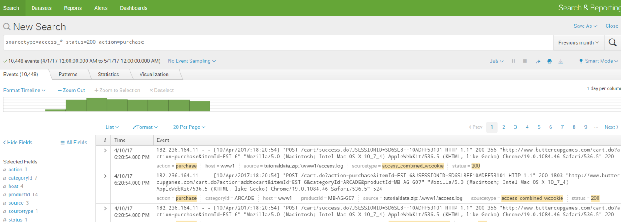

3. Change the status portion of the search and run the search again

sourcetype=access_* status!=200 action=purchase

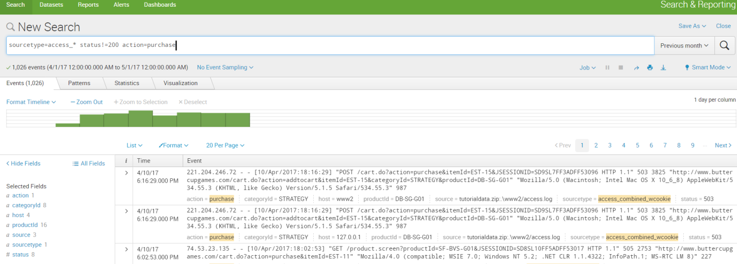

Search for errors

The way that errors are designed in events varies from source to source. To search for errors, your search must specify these different designations.

Use Boolean operators to specify different error criteria. Use parenthesis to group parts of your search string.

1. Start a new search.

2. Run the following search.

(error OR fail* OR severe) OR (status=404 OR status=500 OR status=503)

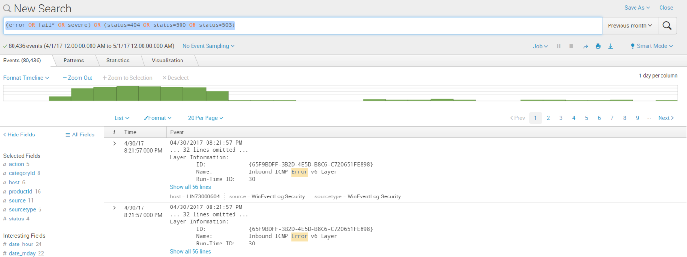

### Search for sales of a specific product

Search for how many simulation style games were bought yesterday.

1. In the time range picker,  presets 🡪All Time
2. Date Range 🡪 Before 05/23/2017

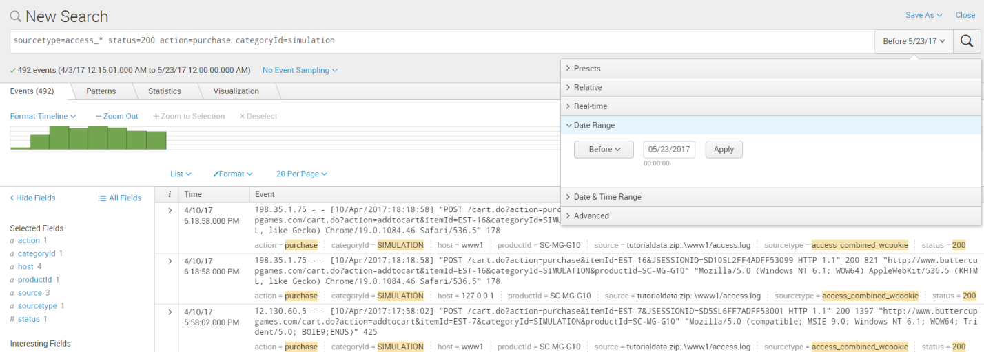

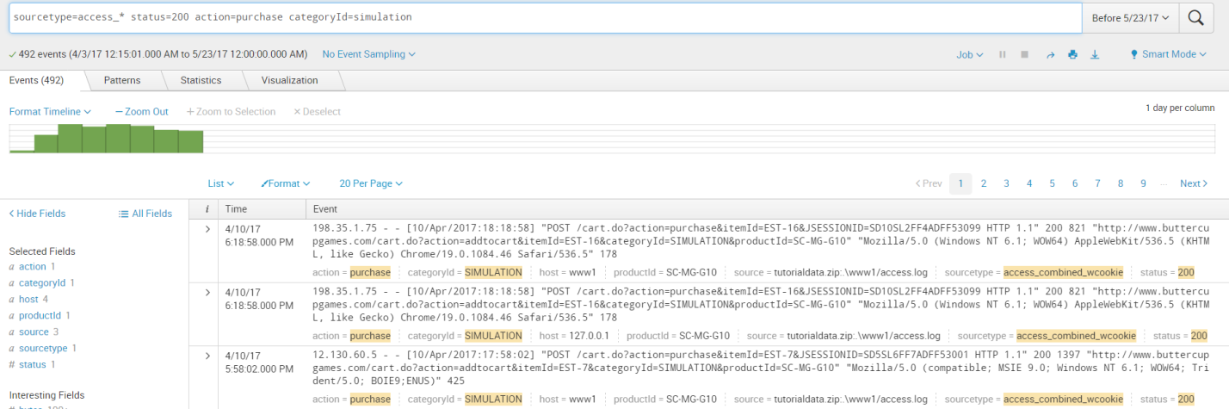

4. Find the number of purchases for each type of product sold at the shop.

a. Locate the unique categoryId values by clicking on the categoryId field in the Selected Fields list.

b. Run the search in step 2 for each unique categoryId value.

**Using the Search Language**

============================

1. To know how many simulation games were purchased

sourcetype=access_* status=200 action=purchase categoryId=simulation

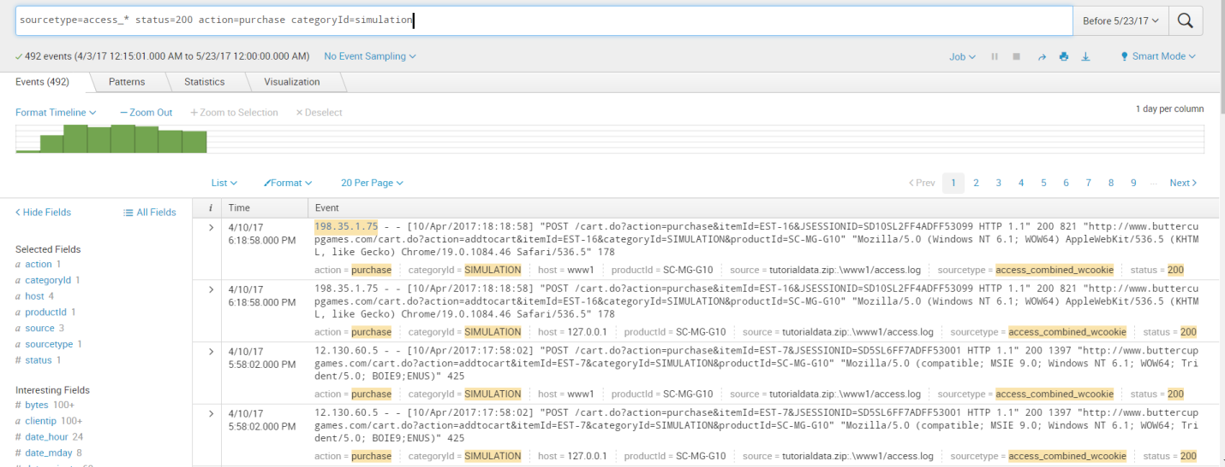

2. Start a new search and restrict your search to Yesterday.

 Type source in the Search bar.

As you type in Search bar, the Search Assistant opens with a list of Matching Searches and the Matching Terms.

3. Select the following search from the Matching Searches, or type the search into the Search bar.

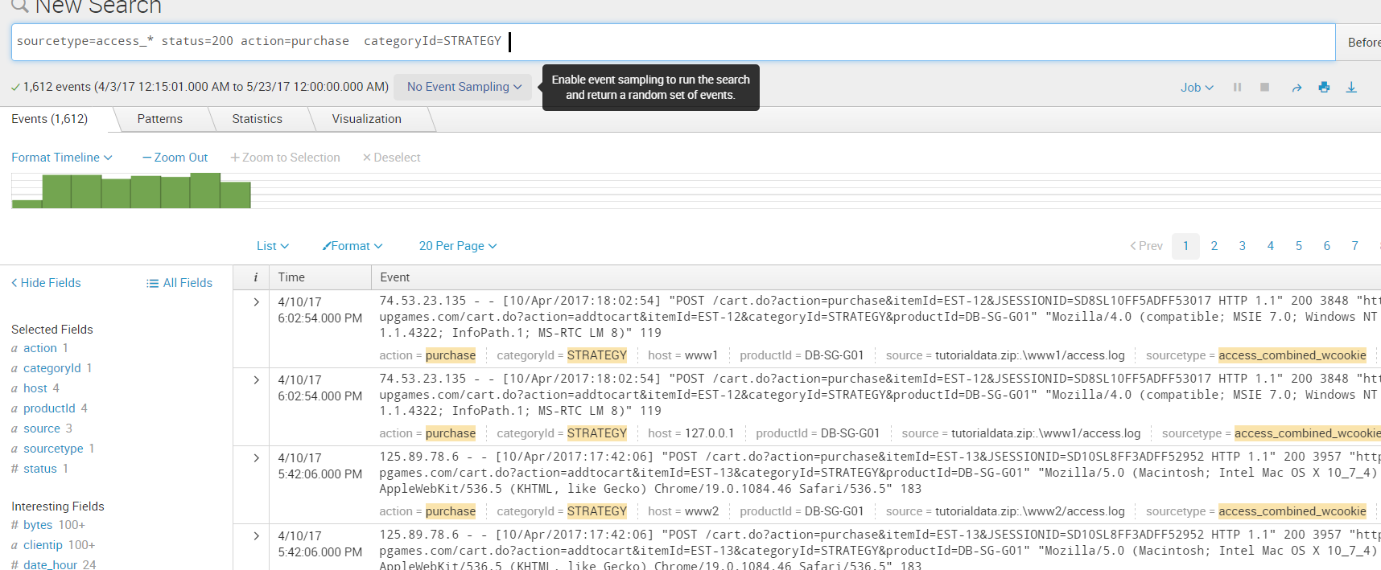

3. Select the following search from the **Matching Searches** list, or type the search into the Search bar.

sourcetype=access_* status=200 action=purchase

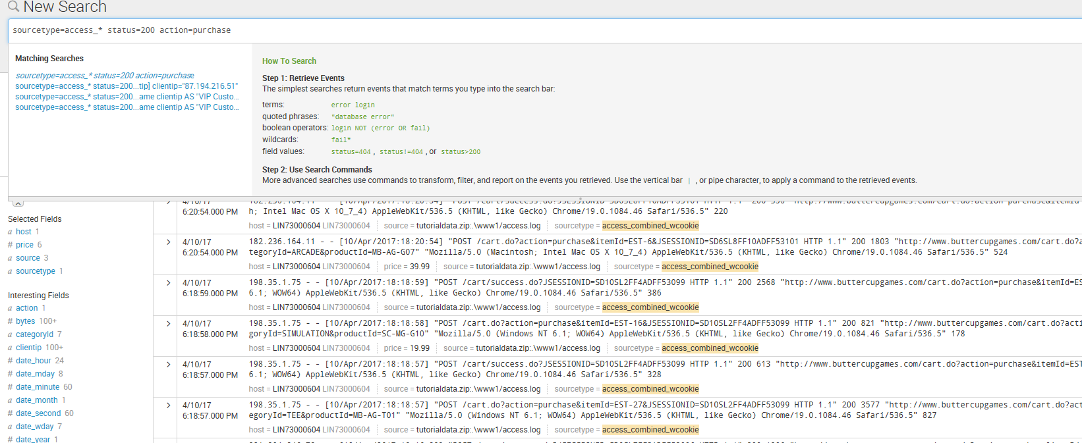

4.  Return the most popular items bought at the Buttercup Games online store.

sourcetype=access_* status=200 action=purchase | top categoryId

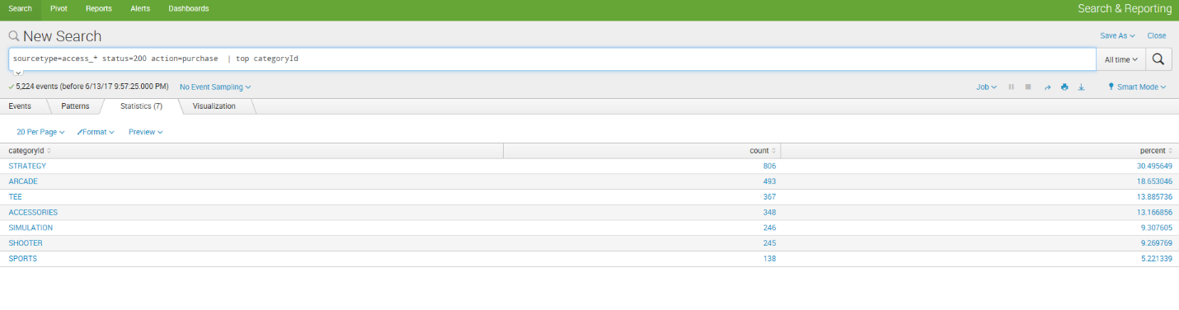

View results in the Statistics tab – In the above screenshot the results are displayed in the statistics tab

**View and format results in the Visualization tab**

You can also view the results of transforming searches in the Visualizations tab,

where you can format the chart type.

1. Click the Visualization tab.

By default, the Visualization tab opens with a Column chart.

1. Click Column Chart to open the visualization type selector.

[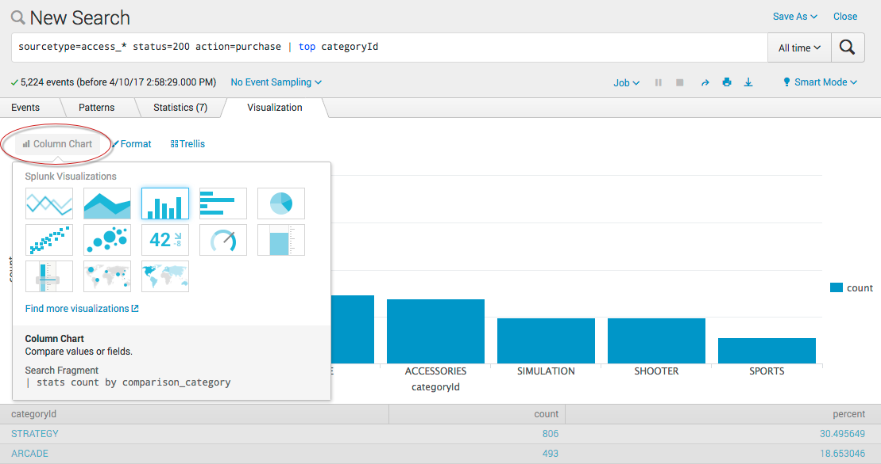](http://docs.splunk.com/File:6.6.0_tutorial_top_column.png)

Column, Bar, and Pie charts are listed as the recommended chart type for this data set.

Select the Pie chart.

Now, your visualization looks like the following pie chart.

[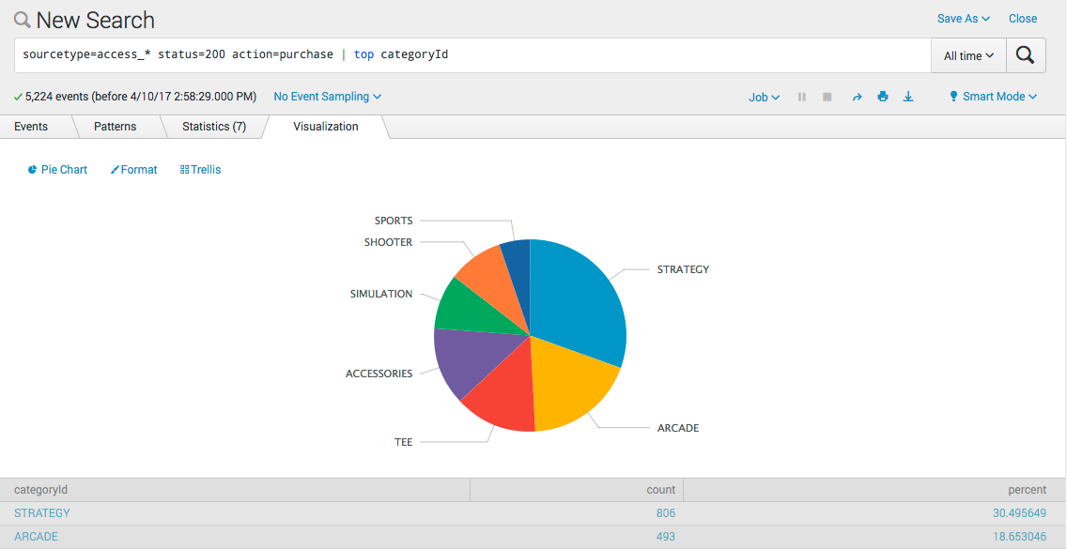](http://docs.splunk.com/File:6.6.0_tutorial_top_pie.png)

Hover over each slice of the pie to see the count and percentage values for each categoryId.

[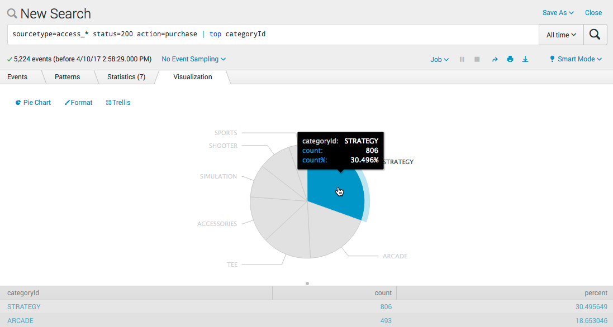](http://docs.splunk.com/File:6.6.0_tutorial_top_pieslice.png)

Click on a slice, such as STRATEGY.

categoryId=STRATEGY is added to your search string, replacing the top command.

The search runs again.

[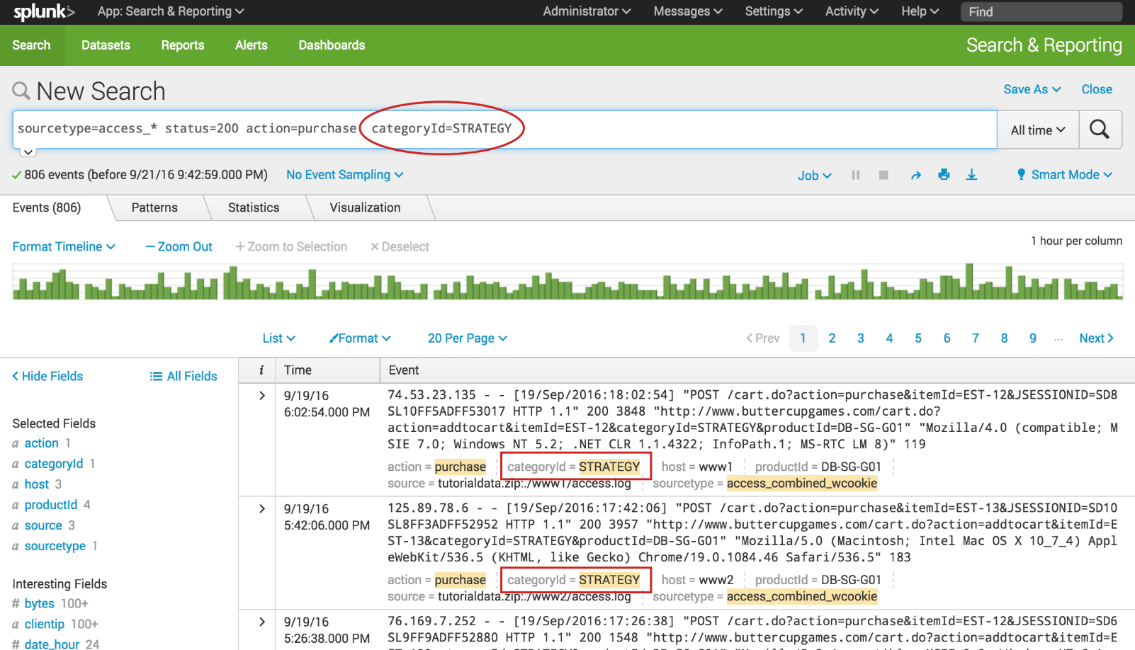](http://docs.splunk.com/File:6.5.0_tutorial_top_drilldown.png)

Use a Sub search

Find the single most frequent shopper on the Buttercup Games online store, and what that shopper has purchased.

Example 1 shows how to find the most frequent shopper without a sub search.

Find the single most frequent shopper on the Buttercup Games online store and

What that shopper has purchased

1. Start a new search.
2. Change the time range to **All time**.
3. To find the shopper who accessed the online shop the most, use this search.

sourcetype=access_* status=200 action=purchase | top limit=1 clientip

1. The limit=1 argument specifies to return 1 value. The clientip argument specifies the field to return.

[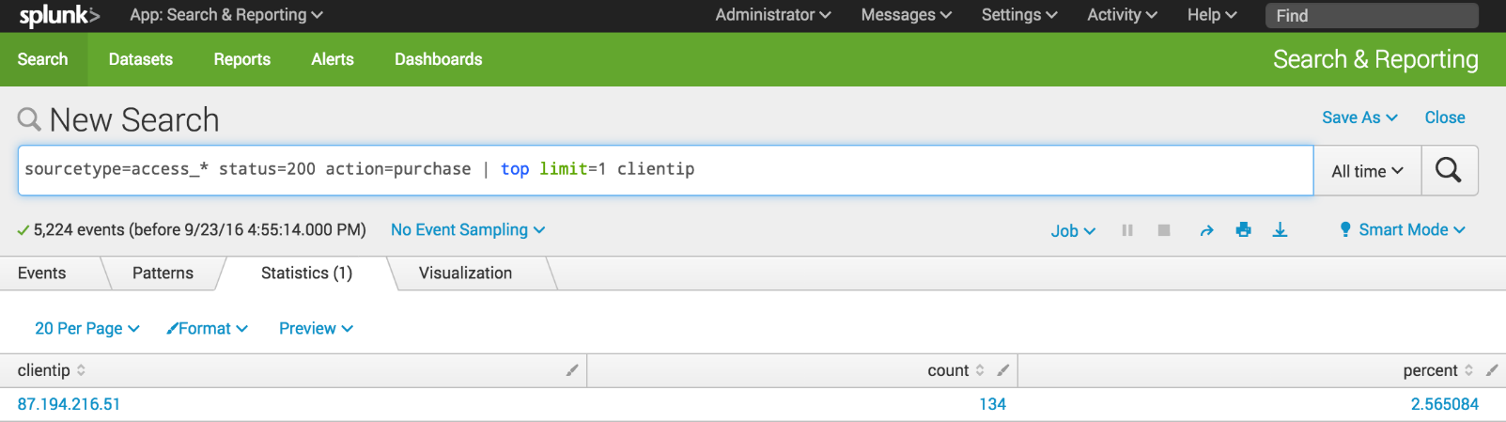](http://docs.splunk.com/File:6.5.0_tutorial_nosubsearch1.png)

This search returns one clientip value, which you will use to identify the VIP shopper.

You now need to run another search to determine how many different products the VIP shopper has purchased.

1. Use the stats command to count the purchases by this VIP customer.

sourcetype=access_* status=200 action=purchase clientip=87.194.216.51 | stats count,

dc(productId), values(productId) by clientip

Note: This search uses the count() function to return the total count of the purchases for the shopper. The dc() function is the distinct count function. Use this function to count the number of different, or unique, products that the shopper bought. The values argument is used to display the actual product IDs in the results.

Example 2: How to find the most frequent shopper with a sub search.

Copy and paste the following search into the Search bar and run the search.

sourcetype=access_* status=200 action=purchase [search sourcetype=access_* status=200 action=purchase | top limit=1 clientip | table clientip] | stats count, dc(productId), values (productId) by clientip

Because the top command returns the **count** and **percent** fields, the table command is used to keep only the clientip value.

[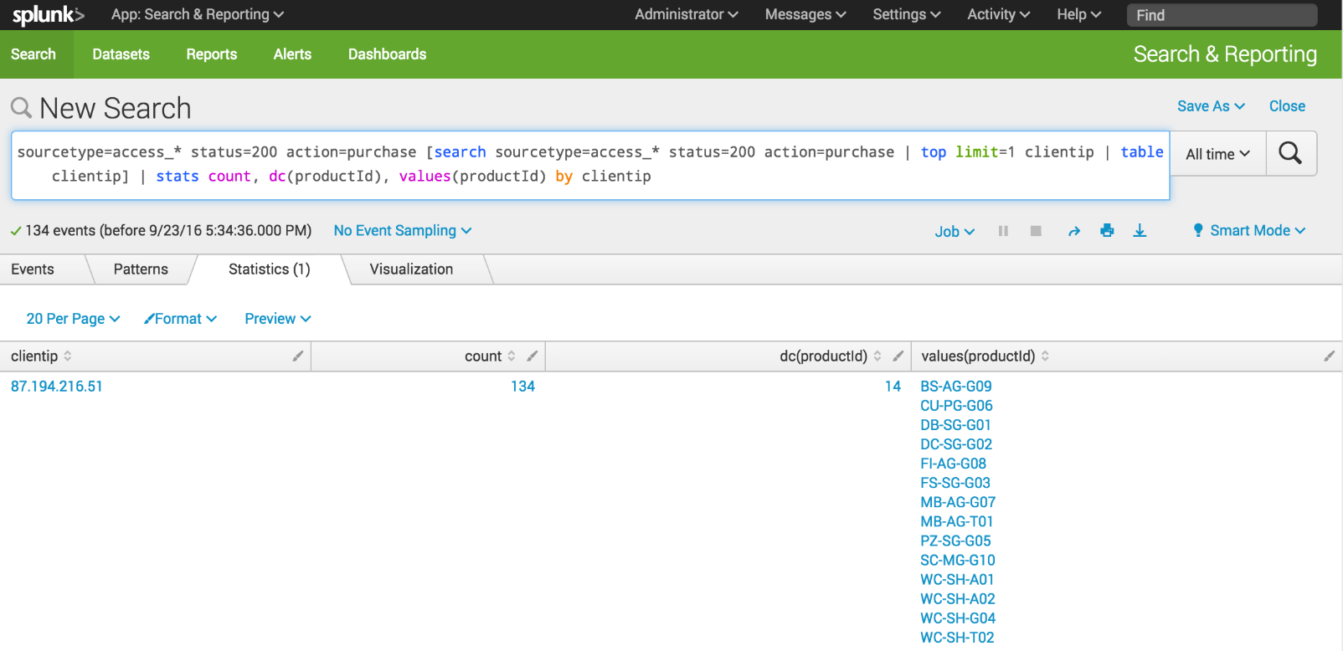](http://docs.splunk.com/File:6.5.0_tutorial_subsearch1.png)

These results should match the result of the two searches in Example 1, if you run it on the same time range. If you change the time range, you might see different results because the top purchasing customer will be different.

**Note:** *The performance of this sub search depends on how many distinct IP addresses match status=200 action=purchase. If there are thousands of distinct IP addresses, the top command has to keep track of all of those addresses before the top 1 is returned, impacting performance. By default, sub searches return a maximum of 10,000 results and have a maximum runtime of 60 seconds. In large production environments, it is possible that the sub search in this example will timeout before it completes. The best option is to rewrite the query to limit the number of events that the sub search must process. Alternatively, you can increase the maximum results and maximum runtime parameters.*

To rename the fields, copy and paste the following search into the Search bar and run the search.

sourcetype=access_* status=200 action=purchase [search sourcetype=access_* status=200 action=purchase | top limit=1 clientip | table clientip] | stats count AS "Total Purchased", dc(productId) AS "Total Products", values(productId) AS "Products ID" by clientip | rename clientip AS "VIP Customer"

[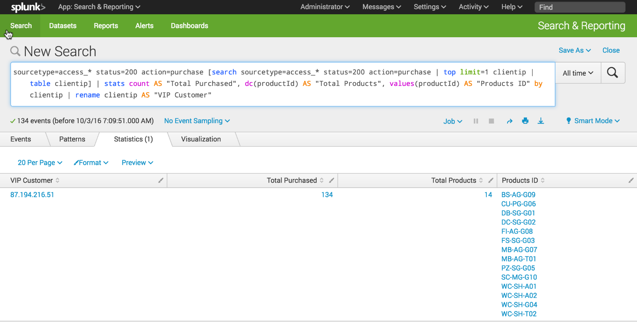](http://docs.splunk.com/File:6.5.0_tutorial_subsearch2.png)

Experiment with this search.

What happens when you run the search over different time periods? What if you wanted to find the top product sold and how many people bought it?

Enabling Lookup Fields

===================

There are five key steps to enabling fields lookups:

1. Upload the lookup file
2. Share the uploaded file with the applications
3. Create a lookup definition and specify permissions
4. Share the lookup definition
5. Optional. Make the lookup definition automatic

Uncompressed the Prices.csv.zip file.

The prices.csv files contains the product names, price, and code. For example:

|  |  |  |  |  |
| --- | --- | --- | --- | --- |
| **productId** | **product_name** | **price** | **sale_price** | **Code** |
| DB-SG-G01 | Mediocre Kingdoms | 24.99 | 19.99 | A |
| DC-SG-G02 | Dream Crusher | 39.99 | 24.99 | B |
| FS-SG-G03 | Final Sequel | 24.99 | 16.99 | C |
| WC-SH-G04 | World of Cheese | 24.99 | 19.99 | D |

Find the Lookups manager

1. In the Splunk bar, click **Settings**.
2. In the **Knowledge** section, click **Lookups**.

[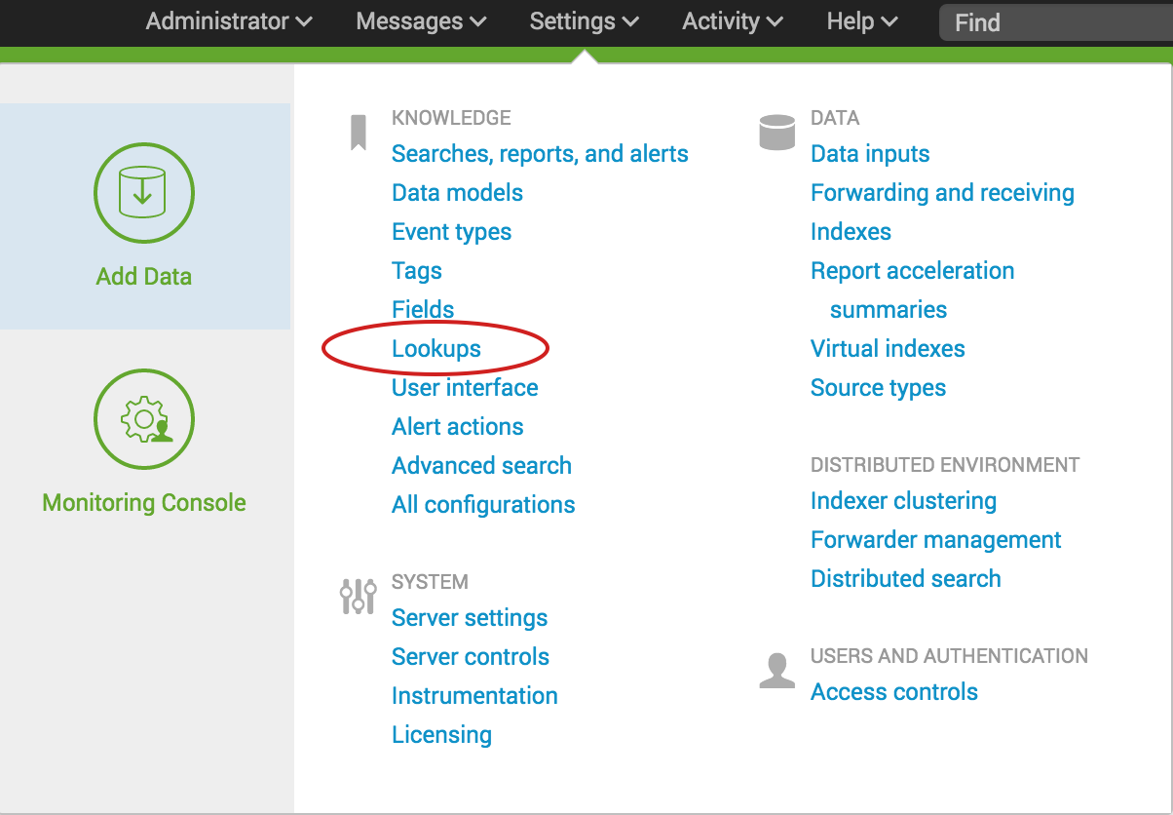](http://docs.splunk.com/File:6.5.0_tutorial_settings_lookups.png)

The Lookups manager opens, where you can create new lookups or edit existing lookups.

[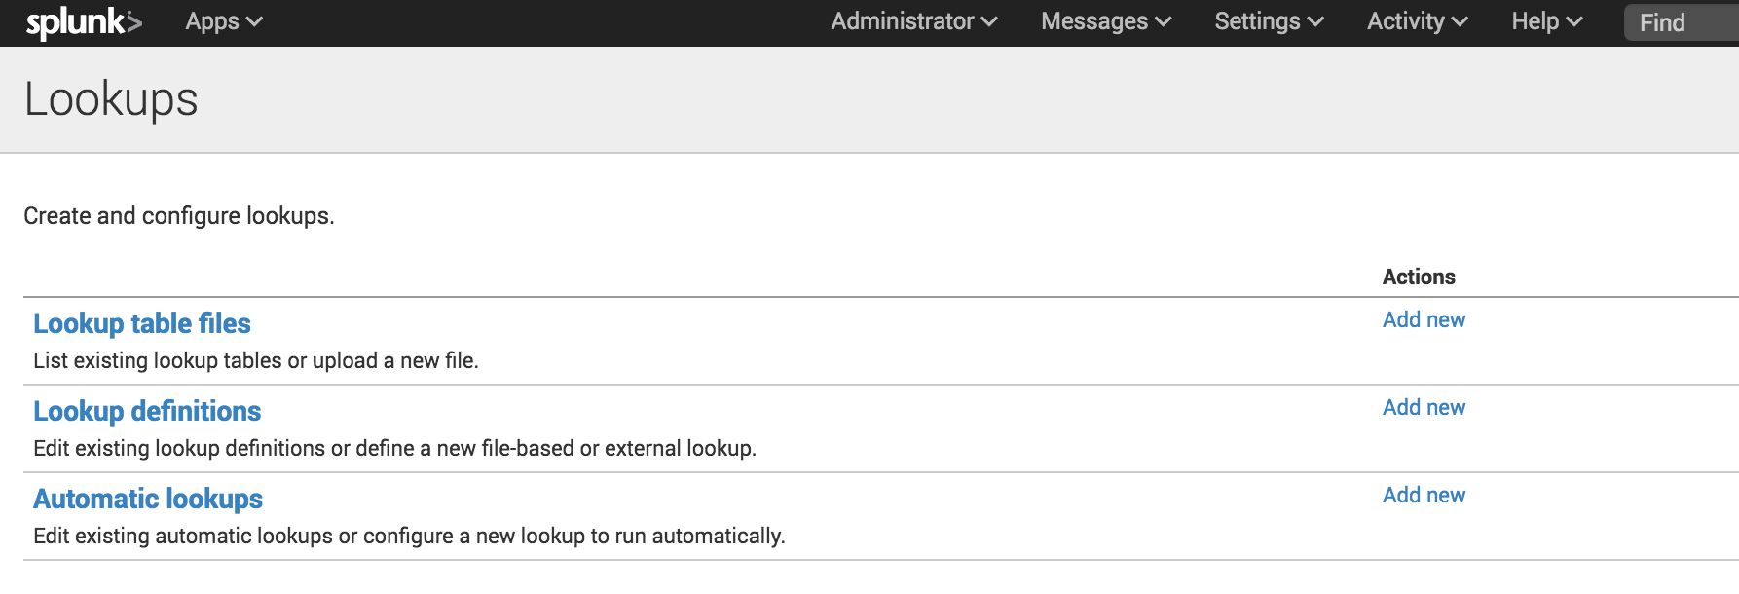](http://docs.splunk.com/File:6.5.0_tutorial_lookupsmanager.png)

You can view and edit existing lookups by clicking on the links in the Lookups manager. In the next few sections of this tutorial, you will upload lookup table files, create lookup definitions, and create automatic lookups.

Upload the lookup table file

To use a lookup table file, you must upload the file to your Splunk platform.

1. In the Lookups manager, locate **Lookup table files**.
2. In the Actions column click **Add new**.

You use the **Add new** lookup table files view to upload CSV files that you want to use.

[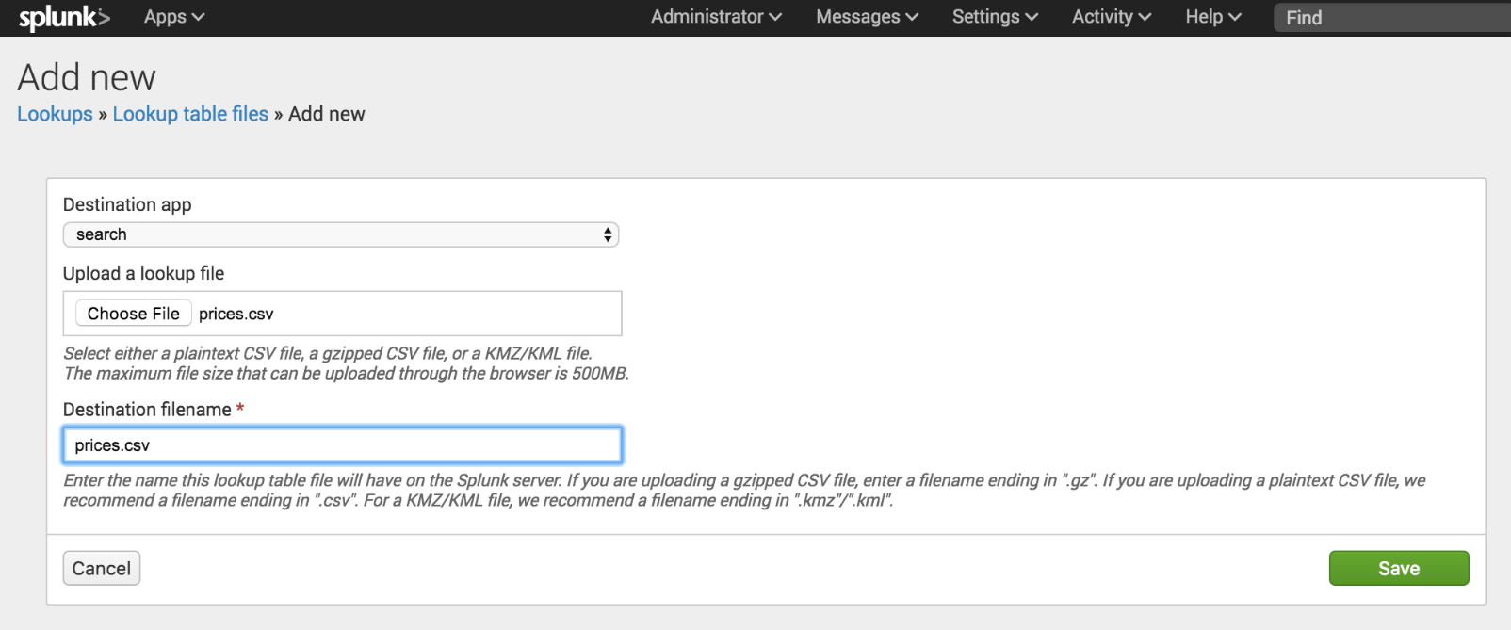](http://docs.splunk.com/File:6.5.0_tutorial_addnewlookuptable.png)

1. The **Destination app** field specifies which app you want to upload the lookup table file to. To upload the file in the Search app, you do not need to change anything. The default value is **search**.
2. Under **Upload a lookup file**, click **Choose File** and browse for the **prices.csv** file.
3. Under **Destination filename**, type **prices.csv**.

This is the name that you will use to refer to the file when you create a lookup definition.

1. Click **Save**.

This uploads your lookup file to the Search app and displays the lookup table files list.

If the Splunk software does not recognize or cannot upload the file, you can take the following actions.

* Check that the file is uncompressed.
* If an error message indicates that the file does not have line breaks, the file has become corrupted. This can happen if the file is opened in Microsoft Excel before it is uploaded. You should delete the Prices.csv.zip and prices.csv files. Then download the ZIP file again, and uncompress the file.

[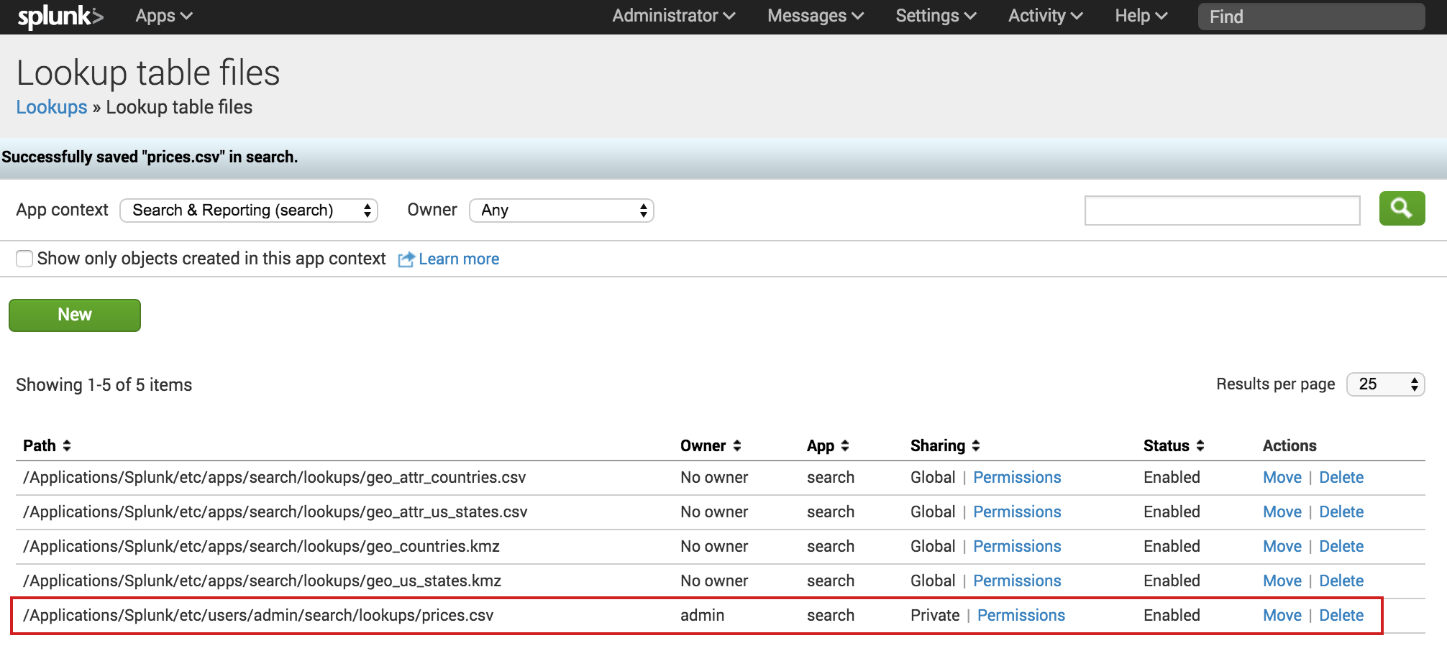](http://docs.splunk.com/File:6.5.0_tutorial_lookuptablefiles.png)

The other lookup table files in the list are included with the Splunk software.

Share the lookup table file

Now that the lookup table file is uploaded, you need tell the Splunk software which applications can use this file. You can share the lookup table file with the Search app or with all of the apps.

1. In the **Lookup table files** list, locate the prices.csv file at the bottom of the **Path** list.
2. In the **Sharing** column, notice that prices.csv is listed as **Private**.
3. To share the lookup table file, click **Permissions**.
4. In the Permissions dialog box, under **Object should appear in**, select **All apps**.

[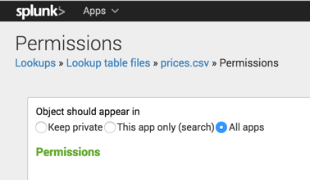](http://docs.splunk.com/File:6.4_tutorial_lookuptablepermissions.png)

1. Click **Save**.

The Sharing setting for the prices.csv lookup table is set to **Global**.

[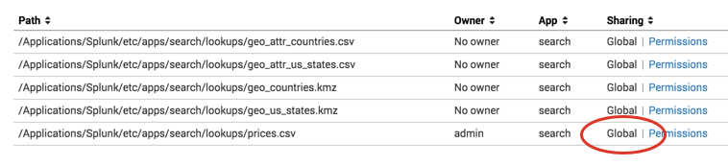](http://docs.splunk.com/File:6.4_tutorial_lookuptableglobal.png)

Add the field lookup definition

It is not sufficient to share the lookup table file with an application. You must create a lookup definition from the lookup table file.

1. In the Lookup table file dialog box, select **Lookups** in the breadcrumbs to return to the Lookups manager.

[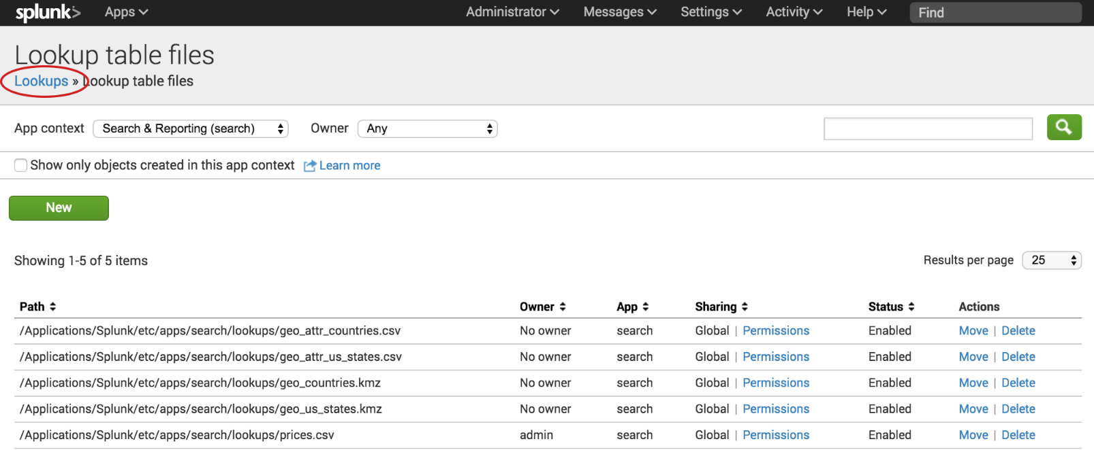](http://docs.splunk.com/File:6.5.0_tutorial_lookupfilebreadcrumbs.png)

1. For **Lookup definitions**, click **Add New**.

The Add new lookups definitions page opens, where you define the field lookup.

1. There is no need to change the **Destination app** setting. It is already set to **search**, referring to the Search app.
2. For **Name**, type **prices_lookup**.
3. For **Type**, select **File-based**.

A file-based lookup is typically a static table, such as a CSV file.

1. For **Lookup file**, select **prices.csv**, which is the name of the lookup table file that you created.

[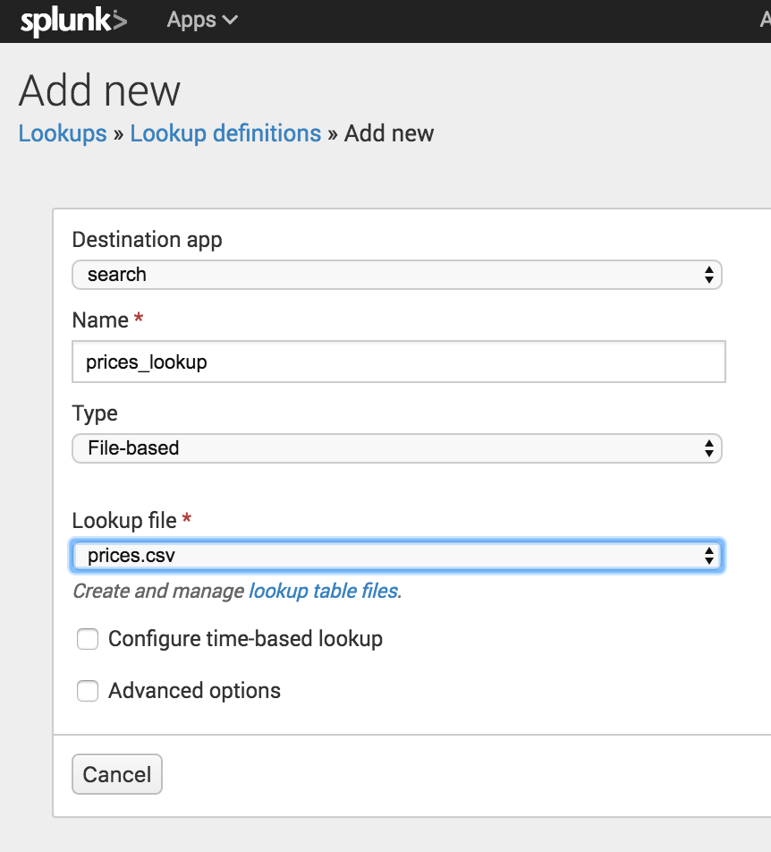](http://docs.splunk.com/File:6.5.0_tutorial_newlookupdefinition.png)

1. For **Configure time-based lookup** and **Advanced options**, leave the check boxes unselected.
2. Click **Save**.

The **prices_lookup** is now defined as a file-based lookup.

[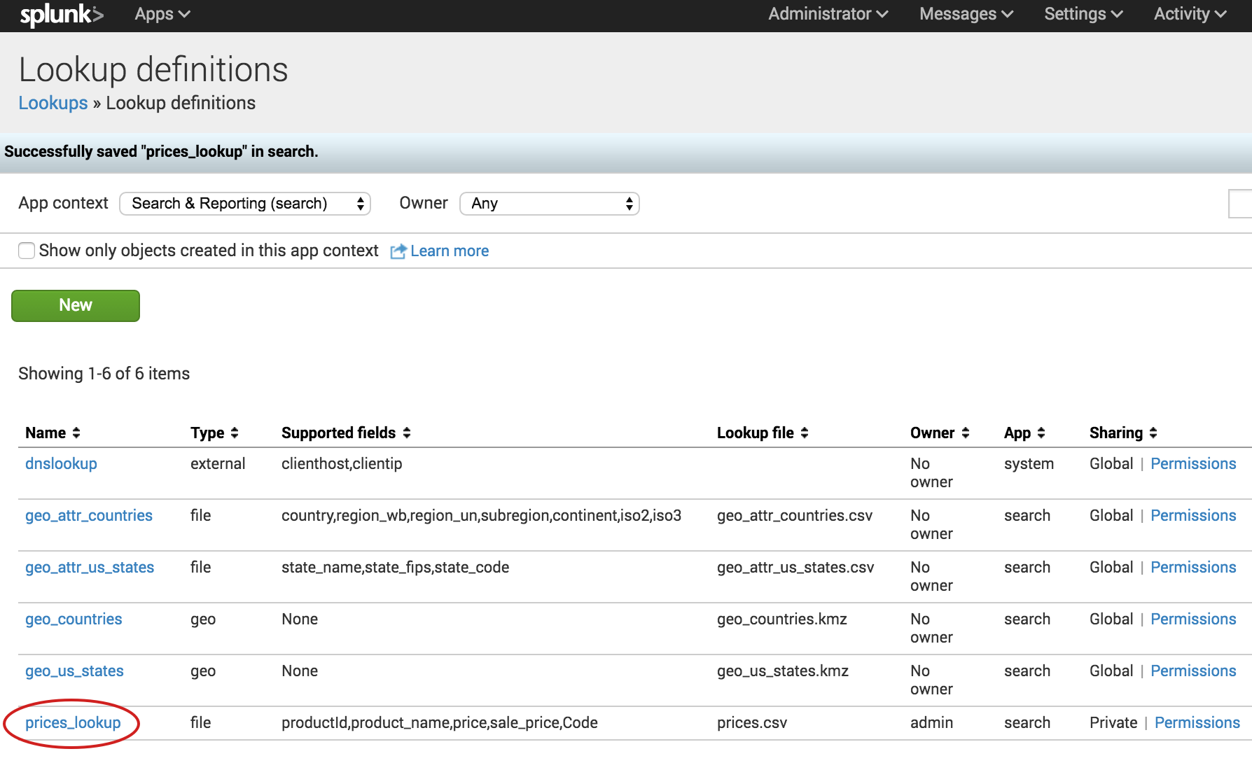](http://docs.splunk.com/File:6.5.0_tutorial_lookupdefinitionsaved.png)

Share the lookup definition with all apps

1. Now that you have created the lookup definition, you need to specify in which apps you want to use the definition.
2. In the Lookup definitions list, for the prices_lookup, click **Permissions**.
3. In the Permissions dialog box, under **Object should appear in**, select **All apps**.

[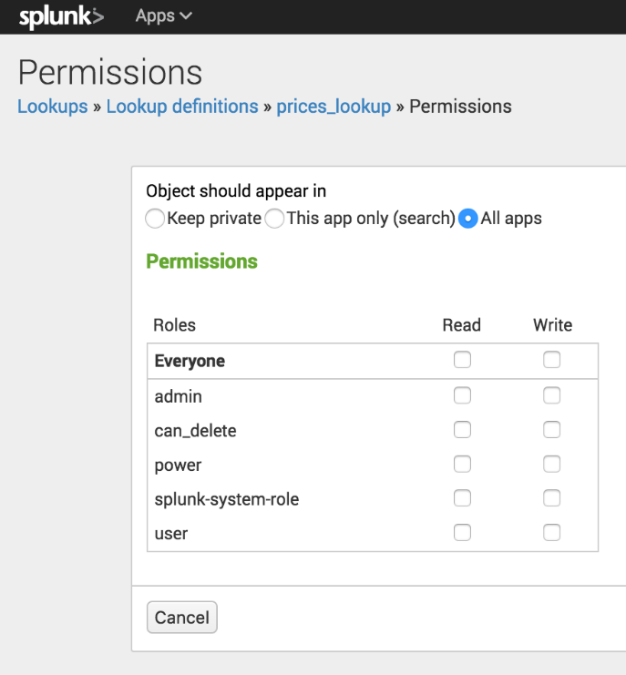](http://docs.splunk.com/File:6.5.0_tutorial_lookupdefinitionspermissions.png)

1. Click **Save**.

In the Lookup definitions page, prices_lookup now has **Global** permissions.

You can use this field lookup to add information from the lookup table file to your events. You use the field lookup by specifying the lookup command in a search string. Or, you can set the field lookup to run automatically.

Make the lookup automatic

Instead of using the lookup command in your search when you want to apply a field lookup to your events, you can set the lookup to run automatically.

1. In the Lookups manager, for Automatic lookups, click Add New.
2. This takes you to the Add new automatic lookups view, where you configure the lookup to run automatically.

[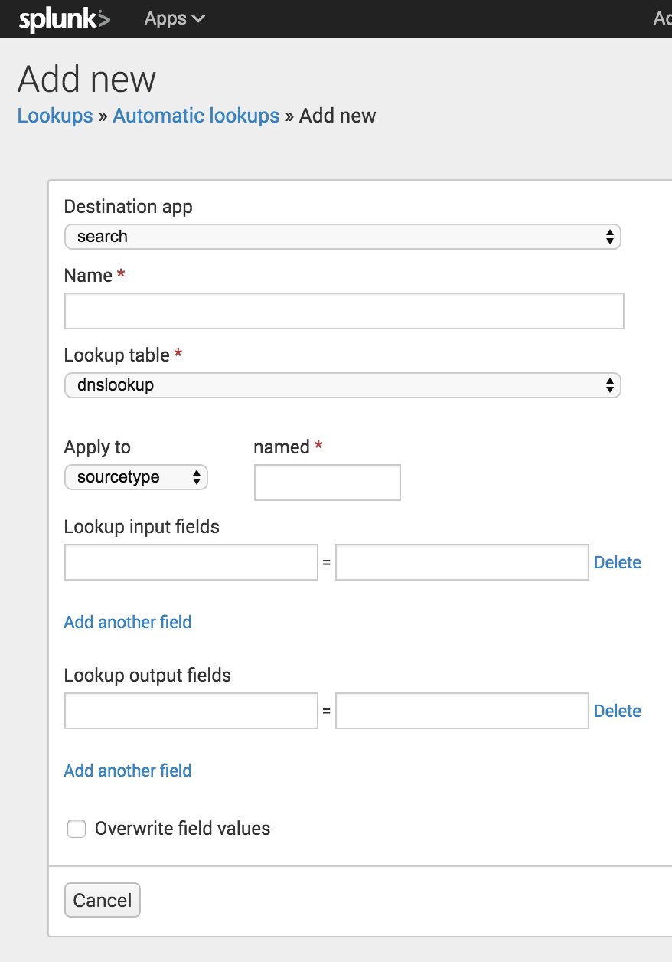](http://docs.splunk.com/File:6.5.0_tutorial_newautomaticlookups.png)

1. There is no need to change the **Destination app** setting. It is already set to **search**, referring to the Search app.
2. For **Name**, type **autolookup_prices**.
3. For **Lookup table**, select **prices_lookup**.

The other options are lookups that are based on the lookup table files that come with the product.

1. For **Apply to**, the value **sourcetype** is already selected. For **named**, type **access_combined_wcookie**.

[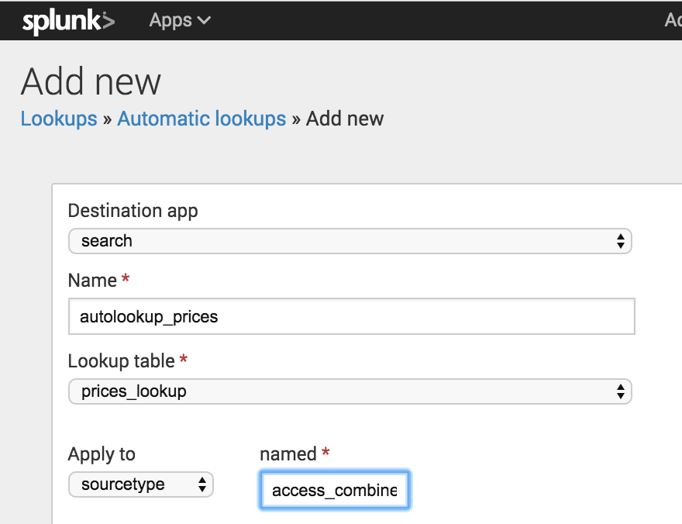](http://docs.splunk.com/File:6.5.0_tutorial_autolookup_sourcetype.png)

1. For **Lookup input fields**, type **productId** in both text boxes.

The lookup input fields are where you associate values from the lookup table file with values in your events.

* + The first text box specifies the value in the lookup table file.
  + The second text box specifies the value in your events.

The lookup table file has a **productId** column that contains values that match the values in the **productId** field in the events.

[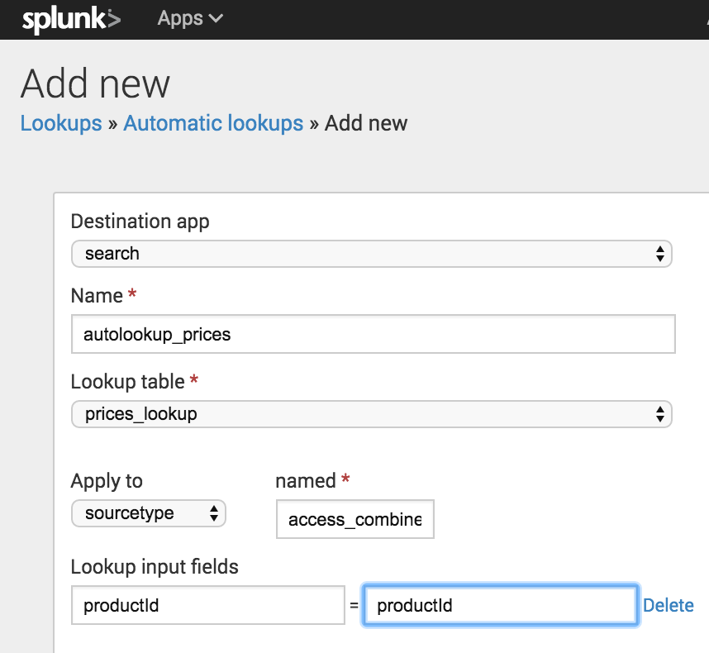](http://docs.splunk.com/File:6.5.0_tutorial_autolookupinputfields.png)

1. For **Lookup output fields**, specify the names of the fields from the lookup table file that you want to add to your event data. You can specify different names. The lookup table file has several fields. You will specify two of the fields to appear in your events.
   * In the first text box, type **product_name**. This is the field in the prices.csv file that contains the descriptive name for each productId.
   * In the second text box, after the equal sign, type **productName**. This is the name of the field that will appear in your events for the descriptive name of the product.
   * Click **Add another field** to add another field after the first one.
   * Type **price** in the first text box. This is the field in the prices.csv file that contains the price for each productId. Let's use the same name for the field that will appear in your events. Type **price** in the second text box.

[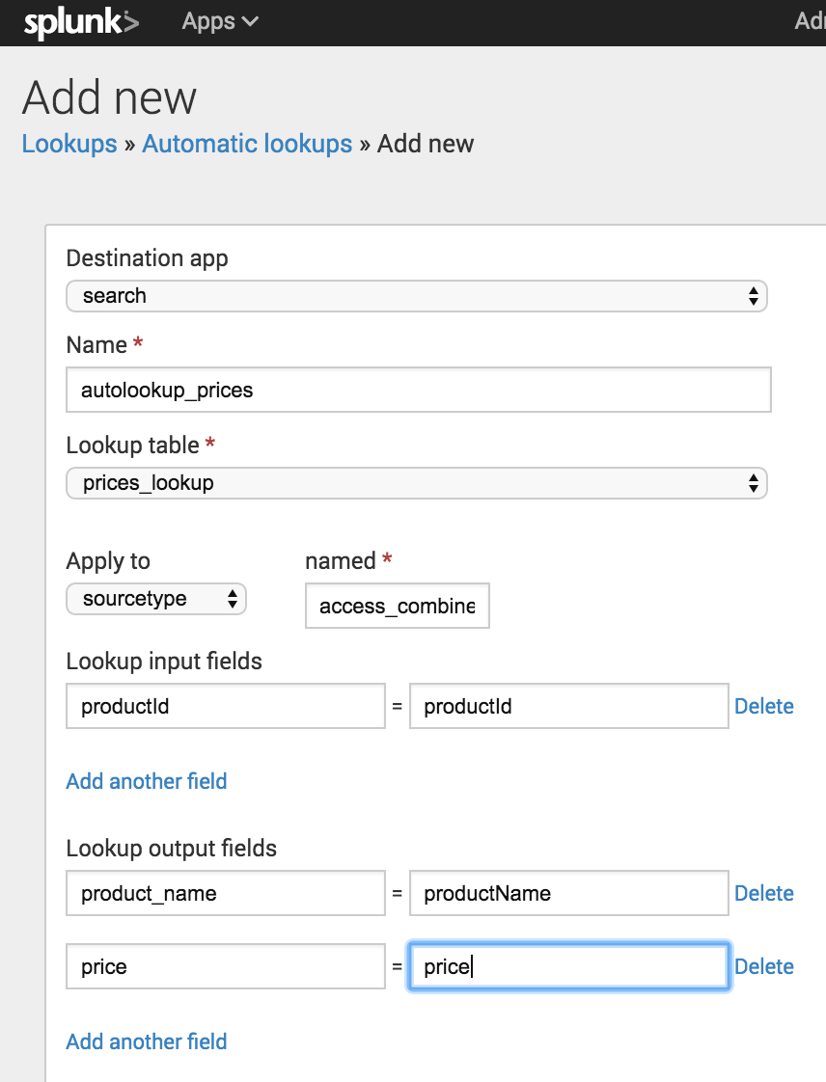](http://docs.splunk.com/File:6.5.0_tutorial_autolookupoutputfields.png)

1. Keep **Overwrite field values** unchecked.
2. Click **Save**.

The Automatic lookup view appears and the lookup that you configured, autolookup_prices, is in the list. The full name is **access_combined_wcookie : LOOKUP-autolookup_prices**.

Find the Lookups manager

1. In the Splunk bar, click **Settings**.
2. In the **Knowledge** section, click **Lookups**.

[](http://docs.splunk.com/File:6.5.0_tutorial_settings_lookups.png)

The Lookups manager opens, where you can create new lookups or edit existing lookups.

[](http://docs.splunk.com/File:6.5.0_tutorial_lookupsmanager.png)

You can view and edit existing lookups by clicking on the links in the Lookups manager. In the next few sections of this tutorial, you will upload lookup table files, create lookup definitions, and create automatic lookups.

Upload the lookup table file

To use a lookup table file, you must upload the file to your Splunk platform.

1. In the Lookups manager, locate **Lookup table files**.
2. In the Actions column click **Add new**.

You use the **Add new** lookup table files view to upload CSV files that you want to use.

[](http://docs.splunk.com/File:6.5.0_tutorial_addnewlookuptable.png)

1. The **Destination app** field specifies which app you want to upload the lookup table file to. To upload the file in the Search app, you do not need to change anything. The default value is **search**.
2. Under **Upload a lookup file**, click **Choose File** and browse for the **prices.csv** file.
3. Under **Destination filename**, type **prices.csv**.

This is the name that you will use to refer to the file when you create a lookup definition.

1. Click **Save**.

This uploads your lookup file to the Search app and displays the lookup table files list.

If the Splunk software does not recognize or cannot upload the file, you can take the following actions.

* Check that the file is uncompressed.
* If an error message indicates that the file does not have line breaks, the file has become corrupted. This can happen if the file is opened in Microsoft Excel before it is uploaded. You should delete the Prices.csv.zip and prices.csv files. Then download the ZIP file again, and uncompress the file.

[](http://docs.splunk.com/File:6.5.0_tutorial_lookuptablefiles.png)

The other lookup table files in the list are included with the Splunk software.

Share the lookup table file

Now that the lookup table file is uploaded, you need tell the Splunk software which applications can use this file. You can share the lookup table file with the Search app or with all of the apps.

1. In the **Lookup table files** list, locate the prices.csv file at the bottom of the **Path** list.
2. In the **Sharing** column, notice that prices.csv is listed as **Private**.
3. To share the lookup table file, click **Permissions**.
4. In the Permissions dialog box, under **Object should appear in**, select **All apps**.

[](http://docs.splunk.com/File:6.4_tutorial_lookuptablepermissions.png)

1. Click **Save**.

The Sharing setting for the prices.csv lookup table is set to **Global**.

[](http://docs.splunk.com/File:6.4_tutorial_lookuptableglobal.png)

Add the field lookup definition

It is not sufficient to share the lookup table file with an application. You must create a lookup definition from the lookup table file.

1. In the Lookup table file dialog box, select **Lookups** in the breadcrumbs to return to the Lookups manager.

[](http://docs.splunk.com/File:6.5.0_tutorial_lookupfilebreadcrumbs.png)

1. For **Lookup definitions**, click **Add New**.

The Add new lookups definitions page opens, where you define the field lookup.

1. There is no need to change the **Destination app** setting. It is already set to **search**, referring to the Search app.
2. For **Name**, type **prices_lookup**.
3. For **Type**, select **File-based**.

A file-based lookup is typically a static table, such as a CSV file.

1. For **Lookup file**, select **prices.csv**, which is the name of the lookup table file that you created.

[](http://docs.splunk.com/File:6.5.0_tutorial_newlookupdefinition.png)

1. For **Configure time-based lookup** and **Advanced options**, leave the check boxes unselected.
2. Click **Save**.

The **prices_lookup** is now defined as a file-based lookup.

[](http://docs.splunk.com/File:6.5.0_tutorial_lookupdefinitionsaved.png)

Share the lookup definition with all apps

Now that you have created the lookup definition, you need to specify in which apps you want to use the definition.

1. In the Lookup definitions list, for the prices_lookup, click **Permissions**.
2. In the Permissions dialog box, under **Object should appear in**, select **All apps**.

[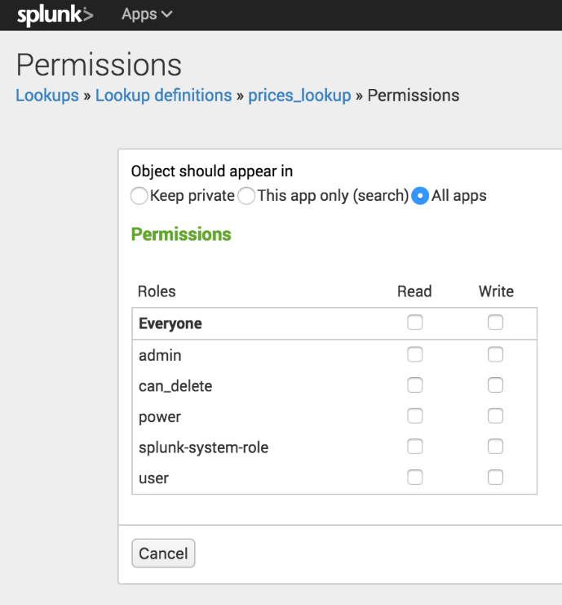](http://docs.splunk.com/File:6.5.0_tutorial_lookupdefinitionspermissions.png)

1. Click **Save**.

In the Lookup definitions page, prices_lookup now has **Global** permissions.

You can use this field lookup to add information from the lookup table file to your events. You use the field lookup by specifying the lookup command in a search string. Or, you can set the field lookup to run automatically.

Make the lookup automatic

Instead of using the lookup command in your search when you want to apply a field lookup to your events, you can set the lookup to run automatically.

1. In the Lookups manager, for **Automatic lookups**, click **Add New**.

This takes you to the Add new automatic lookups view, where you configure the lookup to run automatically.

[](http://docs.splunk.com/File:6.5.0_tutorial_newautomaticlookups.png)

1. There is no need to change the **Destination app** setting. It is already set to **search**, referring to the Search app.
2. For **Name**, type **autolookup_prices**.
3. For **Lookup table**, select **prices_lookup**.

The other options are lookups that are based on the lookup table files that come with the product.

1. For **Apply to**, the value **sourcetype** is already selected. For **named**, type **access_combined_wcookie**.

[](http://docs.splunk.com/File:6.5.0_tutorial_autolookup_sourcetype.png)

1. For **Lookup input fields**, type **productId** in both text boxes.

The lookup input fields are where you associate values from the lookup table file with values in your events.

* + The first text box specifies the value in the lookup table file.
  + The second text box specifies the value in your events.

The lookup table file has a **productId** column that contains values that match the values in the **productId** field in the events.

[](http://docs.splunk.com/File:6.5.0_tutorial_autolookupinputfields.png)

1. For **Lookup output fields**, specify the names of the fields from the lookup table file that you want to add to your event data. You can specify different names. The lookup table file has several fields. You will specify two of the fields to appear in your events.
   * In the first text box, type **product_name**. This is the field in the prices.csv file that contains the descriptive name for each productId.
   * In the second text box, after the equal sign, type **productName**. This is the name of the field that will appear in your events for the descriptive name of the product.
   * Click **Add another field** to add another field after the first one.
   * Type **price** in the first text box. This is the field in the prices.csv file that contains the price for each productId. Let's use the same name for the field that will appear in your events. Type **price** in the second text box.

[](http://docs.splunk.com/File:6.5.0_tutorial_autolookupoutputfields.png)

1. Keep **Overwrite field values** unchecked.

Click **Save**.

The Automatic lookup view appears and the lookup that you configured, autolookup_prices, is in the list. The full name is **access_combined_wcookie : LOOKUP-autolookup_prices**.

[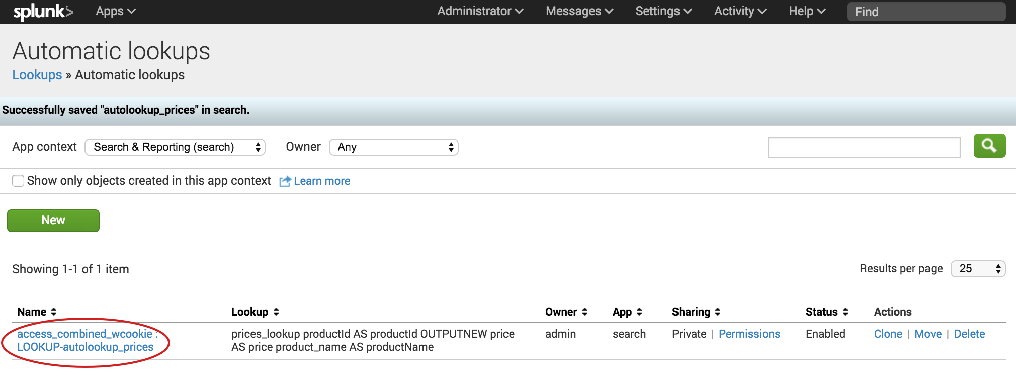](http://docs.splunk.com/File:6.5.0_tutorial_autolookupssaved.png)

Search with field lookups

Show the lookup fields in the search results

Because the prices_lookup is an automatic lookup the fields from the look will automatically appear in your search results.

1. From the Automatic Lookups window. In the **Apps** menu, click **Search & Reporting** to return to the Search summary view.
2. Change the time range to **All time**.
3. Run the following search to locate all of the web access activity.

sourcetype=access_*

1. Scroll through the list of **Interesting Fields** in the Fields sidebar, and find the price field.
2. Click **price** to open the summary dialog box for that field.

[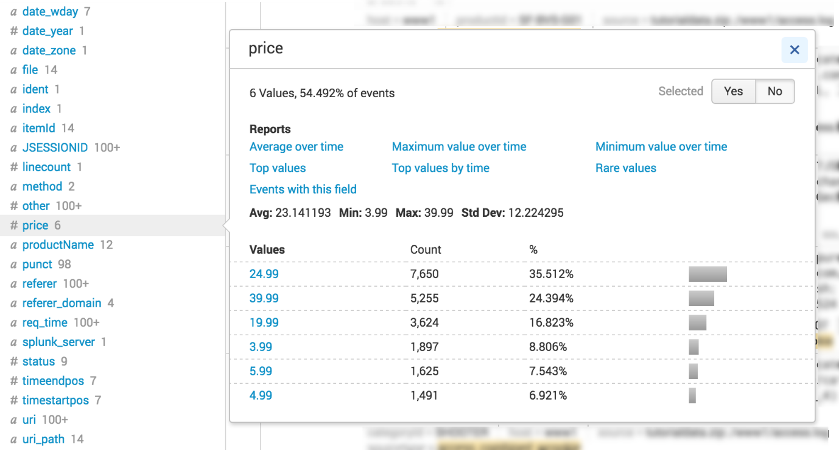](http://docs.splunk.com/File:6.5.0_tutorial_price_fieldsummary.png)

1. Next to **Selected**, click **Yes**. This moves the **prices** field from the list of **Interesting Fields** to the list of **Selected Fields** in the Fields sidebar.
2. Close the dialog box.
3. Scroll through the list of **Interesting Fields** in the Fields sidebar, and find the productName field.
4. Click **productName** to open the summary dialog box for the field.
5. Next to **Selected**, click **Yes**.
6. Close the dialog box.

Both the price field and the productName field appear in the Selected Fields list and in the search results.

Notice that not every event shows the price and the productName fields.

[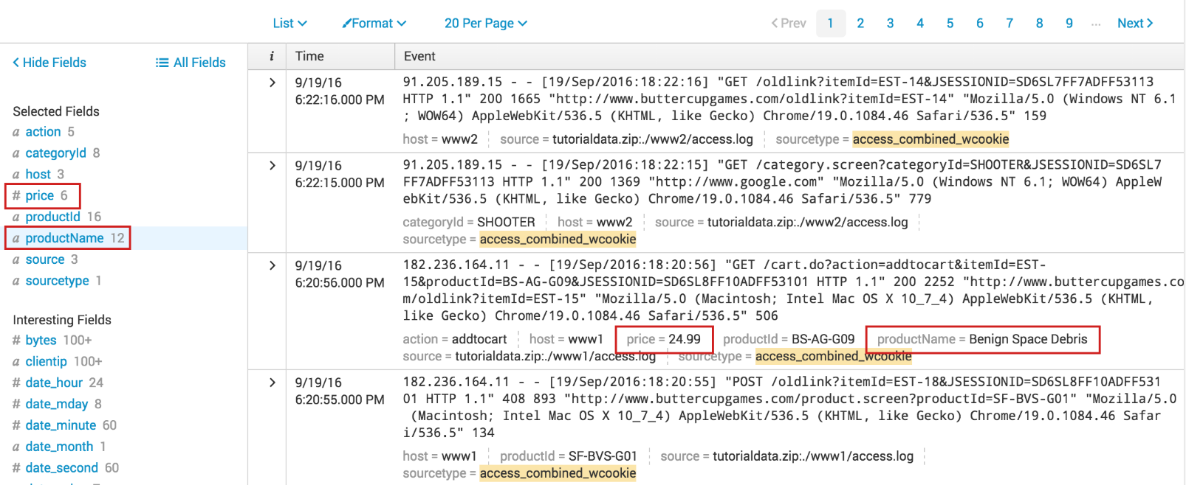](http://docs.splunk.com/File:6.5.0_tutorial_selected_lookupfields.png)

Search with the new lookup fields

When you setup the automatic lookup, you specified that the productId field in your indexed events corresponds to the productId field in the prices.csv file.

When you run a search, the Splunk software uses that relationship to retrieve, or lookup, data from the prices.csv file.

This enables you to specify the productName and price fields directly in your search. The product name and price information does not exist in our indexed fields. This information exists in the lookup file, prices.csv.

Example: Display the product names and prices

1. To show a list of the Buttercup Games product names and the corresponding prices, run the following search.

sourcetype=access_* |stats values(price) AS Price BY productName |rename productName AS "Product Name"

[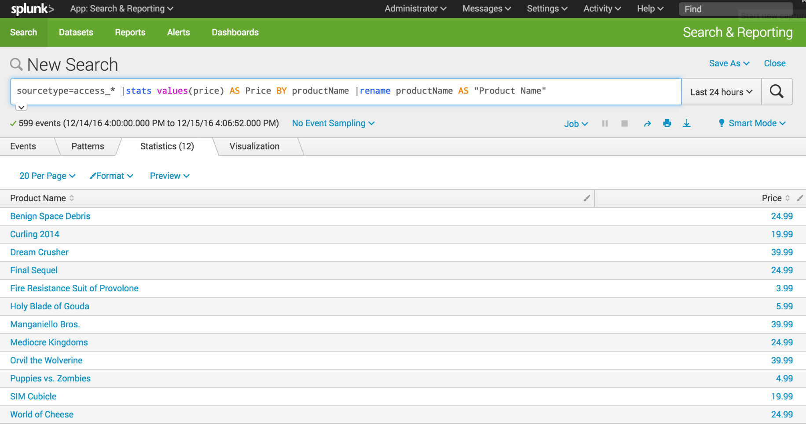](http://docs.splunk.com/File:6.5.1216_tutorial_lookup_prices.png)

Example: Display the VIP client purchases

In the previous section about subsearches, you created a search that returned the product IDs of the products that a VIP client purchased.

sourcetype=access_* status=200 action=purchase [search sourcetype=access_* status=200 action=purchase | top limit=1 clientip | table clientip] | stats count AS "Total Purchased", dc(productId) AS "Total Products", values(productId) AS "Products ID" BY clientip | rename clientip AS "VIP Customer"

[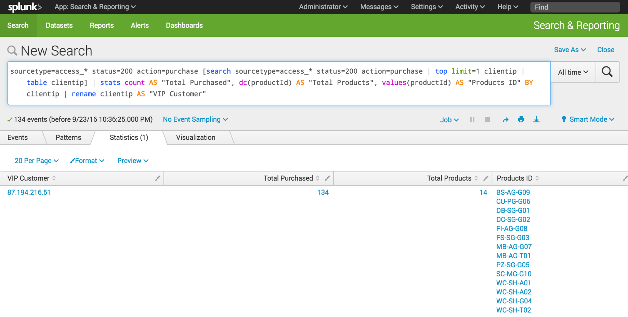](http://docs.splunk.com/File:6.5.0_tutorial_lookupsearch1.png)

The events return the product IDs because that is the only data in your events about the product. However, now that you have defined the automatic lookup, you can return the actual product names.

1. Make sure that the time range is set to **All time**.
2. Using the same search, for the **values** parameter, replace the productId field with the productName field.

sourcetype=access_* status=200 action=purchase [search sourcetype=access_* status=200 action=purchase | top limit=1 clientip | table clientip] | stats count AS "Total Purchased", dc(productId) AS "Total Products", values(productName) AS "Product Names" BY clientip | rename clientip AS "VIP Customer"

The results are the same as in the previous search, showing the purchases by the VIP customer. However, the results are more meaningful because the product names, which are coming from the lookup table, appear instead of the more cryptic product IDs.

[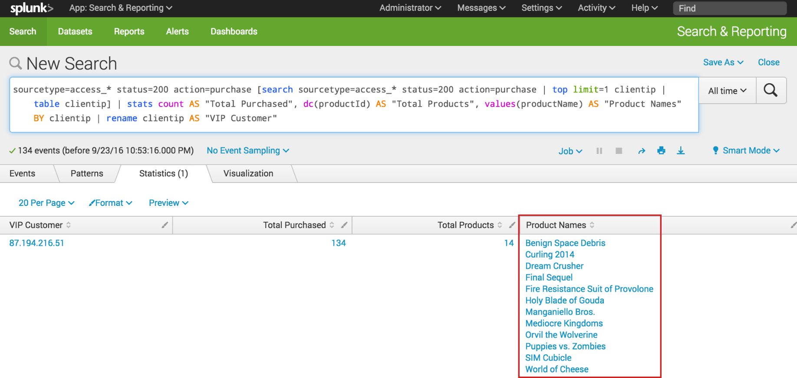](http://docs.splunk.com/File:6.5.0_tutorial_lookup_subsearch.png)

Save and share the reports

Reports are created whenever you save a search. After you create a report, you can do a lot with it.

1. Set the time range to **Last 7 days** and run the following search.

This is the same search that you ran in the section [Search with field lookups](http://docs.splunk.com/Documentation/Splunk/6.6.1/SearchTutorial/Searchwithfieldlookups).

sourcetype=access_* status=200 action=purchase [search sourcetype=access_* status=200 action=purchase | top limit=1 clientip | table clientip] | stats count AS "Total Purchased", dc(productId) AS "Total Products", values(productName) AS "Product Names" BY clientip | rename clientip AS "VIP Customer"

**Note:** If your search does not return results, increase the time range of the search. For example, you can run search over the time range **Last 30 days** or **All Time**.

1. Above the Search bar, click **Save as** and select **Report**.

[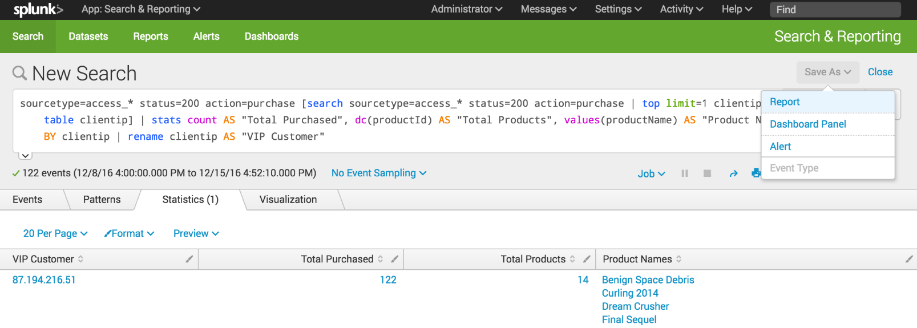](http://docs.splunk.com/File:6.5.1216_tutorial_savereport.png)

1. In the Save As Report dialog box for **Title** type **VIP Customer**.
2. For **Description**, type **Buttercup Games most frequent shopper**.

[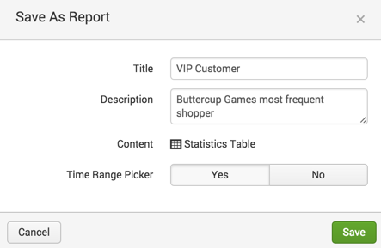](http://docs.splunk.com/File:6.4_tutorial_savereport2.png)

1. For **Time Range Picker**, click **Yes**.

When you include a Time range picker in a report, it gives you the option of running the report with a different time range.

1. Click **Save**.

A confirmation dialog box opens confirming that your report has been created. From this dialog box you can perform the following actions.

* + **Continue Editing**. To refine the search and report format.
  + **Add to Dashboard**. To add the report to a new or existing dashboard.
  + **View**. To view the report.

1. Click **View.**

[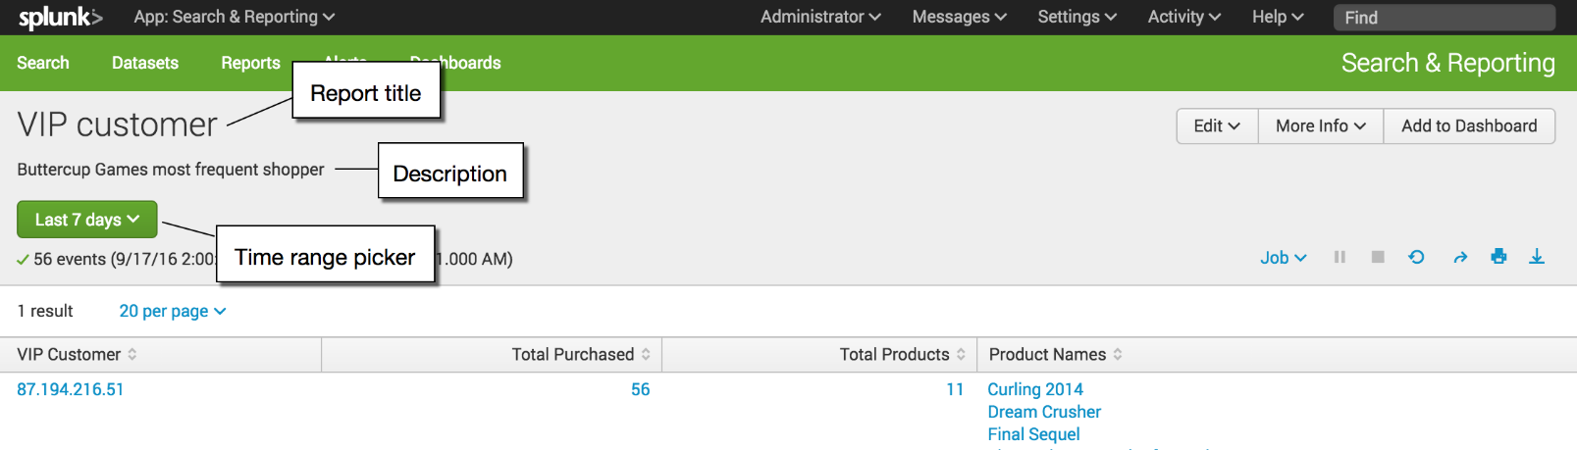](http://docs.splunk.com/File:6.5.0_tutorial_savedreport_view.png)

The title and description that you specified appear at the top of the report. Time range picker is also included at the top of the report. If you specified some other time range for the search, that time range appears in the report.

View and edit reports

You can view and edit reports that you have saved. You edit a report directly from within the report.

1. In the VIP Customer report, click **Edit**.

[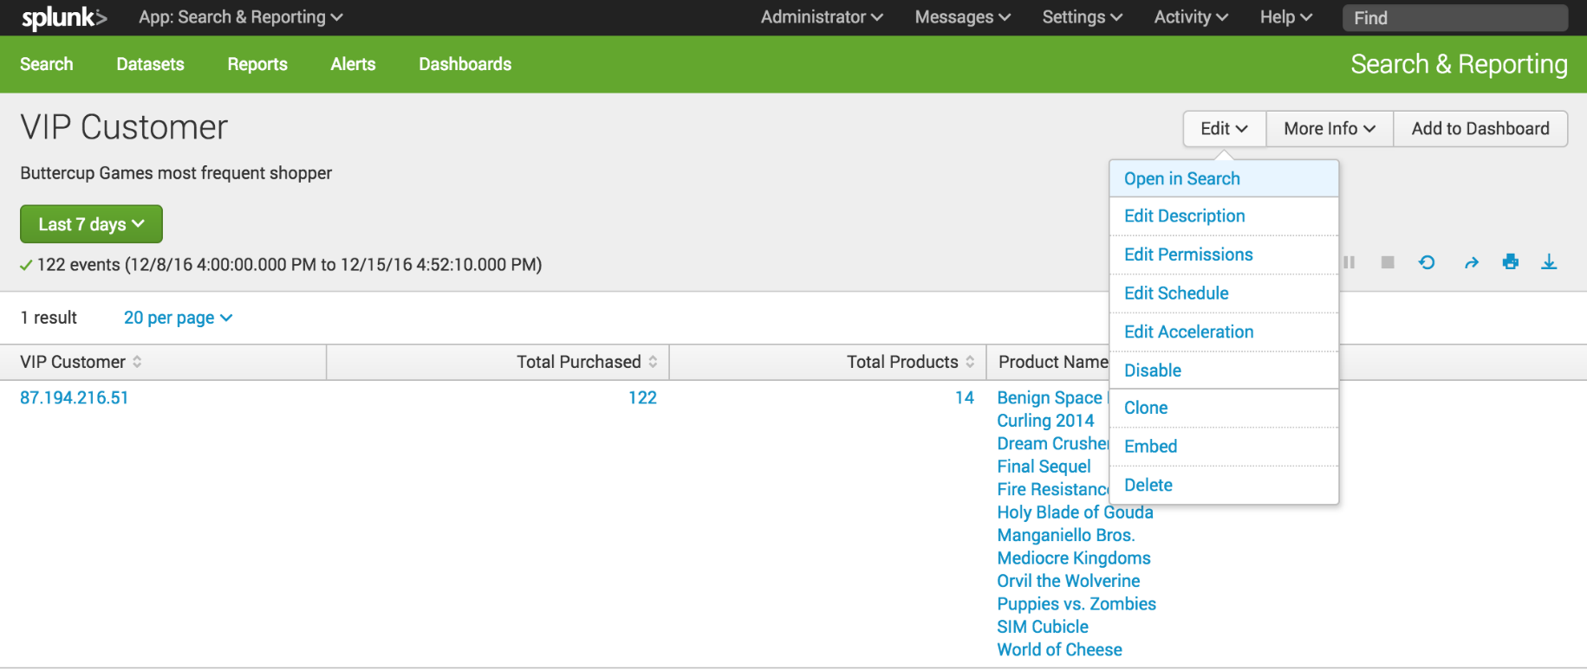](http://docs.splunk.com/File:6.5.1216_tutorial_report_edit.png)

The options are to open the report in the Search view, or to edit the report description, permissions, schedule, and acceleration. You can also clone, embed, and delete the report from this menu.

1. Click **More Info** to view information about the report.

[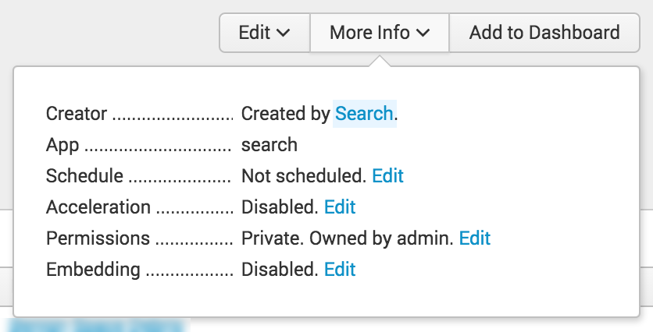](http://docs.splunk.com/File:6.5.0_tutorial_report_moreinfo.png)

From the **More Info** menu, you can view and edit different properties of the report, including its schedule, acceleration, permissions, and embedding.

1. Look at the time range picker, located at the upper left corner of the window.

With the Time range picker, you can change the time period to run this search. For example, you can use this time range picker to run this search for the VIP Customer **Week to date**, **Last 60 minutes**, or **Last 24 hours** just by selecting the Preset time range or defining a custom time range.

[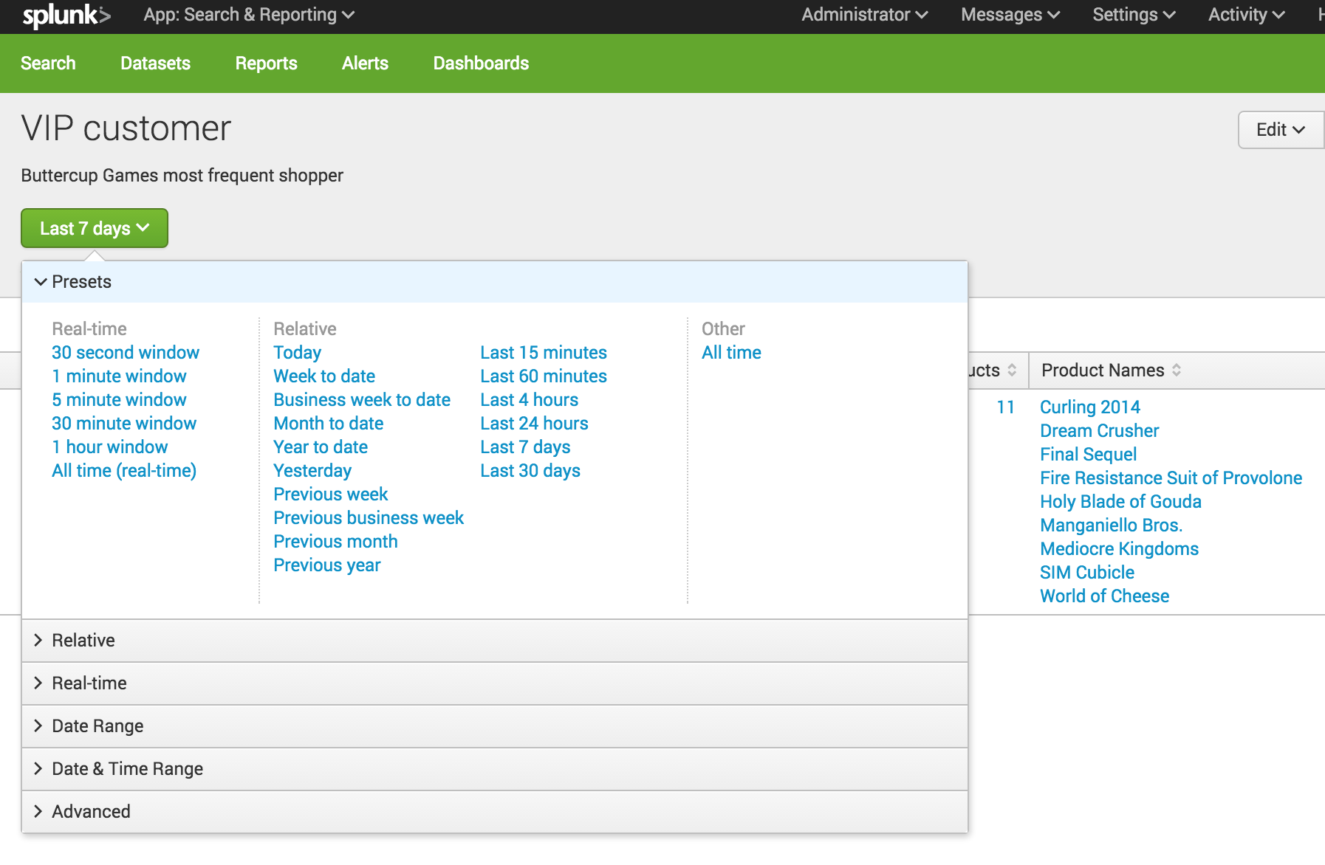](http://docs.splunk.com/File:6.5.0_tutorial_timerange_reportview.png)

Find and share reports

You can access your reports using the App bar.

1. Click **Reports** to open the Reports page and view the list of reports.

[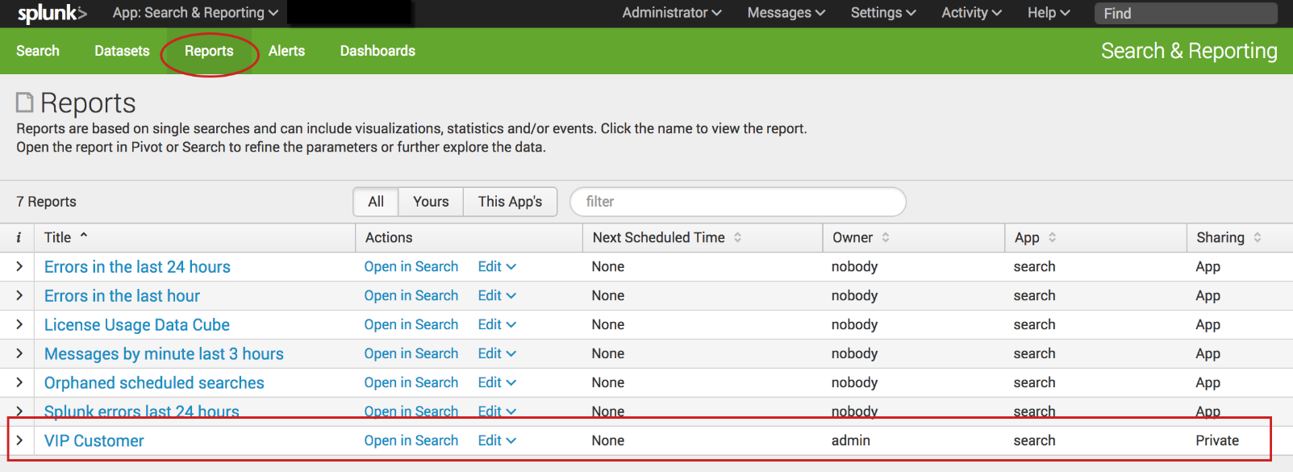](http://docs.splunk.com/File:6.6.0_tutorial_reportslist.png)

When you save a report, **Sharing** is set to **Private**. Only you can view and edit the report. You can allow other apps to view, edit, or both view and edit the report by changing the report permission.

1. For the **VIP Customer** report, under **Actions** click **Edit**.
2. Select **Edit Permissions**.

[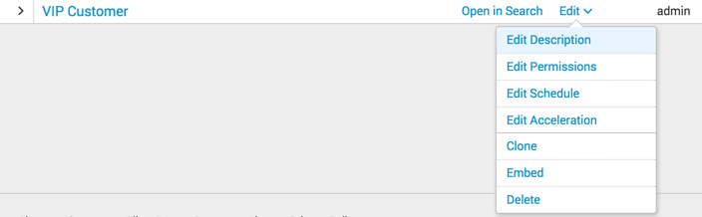](http://docs.splunk.com/File:6.4_tutorial_report_editpermissions.png)

1. In the Edit Permissions dialog box, set **Display For** to **App**.

The display expands to show more settings.

1. For **Everyone**, mark the check box under **Read**.

[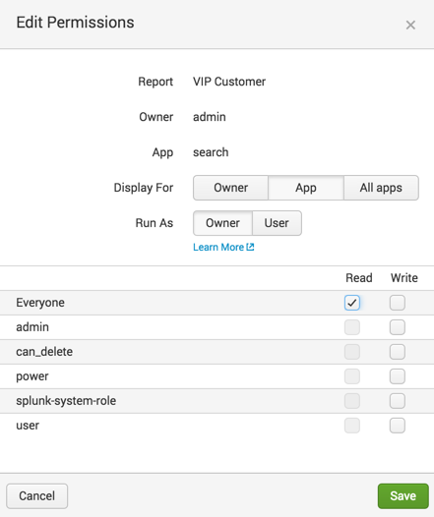](http://docs.splunk.com/File:6.4_tutorial_report_editpermissions2.png)

This action gives everyone who has access to this app the permission to view the report.

1. Click **Save**.

The Reports page appears. The **Sharing** setting for the VIP Customer report now reads **App** instead of Private.

[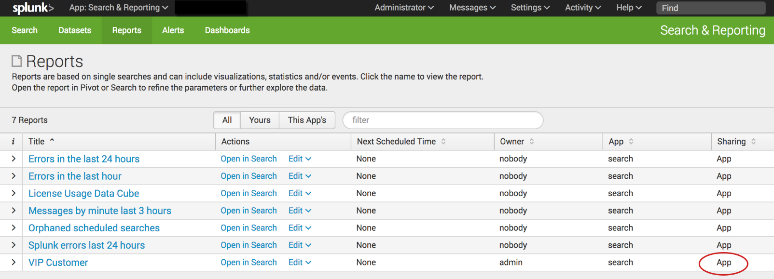](http://docs.splunk.com/File:6.6.0_tutorial_report_changedpermissions.png)

Search , chart and report Examples

Example: Compare counts of user actions

In this example you will calculate information about the actions customers have taken on the online store website.

* The number of times each product is viewed
* The number of times each product is added to the cart
* The number of times each product is purchased

**Prerequisite**   
This example uses the productName field from the prices_lookup that you created in the [Enabling field lookups](http://docs.splunk.com/Documentation/Splunk/6.6.1/SearchTutorial/Usefieldlookups) section in this tutorial. You must complete all of those steps in that section before continuing with this example.

**Steps**

1. Start a new search.
2. Set the time range to **All time**.
3. Run the following search.

sourcetype=access_* status=200 | chart count AS views count(eval(action="addtocart")) AS addtocart count(eval(action="purchase")) AS purchases by productName | rename productName AS "Product Name", views AS "Views", addtocart AS "Adds to Cart", purchases AS "Purchases"

This search uses the chart command to count the number of events that are action=purchase and action=addtocart. The search then uses the rename command to rename the fields that appear in the results.

The chart command is a transforming command. The results of the search appear on the **Statistics** tab.

[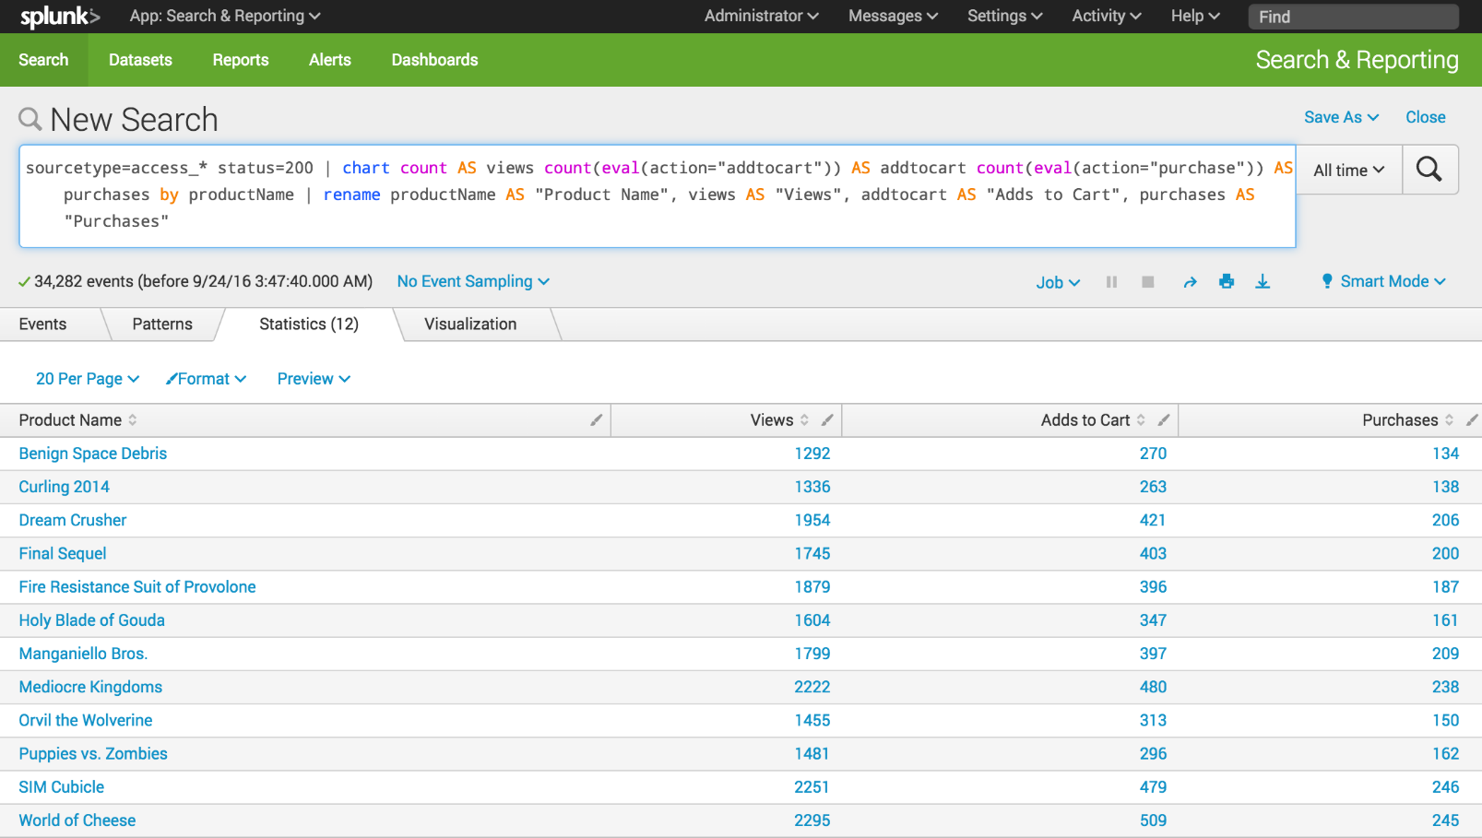](http://docs.splunk.com/File:6.5.0_tutorial_moresearches_ex1.1.png)

1. Click the **Visualization** tab. The search results appear in a Pie chart.
2. Change the display to a **Column** chart.

[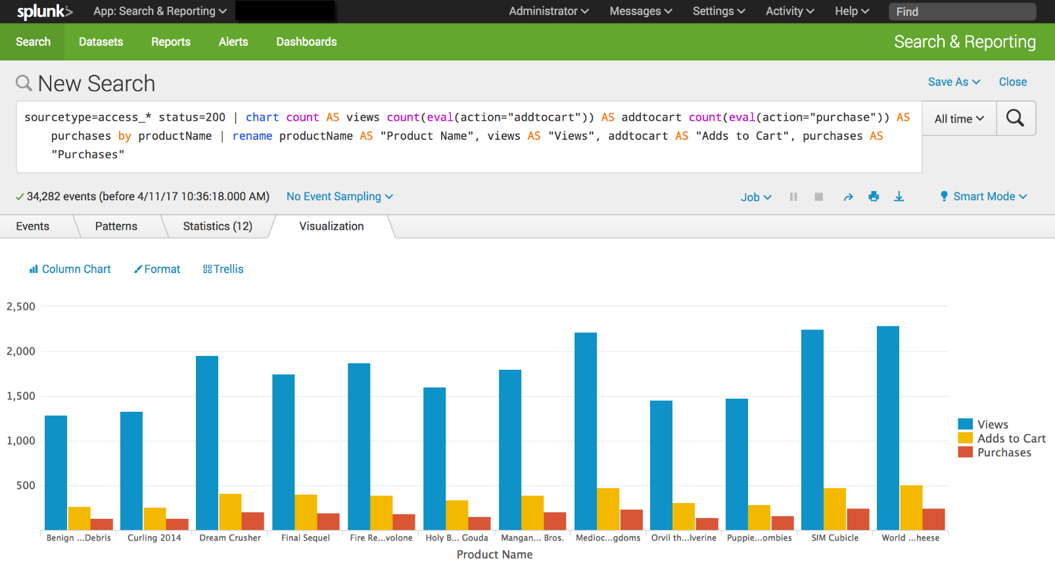](http://docs.splunk.com/File:6.6.0_tutorial_moresearches_ex1.2.png)

Example: Overlay Actions and Conversion Rates on one chart

In this example, you will use the stats command to count the user actions. The eval command is used to calculate the conversion rates for those actions. For example, how often someone who viewed a product added the product to their cart.

**Prerequisite**   
This example uses the productName field from the prices_lookup that you created in the [Enabling field lookups](http://docs.splunk.com/Documentation/Splunk/6.6.1/SearchTutorial/Usefieldlookups)  You must complete all of those steps in that section before continuing with this example.

**Steps**

1. Start a new search.
2. Change the time range to **All time**.
3. Run the following search.

sourcetype=access_* status=200 | stats count AS views count(eval(action="addtocart")) AS addtocart count(eval(action="purchase")) AS purchases by productName | eval viewsToPurchases=(purchases/views)*100 | eval cartToPurchases=(purchases/addtocart)*100 | table productName views addtocart purchases viewsToPurchases cartToPurchases | rename productName AS "Product Name", views AS "Views", addtocart as "Adds To Cart", purchases AS "Purchases"

The eval command is used to define two new fields. These fields contain the conversion rates.

* + The **viewToPurchases** field calculates the number of customers who viewed the product to the number of customers who purchased the product. The calculation returns a percentage.
  + The **cartToPurchases** field calculates the number of customers who added the product to their cart to the number of customers who purchased the product. The calculation returns a percentage.

[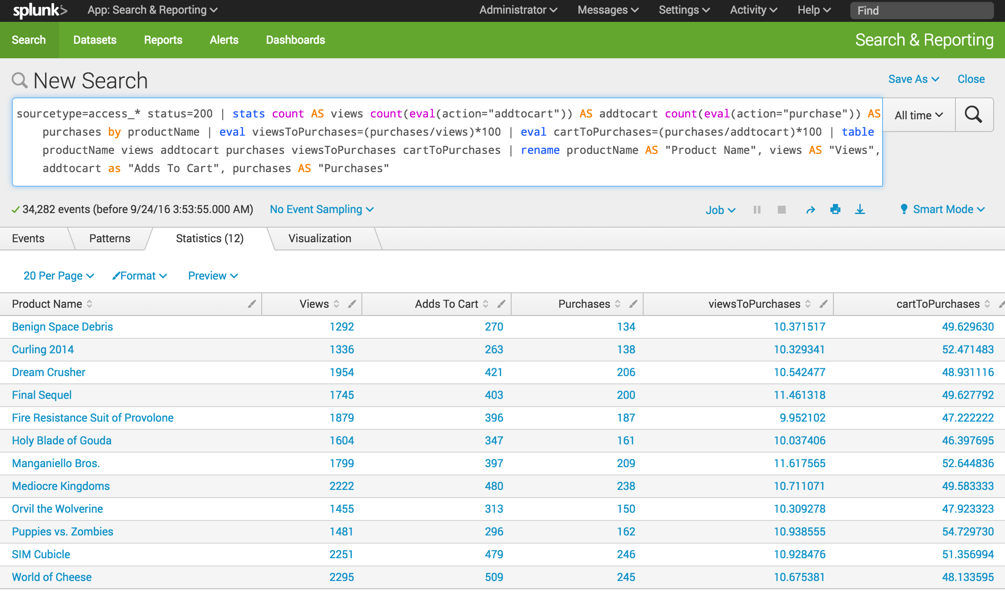](http://docs.splunk.com/File:6.5.0_tutorial_moresearches_ex2.1.png)

The next few steps reformat the chart visualization to overlay the two data series for the conversion rates, onto the three data series for the actions.

1. Click the **Visualization** tab.

This is the same chart as in Example 1, with two additional data series, **viewsToPurchase** and **cartToPurchase**.

[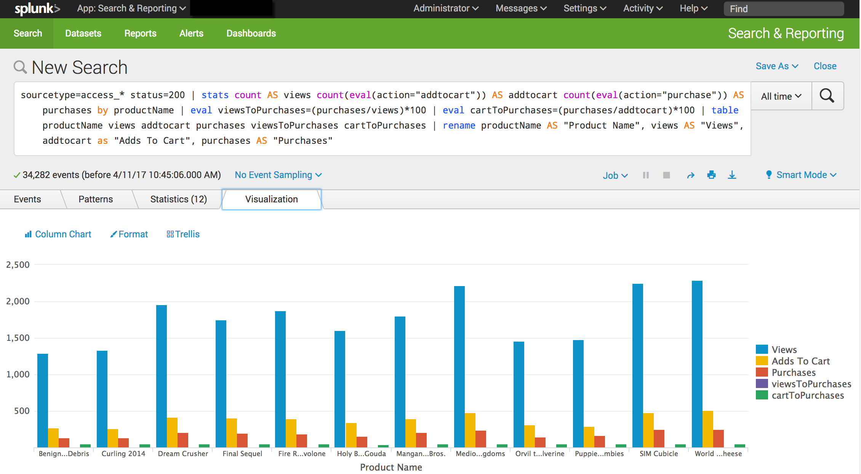](http://docs.splunk.com/File:6.6.0_tutorial_moresearches_ex2.2.png)

1. Click **Format** and **X-Axis**.

Because the labels on the X-Axis are difficult to read, let's fix that.

[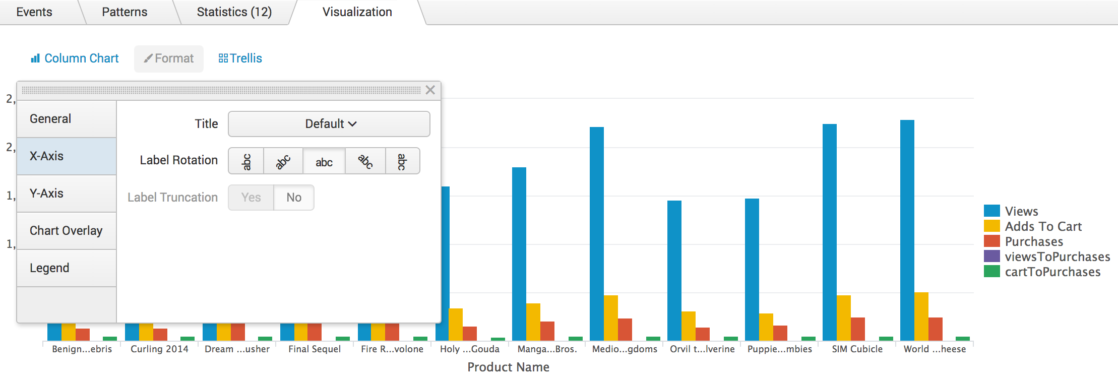](http://docs.splunk.com/File:6.6.0_tutorial_moresearches_ex2.3.png)

* + Rotate the label **-45** degrees.
  + Close the Format dialog box.

Notice the change in the labels on the X-Axis. Look at the numbers on the Y-Axis. They range from 1000 to 3000.

1. Click **Format** and **Y-Axis**.

To make the chart easier to read, add a label and specify different number intervals on the Y-Axis.

* + For **Title**, choose **Custom** and type **Actions**.
  + For **Interval** type **500**.
  + For **Max Value** type **2500**.

[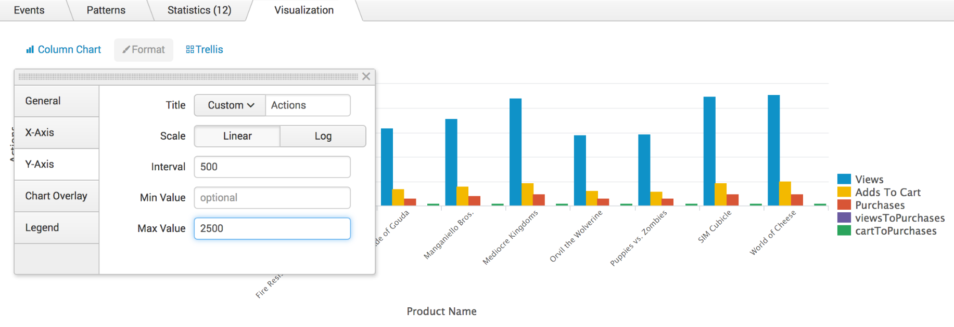](http://docs.splunk.com/File:6.6.0_tutorial_moresearches_ex2.4.png)

* + Close the Format dialog box. Notice the label and values on the Y-Axis.

1. Click **Format** and **Chart Overlay**.

To separate the actions (views, adds to cart, and purchases) from the conversion rates (viewToPurchases and cartToPurchases), you can overly one set of values over another set. In this example you will overlay the conversion rates over the actions.

* + For **Overlay**, click inside the box and select **viewsToPurchase**. Click inside the box again and select **cartToPurchase**.
  + For **View as Axis**, click **On**.
  + For **Title**, choose **Custom**

[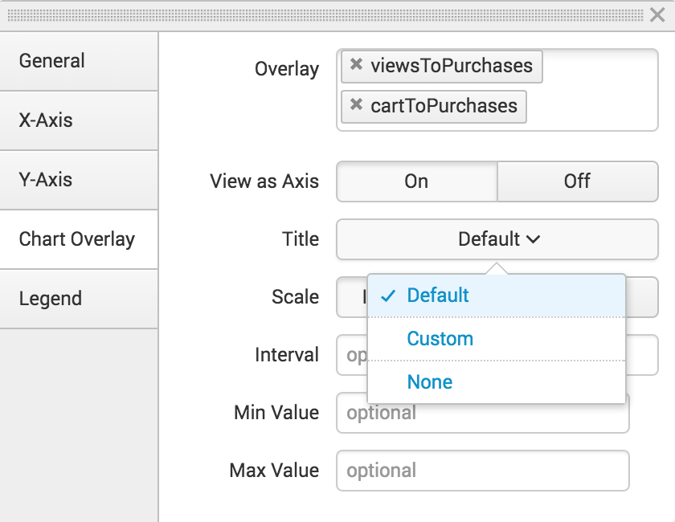](http://docs.splunk.com/File:6.5.0_tutorial_moresearches_ex2.5.png)

* + Type **Conversion Rates**.
  + For **Scale**, click **Linear**.
  + For the **Interval** type **20**. For the **Max Value** type **100**.

[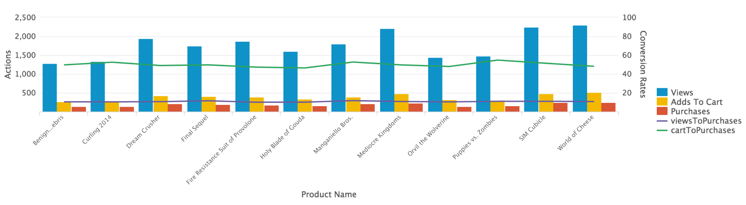](http://docs.splunk.com/File:6.5.0_tutorial_moresearches_ex2.6.png)

The axis on the right side of the chart is called the **second Y-Axis**. The label and values for the line series appear on this axis.

1. Click **Save As** and select **Report**.

[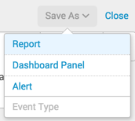](http://docs.splunk.com/File:6.4_tutorial_moresearches_saveAs.png)

* + In the Save Report As dialog box, for **Title** type **Comparison of Actions and Conversion Rates by Product.**
  + For **Description**, type **The number of times a product is viewed, added to cart, and purchased and the rates of purchases from these actions.**

1. Click **Save**
2. In the confirmation dialog box, click **View**.

[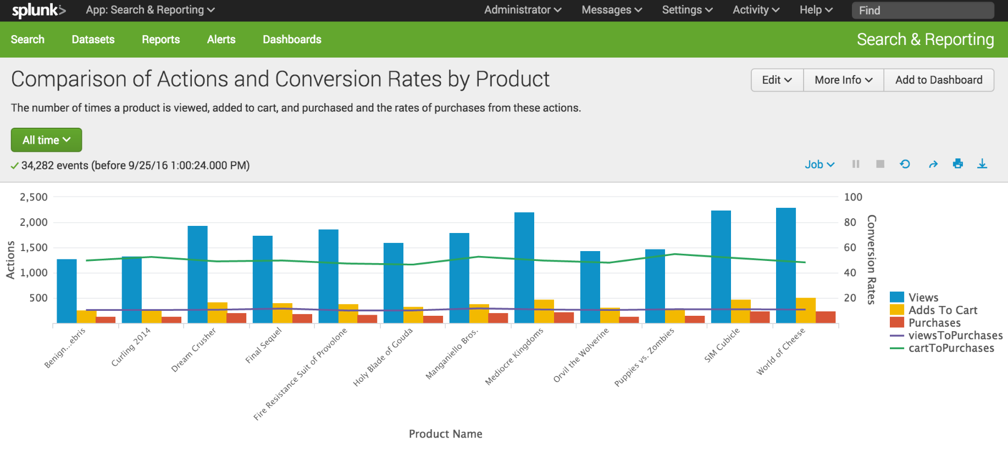](http://docs.splunk.com/File:6.5.0_tutorial_moresearches_ex2.8.png)

Example: Products purchased over time

Create a report that charts the number of purchases that were completed for each item in the last week.

**Prerequisite**   
This example uses the productName field from the prices_lookup that you created in the [Enabling field lookups](http://docs.splunk.com/Documentation/Splunk/6.6.1/SearchTutorial/Usefieldlookups) section of this tutorial. You must complete all of those steps in that section before continuing with this example.

**Steps**

1. Start a new search.
2. Change the time range to **Previous week**.
3. Run the following search.

sourcetype=access_* | timechart count(eval(action="purchase")) by productName usenull=f useother=f

This search uses the count() function to count the number of events that have the field action=purchase.

The search also uses the usenull and useother arguments to ensure that the timechart command only counts events that have a value for productName.

The following table appears on the **Statistics** tab.

[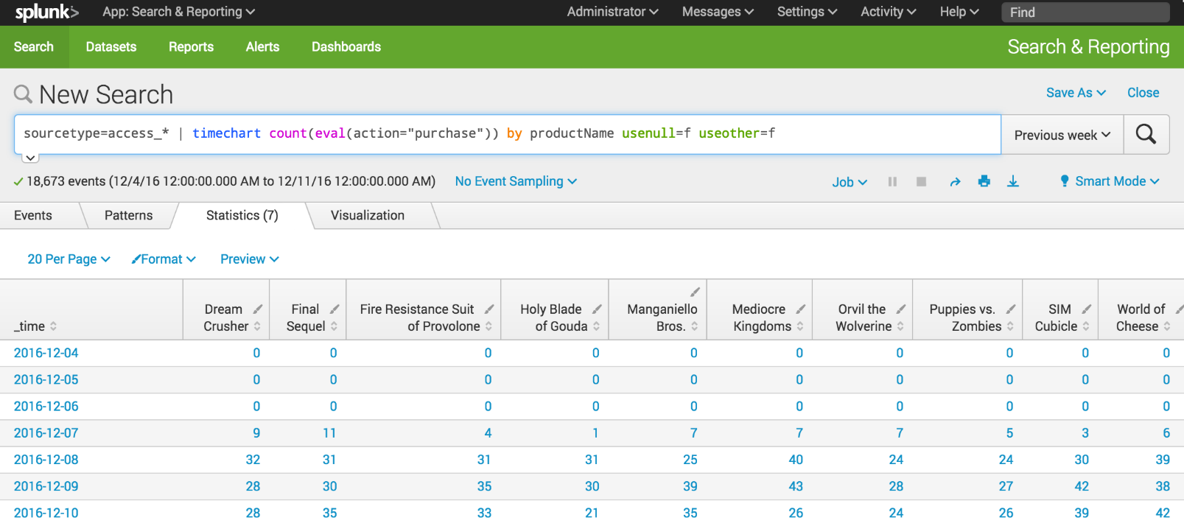](http://docs.splunk.com/File:6.5.1216_tutorial_moresearches_ex3.1.png)

1. Click the **Visualization** tab.
2. Change the chart type to a Line chart.
3. In the **Format** drop-down list, format the **X-Axis**, **Y-Axis**, and **Legend** using the settings in the following table.

|  |  |
| --- | --- |
| **Chart changes** | **Setting or value** |
| Chart type | Line |
| X-Axis CustomTitle | Date |
| X-Axis Labels | -45 degree angle |
| Y-Axis Custom Title | Purchases |
| Y-Axis Interval | 10 |
| Legend Position | Top |

1. The following image shows the updated chart.
2. [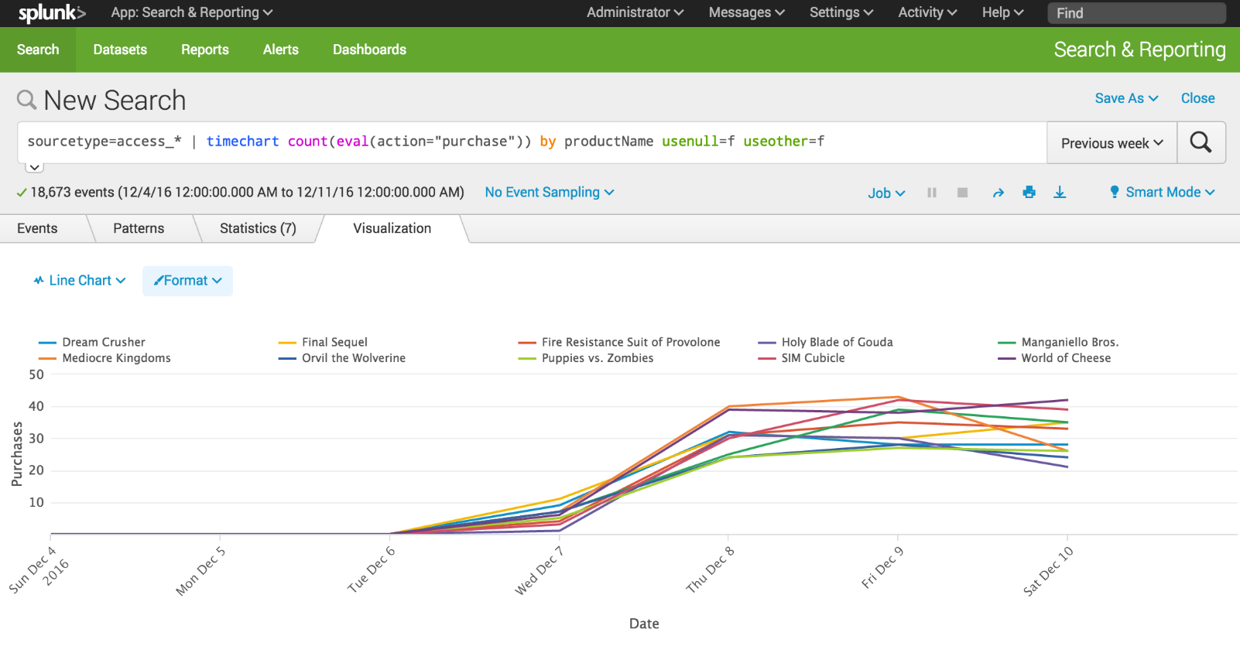](http://docs.splunk.com/File:6.5.1216_tutorial_moresearches_ex3.2.png)
3. Click **Save As** and select **Report**.

[](http://docs.splunk.com/File:6.4_tutorial_moresearches_saveAs.png)

* 1. In the **Save Report As** dialog box, for **Title** type **Product Purchases over Time**.
  2. For **Description**, type **The number of purchases for each product**.
  3. For **Content**, select **Line Chart and Statistics Table**.
  4. For **Time Range Picker**, keep the default setting **Yes**.

1. Click **Save**.
2. In the confirmation dialog box, click **View** to see the report.

[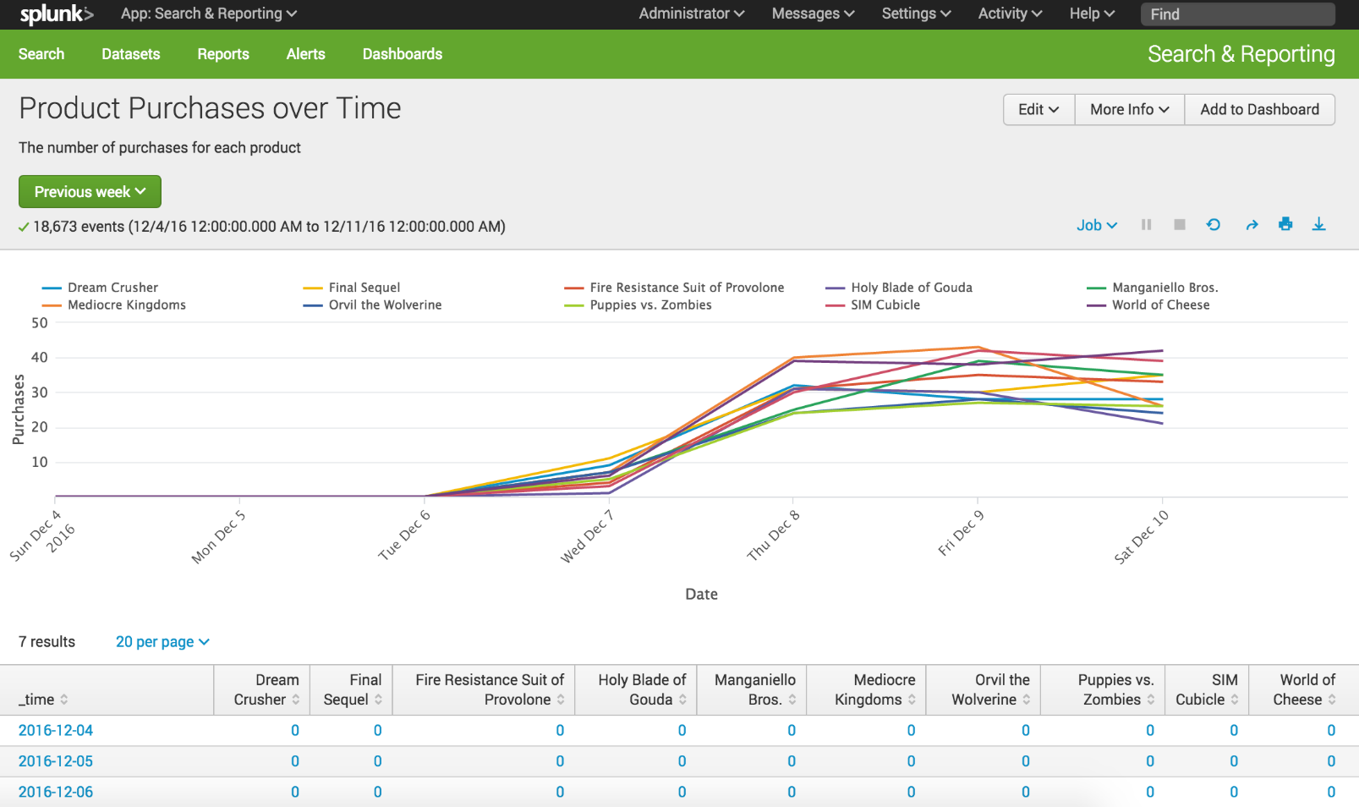](http://docs.splunk.com/File:6.5.1216_tutorial_moresearches_ex3.3.png)

Example: Purchasing trends

This example uses sparkline charts to show trends in the number of purchases made over time.

*Sparklines* are inline charts that appear in the search results table and are designed to display time-based trends associated with the primary key of each row. For searches that use the stats and chart commands, you can add sparkline charts to the results tables.

**Prerequisite**   
This example uses the productName field from the prices_lookup that you created in the [Enabling field lookups](http://docs.splunk.com/Documentation/Splunk/6.6.1/SearchTutorial/Usefieldlookups) section in this tutorial. You must complete all of those steps before continuing with this example.

**Steps**

1. Start a new search.
2. Change the time range to **All time**.
3. Run the following search.

sourcetype=access_* status=200 action=purchase| chart sparkline(count) AS "Purchases Trend" count AS Total by categoryId | rename categoryId AS "Category"

This search uses the chart command to count the number of purchases by using action="purchase". The search specifies the purchases made for each product by using categoryId. The difference is that the count of purchases is now an argument of the sparkline() function.

[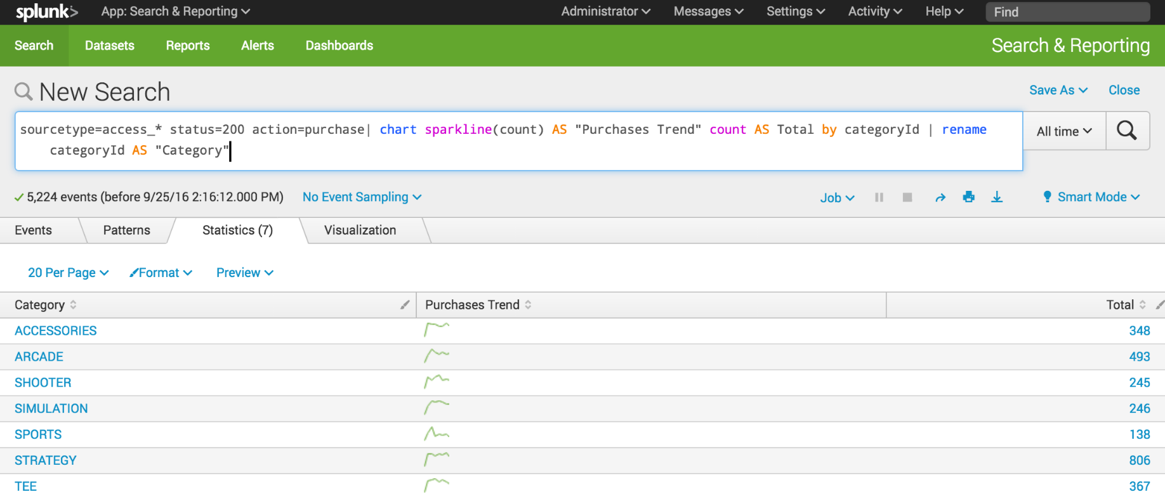](http://docs.splunk.com/File:6.5.0_tutorial_moresearches_ex4.1.png)

1. Click **Save As** and select **Report**.
2. In the **Save Report As** dialog box, for **Title** type **Purchasing trends**.
3. For **Description**, type **Count of purchases with trending**.

[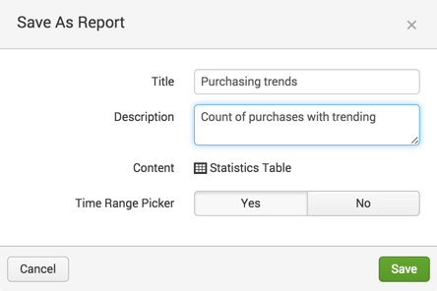](http://docs.splunk.com/File:6.4_tutorial_moresearches_ex4.2.png)

1. Click **Save**.
2. In the confirmation dialog box, click **View**.

[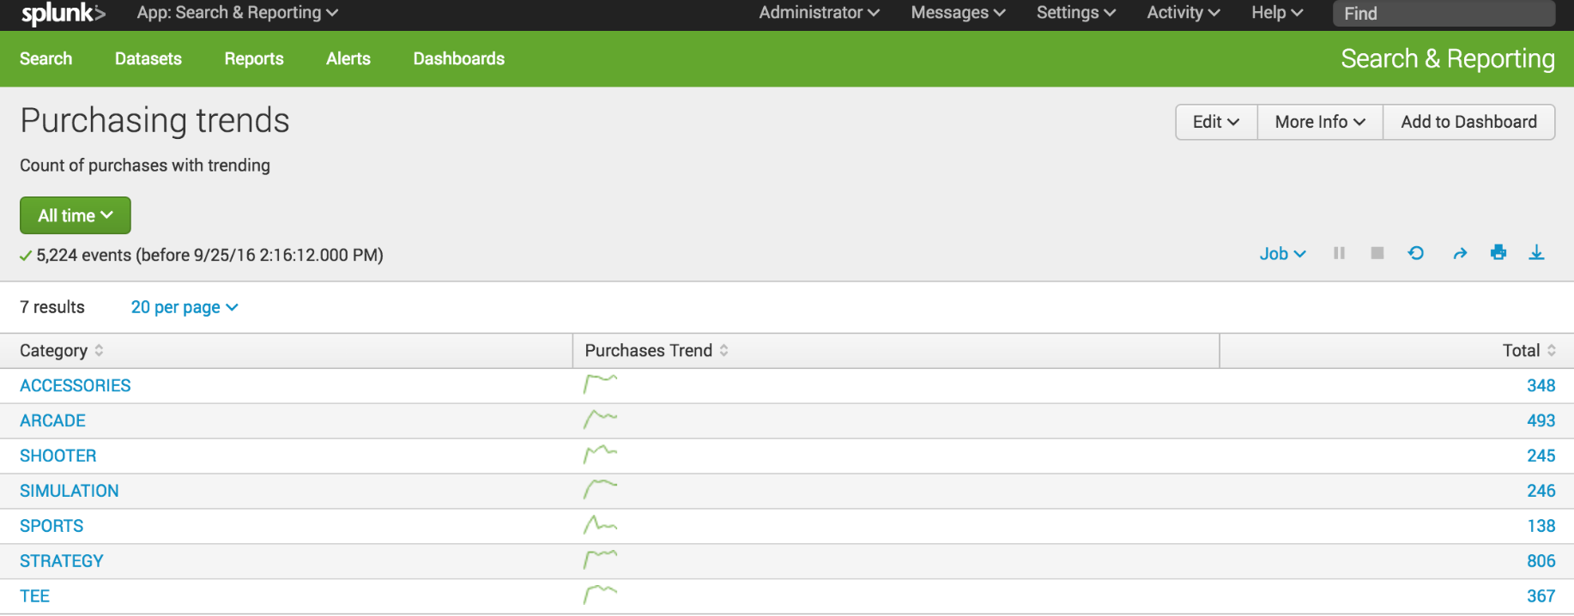](http://docs.splunk.com/File:6.5.0_tutorial_moresearches_ex4.3.png)

Create Dashboard and Panels

Save a search as dashboard panel

1. Start a new search.
2. Change the time range to **Yesterday**.
3. Run the following search.

sourcetype=access_* status=200 action=purchase | top categoryId

If no results are returned, expand your time range to **Previous week**.

[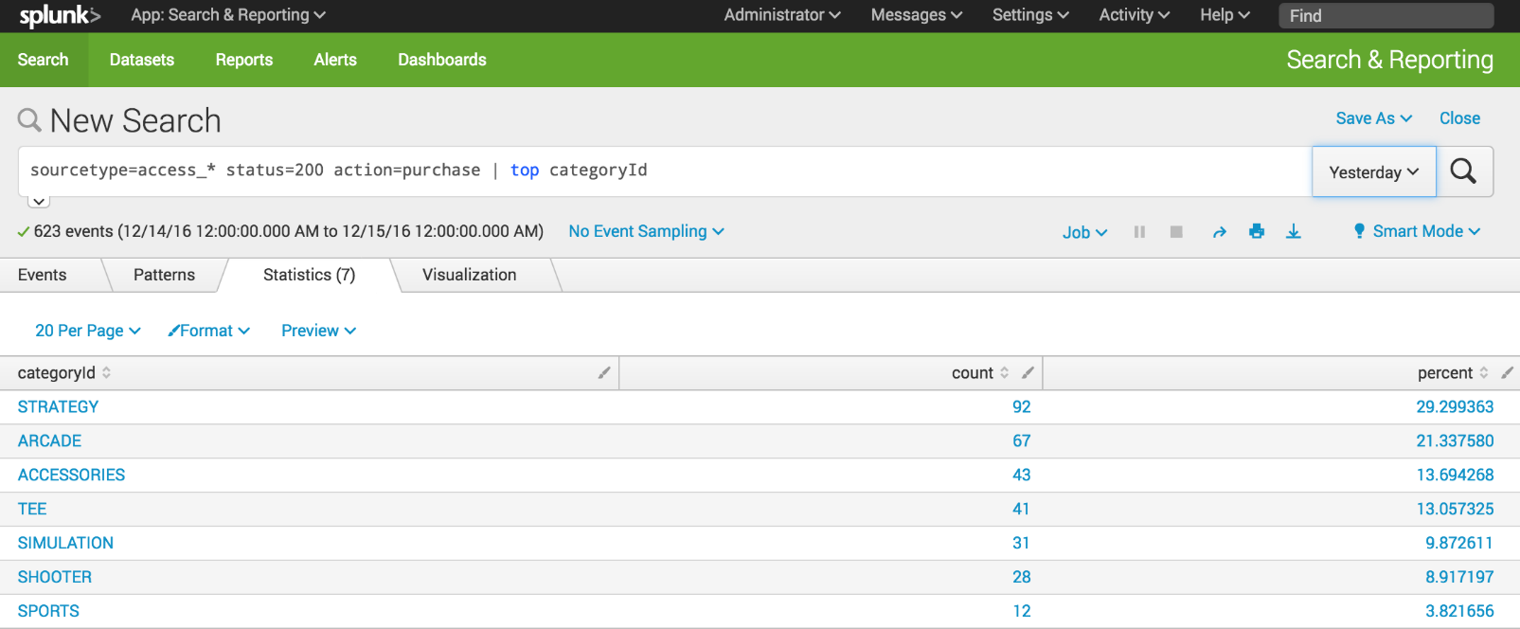](http://docs.splunk.com/File:6.5.1216_tutorial_dashboards1.png)

1. Click the **Visualization** tab. The displays shows a Line Chart.
2. Change the Line Chart to **Pie Chart**.

[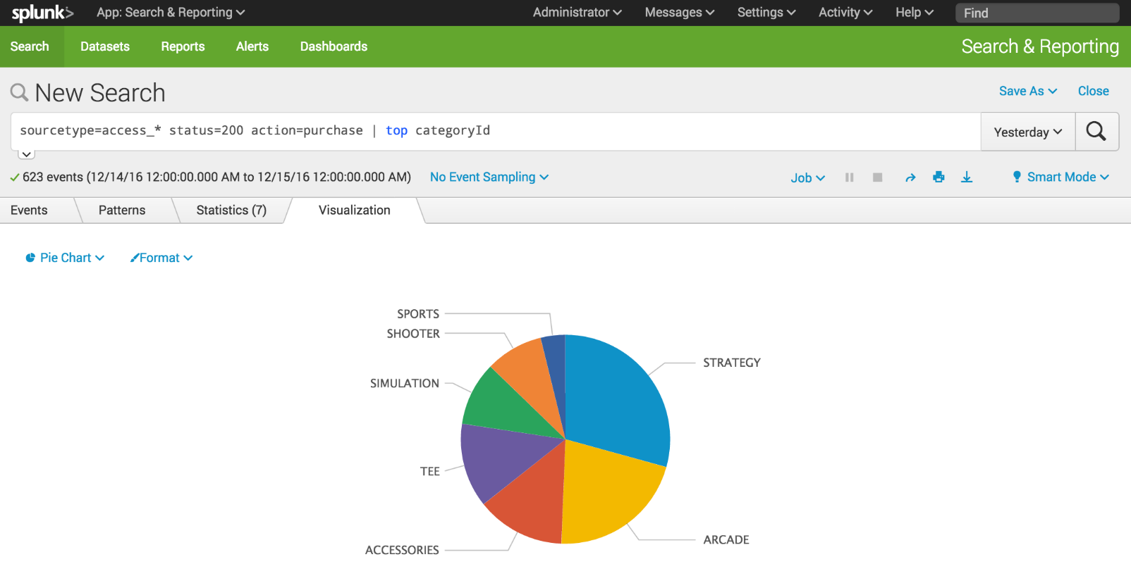](http://docs.splunk.com/File:6.5.1216_tutorial_dashboards2.png)

1. Click **Save As** and select **Dashboard Panel**.
2. Define a new dashboard and dashboard panel.
   1. For **Dashboard**, click **New**.
   2. For **Dashboard Title**, type **Buttercup Games - Purchases**.

The **Dashboard ID** field displays **buttercup_games__purchases**.

* 1. For **Dashboard Description**, type **Reports on Buttercup Games purchases data**.
  2. For **Dashboard Permissions**, keep the default setting **Private**.
  3. For **Panel Title**, type **Top Purchases by Category**.
  4. For **Panel Powered By**, keep the default setting **Inline search**.
  5. For **Panel Content**, keep the setting for **Pie Chart**.

[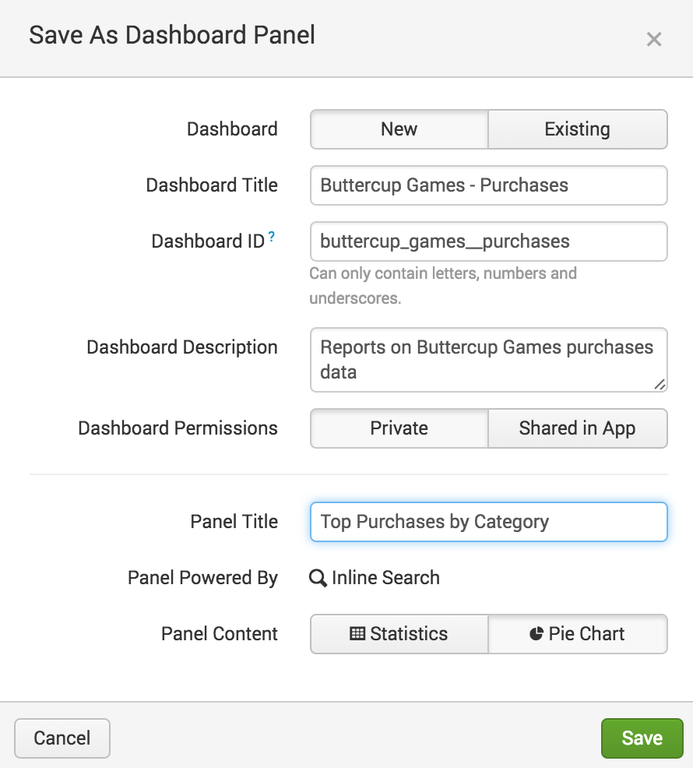](http://docs.splunk.com/File:6.5.0_tutorial_dashboards4.png)

1. Click **Save**.
2. In the confirmation dialog box, click **View Dashboard**.

[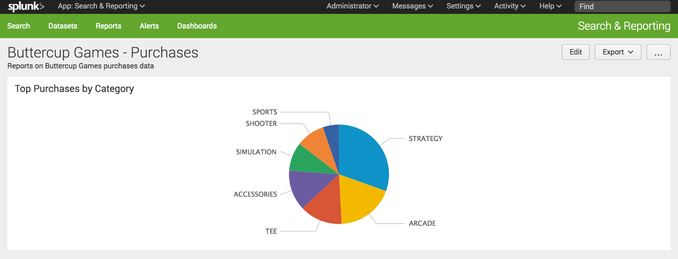](http://docs.splunk.com/File:6.5.0_tutorial_dashboards6.png)

You now have a dashboard with one report panel. To add more report panels, you can either run new searches and save them to this dashboard, or you can add saved reports to this dashboard. You will add more panels to this dashboard in the next section.

For now, let's spend a little bit more time on this dashboard panel.

## View and edit dashboard panels

There is a separate view to see a list of the dashboards that you have access to. From this view, you can create dashboards, and make changes to dashboards and dashboard panels.

1. Click **Dashboards** in the App bar to see the Dashboards view.

You might see a pop-up dialog box asking if you want to take a tour about dashboards. If you take the tour, there is an option at the end of the tour to try dashboards yourself. This option displays the Dashboards view.

In addition to the **Buttercup Games - Purchases** dashboard that you created, there are several built-in dashboards.

[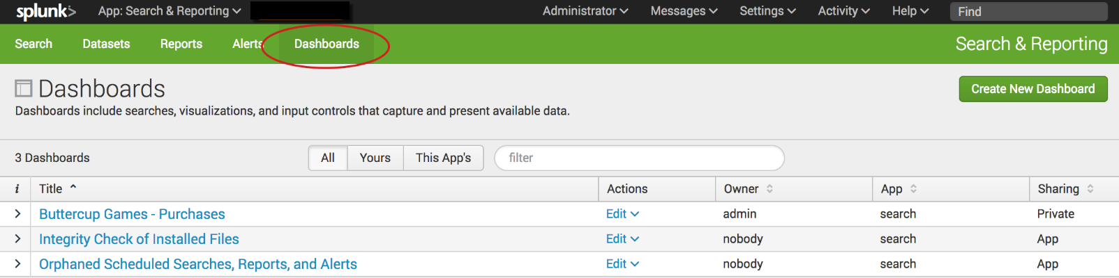](http://docs.splunk.com/File:6.6.0_tutorial_dashboardslist.png)

1. For the **Buttercup Games - Purchases** dashboard, click the arrow ( > ) symbol in the ***i***column to expand the dashboard information.

You can see information about the app that this dashboard is associated with, whether or not the dashboard is scheduled, and the dashboard permissions.

[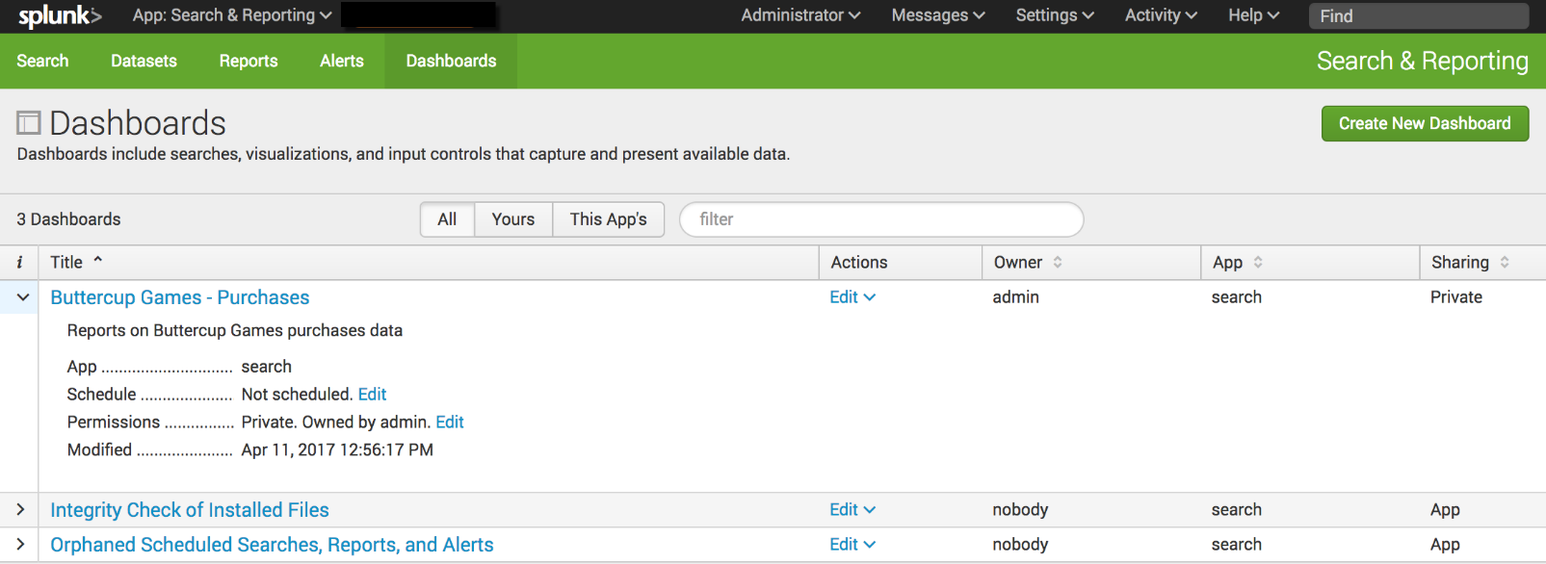](http://docs.splunk.com/File:6.6.0_tutorial_dashboardslistinfo.png)

## Add controls to a dashboard

You can add input controls, such as the Time range picker, to dashboard panels.

1. In the **Dashboards** list, click **Buttercup Games - Purchases** to display that dashboard.
2. Click **Edit**.

[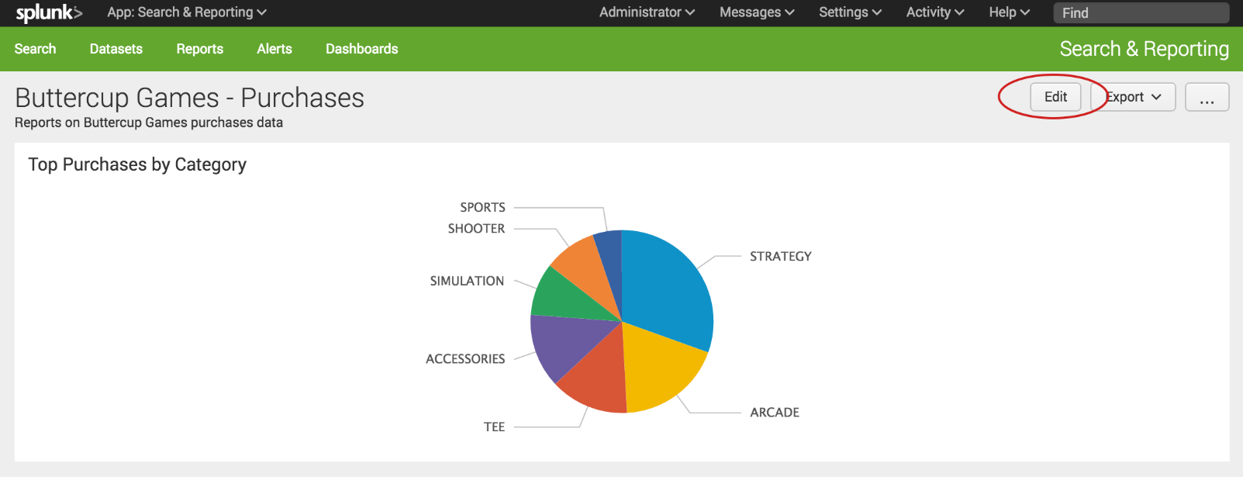](http://docs.splunk.com/File:6.5.0_tutorial_dashboards_edit.png)

You can either edit the dashboard using the UI or the Source. With the UI option you can add panels and inputs to the dashboard.

* + Use the **Add Panel** option to create a new panel, add a report as a panel, or clone from an existing dashboard.
  + Use the **Add Input** option to choose from a list of controls to add to the dashboard, including text, a checkbox, and a time range picker.

With the Source option, you can edit the XML source for the panel directly. Editing the source directly is not discussed in this tutorial.

[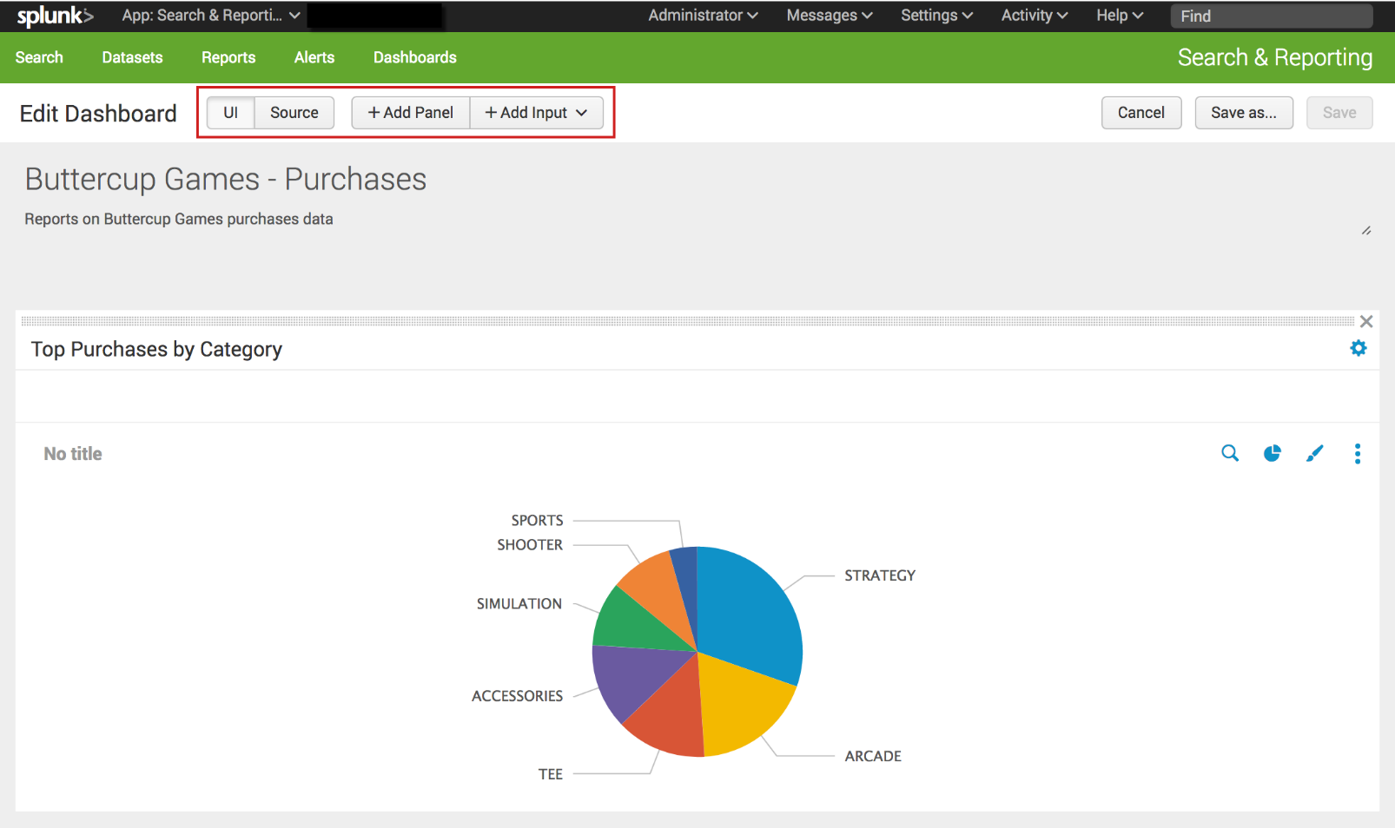](http://docs.splunk.com/File:6.6.0_tutorial_dashboards_edit.png)

1. Click **Add Input**, and select **Time**.

[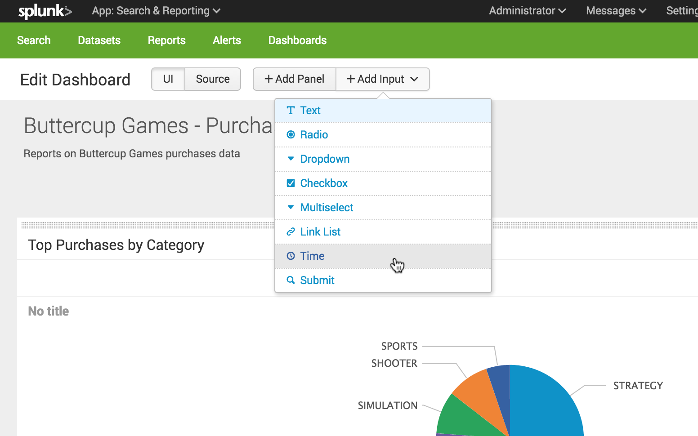](http://docs.splunk.com/File:6.5.0_tutorial_dashboards_addtimeinput.png)

The Time range picker input control appears on the dashboard.

[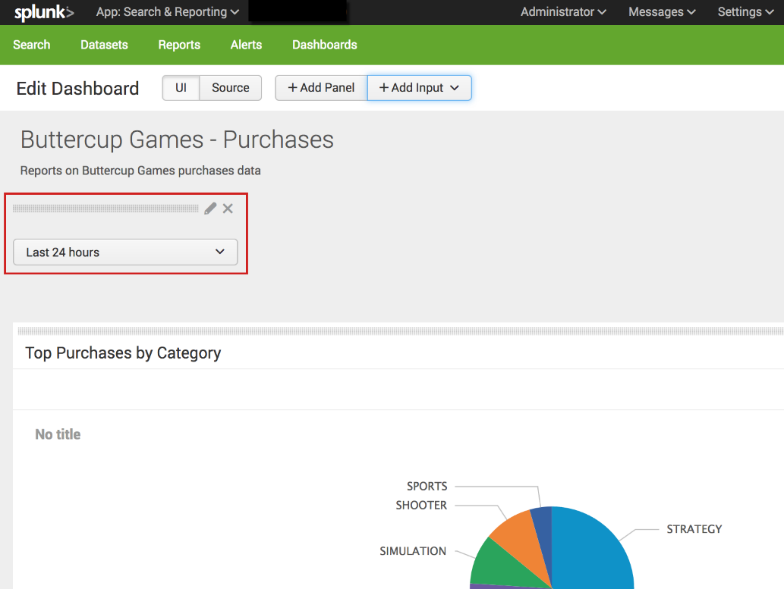](http://docs.splunk.com/File:6.6.0_tutorial_dashboards_timeinput_edit.png)

1. Click the **Edit Input** icon for the Time range picker. The icon looks like a pencil.

This opens a set of input controls. The **Time** input type is selected.

[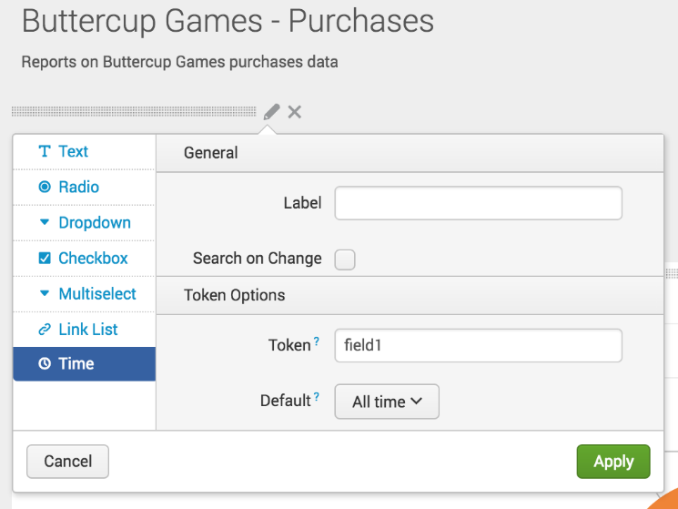](http://docs.splunk.com/File:6.5.0_tutorial_dashboards_timeinput_editoptions.png)

* 1. For **Label**, type **Time range**
  2. For **Token**, replace field 1 type **BG_Purchases_Time_Range**.

The controls that you add to a dashboard have identifiers called **input tokens**. This step redefines the name of the input token for the Time range picker. The default names for input tokens are field1, field2, field3, and so on. You can change the input tokens when you add controls to your dashboard. Naming the tokens makes it easier to understand which input you are working with. In this example you used a token name that includes the a short version of the dashboard title.

* 1. For **Default**, change the default time range to **Previous week**.
  2. Click **Apply**.

The input controls that you add to a dashboard are independent from the dashboard panels. If you want the chart on the panel to refresh when you change the time range, you need to connect the dashboard panel to the Time range picker input control.

1. In the dashboard panel, click the **Edit Search** icon.

[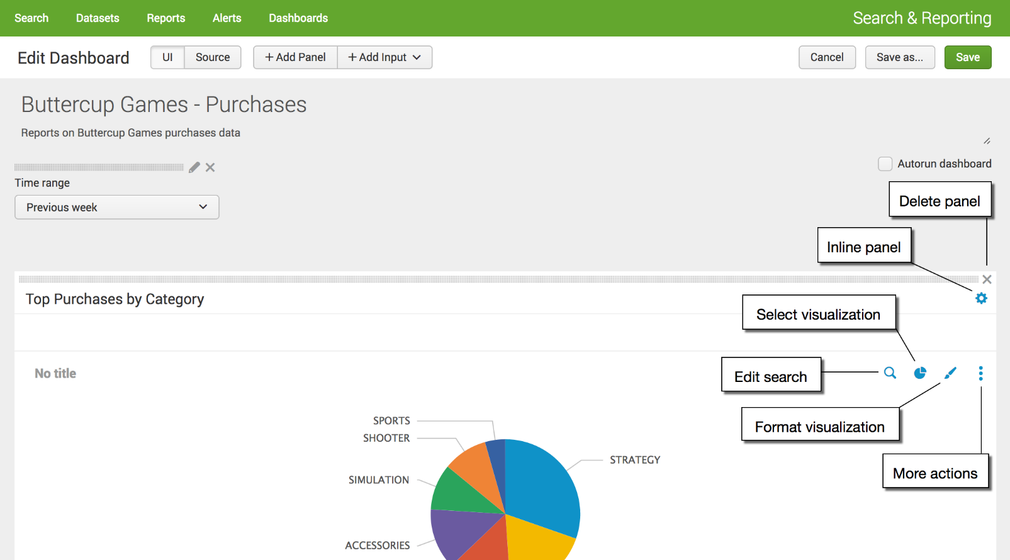](http://docs.splunk.com/File:6.6.0_tutorial_dashpanel_editsearch.png)

1. In the Edit Search dialog box, for **Time range** select **Shared Time Picker (BG_Purchases_Time_Range)**.

[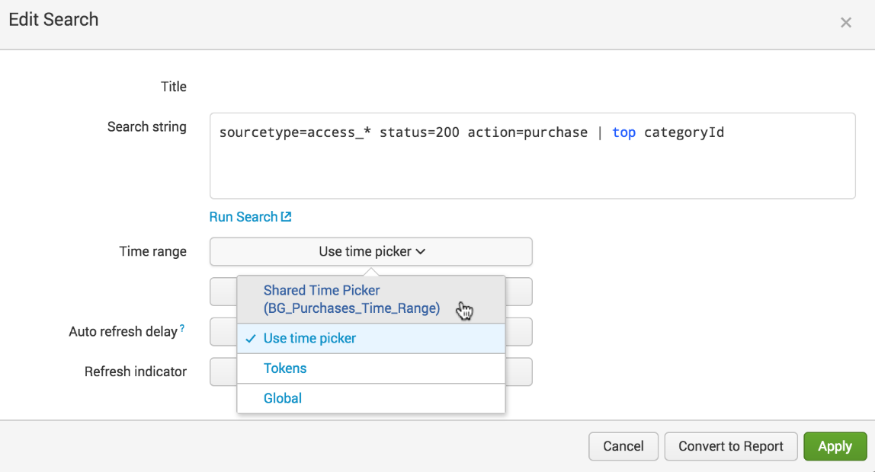](http://docs.splunk.com/File:6.6.0_tutorial_dashpanel_editsearch_edit.png)

1. Click **Apply**.
2. In the **Edit Dashboard** window, click **Save** to save the changes to the dashboard.

The panel is now connected to the Time range picker input control in the dashboard. This Time range picker is referred to as the **shared time picker**. The inline search that powers the panel now uses the time range that is specified in the shared time picker.

You can have dashboards that contain a mix of panels. Panels that are connected to the shared Time range picker, and panels that show data for the time range specified in the in the search that the panel is based on. To connect panels to the shared time picker, repeat the '''Edit Search''' steps above.

[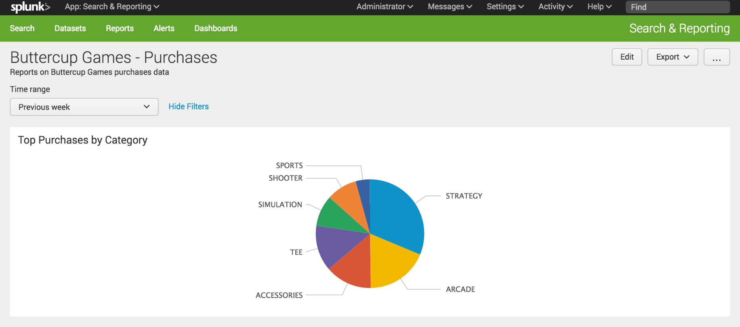](http://docs.splunk.com/File:6.5.0_tutorial_dashboardpaneledited.png)